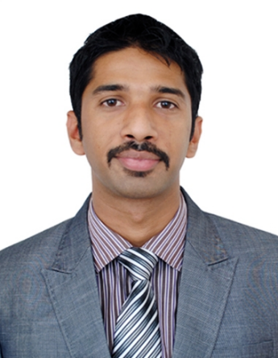
Gulfjobseeker.com CV No: 1318830
Mobile +971505905010 / +971504753686

To get contact details of this candidates
Submit request through Feedback Link
http://www.gulfjobseeker.com/feedback/submit_fb.php

Sr. Sales executive (Retail) with UAE experience
D.O.B:06-SEPT-1987
Nationality: Indian

SUMMARY

A dedicated professional with 4+ years combined experience as a customer service professional / sales executive in retail and hospitality environment with proven strengths in customer service, sales, negotiations and presentation skills. Backed by solid credentials including MBA (concentration in marketing management), BCOM in finance & International business & a certificate course in air travel & hospitality. I am interested in working with an organization which would provide me career growth and a challenging role.

PROFESSIONAL EXPERIENCE

LANDMARK GROUP (Home Centre) – Abu Dhabi, UAE
Sr. Sales Associate - Household department from December 2009 to June 2012

Role Details:
- Lead a team of 4 employees to meet the organization's expectations for productivity and goal accomplishment
- Manage the department budgetary and financial responsibilities of the department.
- Communicate regularly with other managers regarding the development in the department.
- Stock control and Replenishment of finished stock.
- Handling customer complaints and issues at customer service department.
- Displaying products according to the Merchandising principles.
- Assists in stocking sales floor, stock rotation, displays and organization of merchandise.
KINGFISHER AIRLINES – Ahmedabad Airport, Gujarat, India.
Guest Service Executive from 21st Jan 2008 to 2nd Dec’ 2009

Role Details:
- Responsible for looking after passengers from when they book in, to when they board an aircraft.
- Reservation and ticketing.
- Checking passengers’ ID and tickets, allocating seats, weighing luggage and issuing boarding cards.
- Work closely with service agents, airport staff, security staff, flight dispatchers and airline operating staff such as cabin crew.
- Security of the flight.

QUALIFICATIONS

- Academic

2012 – 2014 - Karunya University Business School
Master in Business Administration – Specialization in Marketing

2005 – 2008 - S.D School of Commerce (Gujarat University)
Bachelor of Commerce – Specialization in Finance & International Business

- Professional

2006 – 2007 - Frankfinn Institute of Air hostess Training
Diploma in Aviation, Travel & Hospitality Management

SPECIALIZED SKILLS
- Building relationships
- Presentation Style
- Teamwork
- Organizational ability
- Drive and ambition
- Communicate, network and negotiate

INTERESTS

Socializing with friends and family, Watching TV (documentaries), Playing cricket on a weekly basis, Reading non-fiction books.

LANGUAGE KNOWN
English - Excellent reading, writing & speaking
Malayalam - Mother tongue
Hindi - Read, write & speak
Gujarati - Read, write & speak
Arabic - Basic

