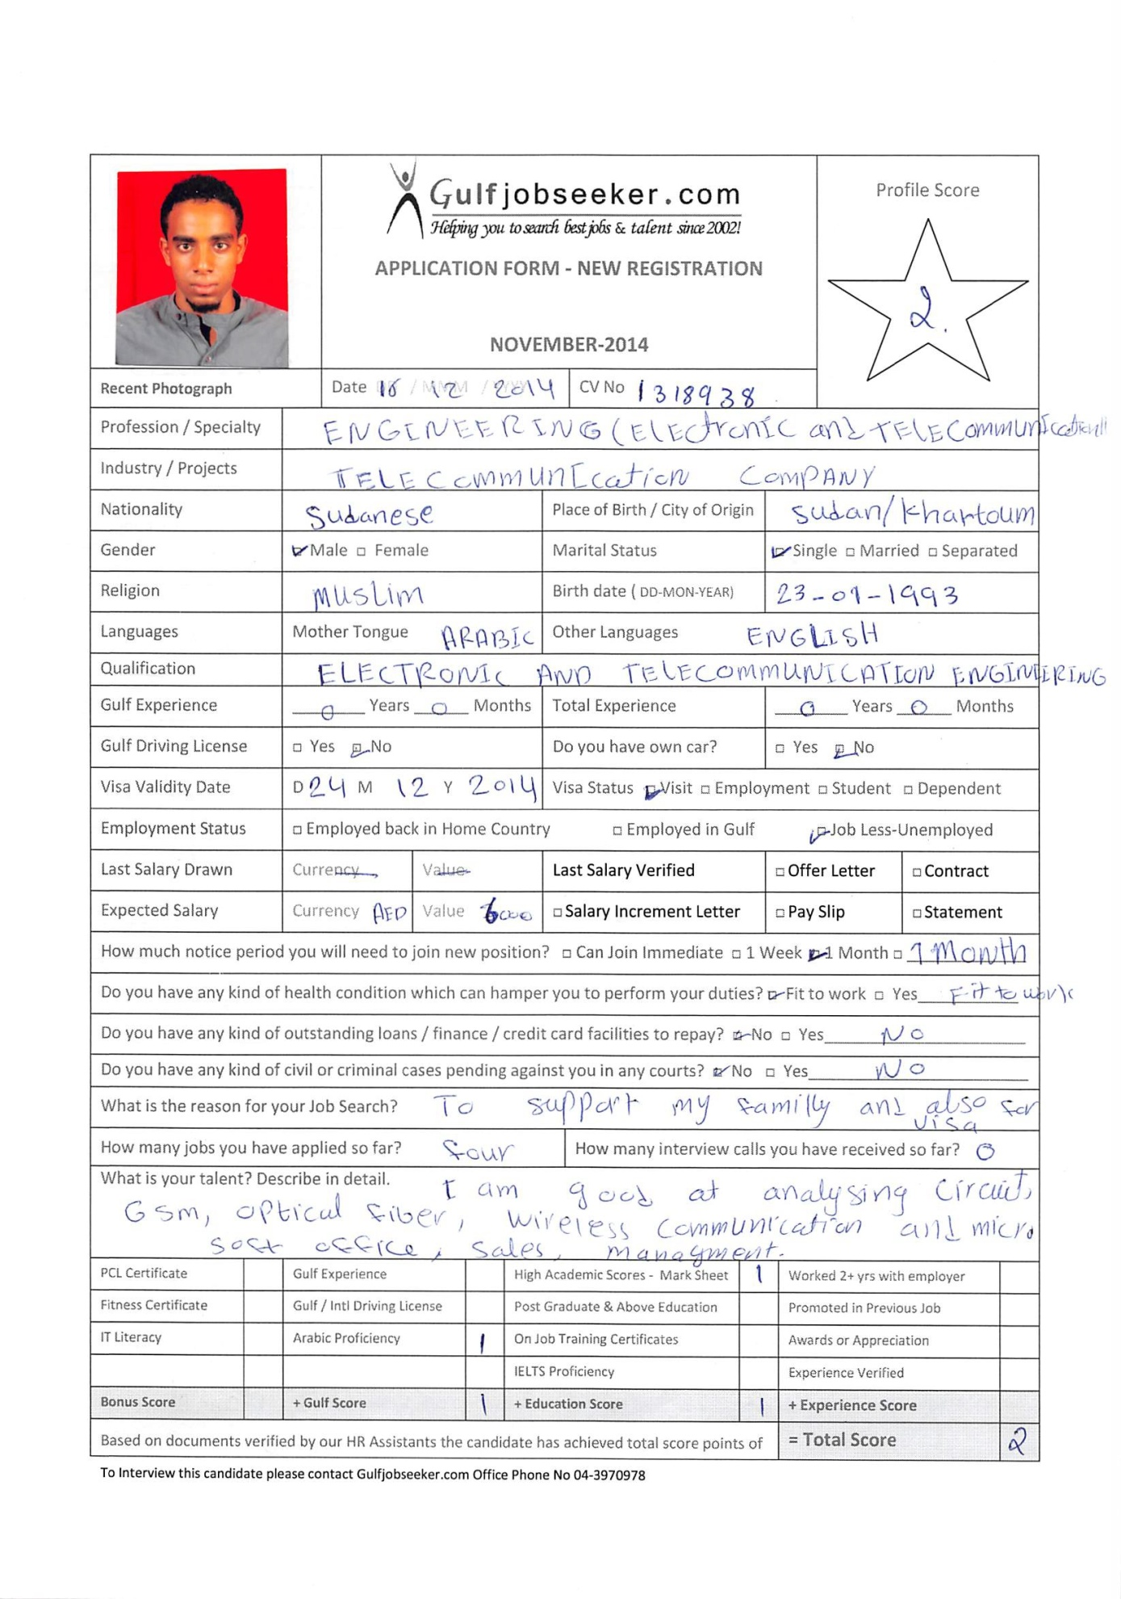

OBJECTIVES
- I present myself with a strong desire to achieve the organizational goals.
- I look forward towards a progressive and challenging career in Telecommunication and Electronic Engineering.
PROFILE
- Comprehensive problem solving encountered in data, networking and electronic devices.
- Self-motivated and hard working person with potential considered an added value to Employer.
- Capable to learn and realize organization procedures and core business strategies to reveal
a key team player.
- Ability to handle pressurized situations and multitasks.
- Ability to deal with people from different cultures.
- Proficient knowledge in computer skills.

EDUCATION
Bachelor of Electronic and Communication Engineering
Visvesvaraya Technological University - (2010-2014) (First Class)
- Elite High School – (2005-2008)
- Mowrada Primary School – (1997-2005)

TECHNICAL KNOWLEDGE
- Network
- Global system mobile communication(GSM)
- Wireless communication(WC).
- Good understanding of electronics circuit analysis

PROJECT

Device control using flex sensors:
Dumb and deaf people have difficulty to communicate with other people, thus device control using
Flex sensors is going to help them to communicate with such people, the device control using flex
Sensors consist of:
- Flex sensors.
- Interface.
- Transmitter.
- Receiver(decoder).
- Voice.
- Relay and micro-controller.
- The program language which use is (C-Language)

LANGUAGES
- Arabic and English(Fluent).

PERSONAL INFORMATION
- Place of birth:Khartoum, Sudan
- Date of birth:23/01/1993
- Nationality :Sudanese
- Gender:Male

DRIVING LICENSE
- International License.

