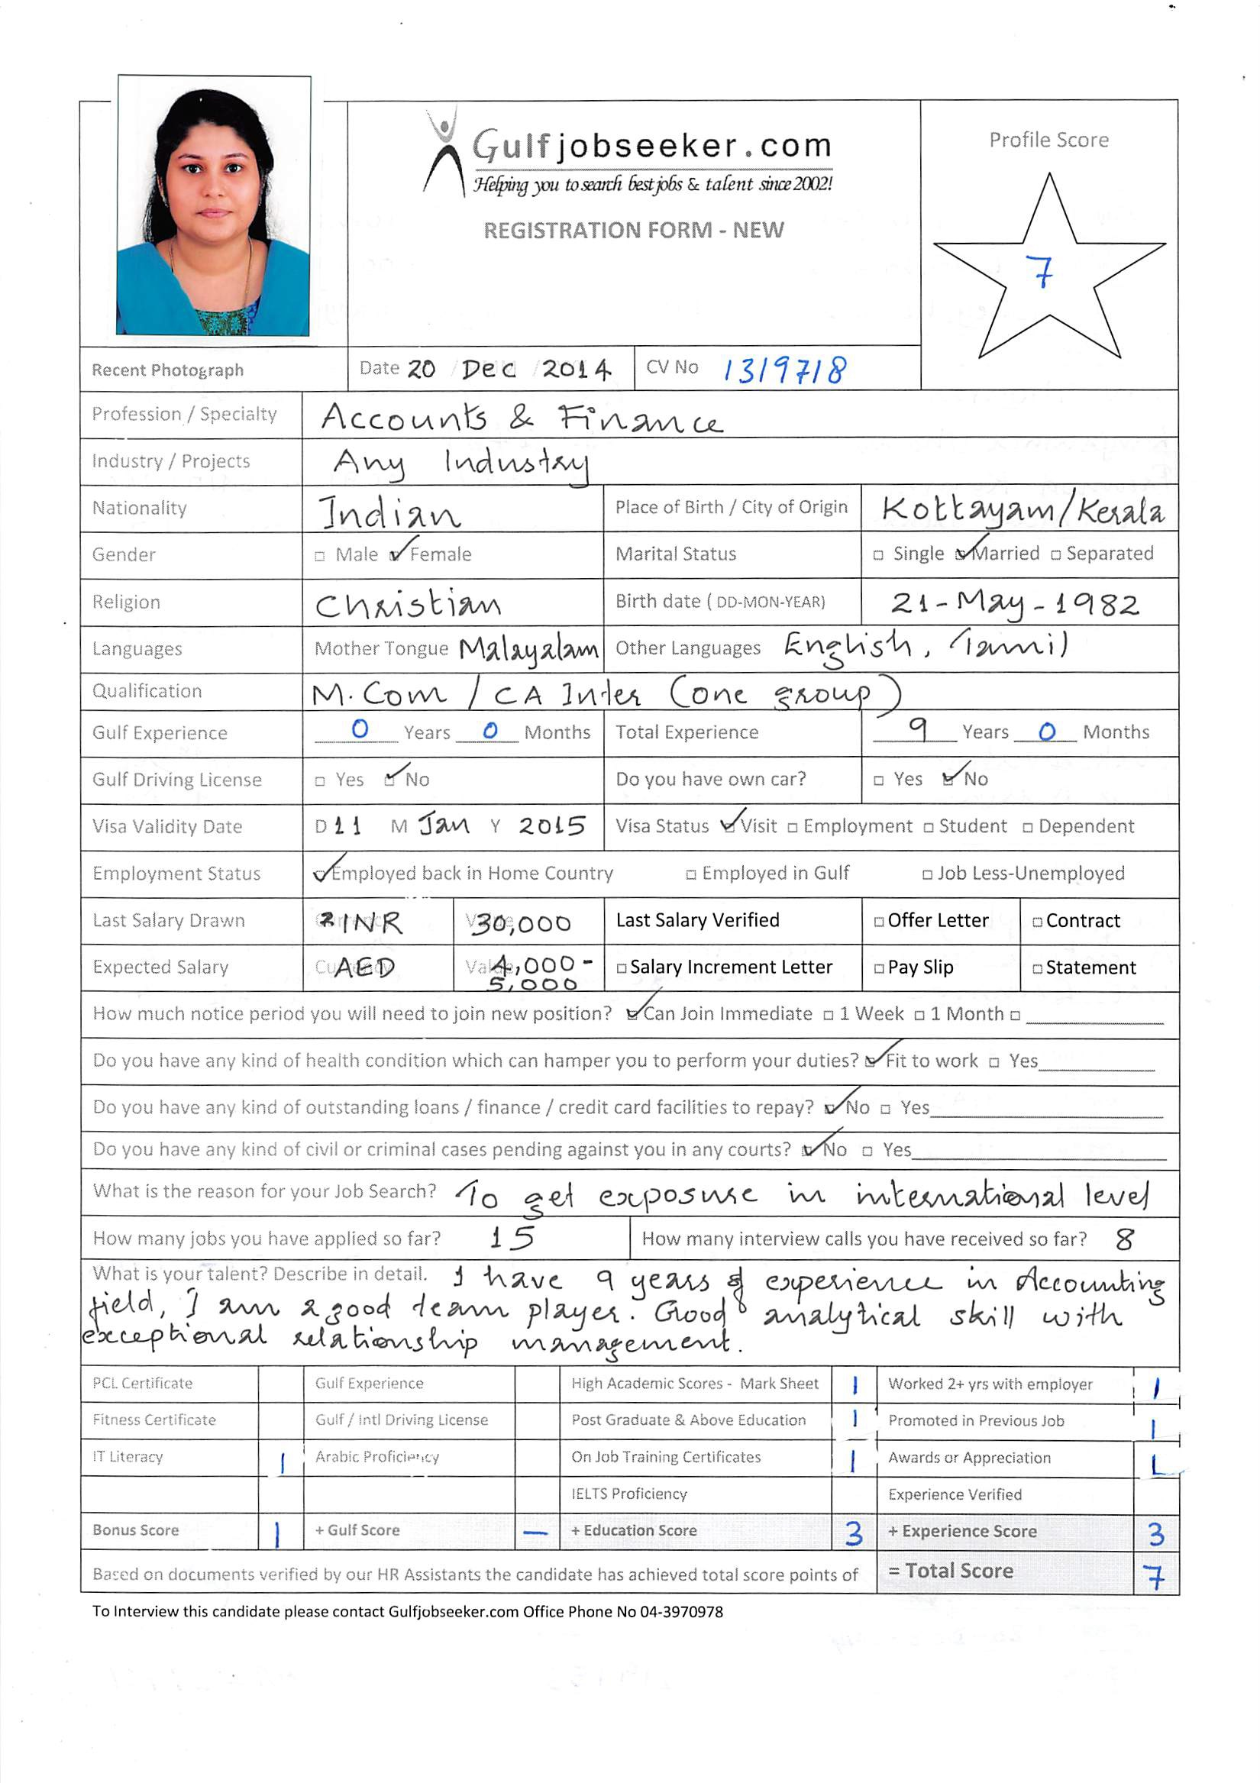

Aspiring for senior level assignments in Accounts/Finance with an organization of repute.
Location Preference: UAE/ Middle East

Processing Journals MIS Reporting Statutory Compliance
Month end Reports Finalisation of Accounts Budgetary Control
Reconciliations Cash Flow/Fund Flow Forecasts Liaising with Auditors

A pro-active and result oriented accounts professional with over 9 years experience in accounting, achieving revenue, profit and business growth objectives within start-up and rapid-change environments.

Expertise in account reconciliations, finalising accounts, management reporting and liaising with auditors.

Expertise in Oracle 11i, Tally7.2, MS Office Packages.

Good analytical skills with exceptional relationship management & negotiation capabilities with proven abilities in liaising with Banks, Financial Institutions and various regulatory authorities.

Academic Credentials
Masters Degree in Commerce from Annamalai University, Tamilnadu.
CA Intermediate (one group cleared)
B.Com. from M. G. University, Kerala .

Organizational Experience

Type of Industry : Self Employed
Duration : Nov 2012 to date
Key Services rendered:

- Outsourced book keeping function for various SME clients.
- Monthly reporting of revenue and profitability.
- Reconciliations
- Finalization of accounts and liaising with auditors for smooth completion of audits.
- Reconciliation – Excel reconciliation for various accounts and reporting.
- Month end account closing and reporting.
- Monitoring preparation of statutory books of accounts, bank reconciliation, schedules along with notes of accounts in compliance with the norms.
- Overseeing financial statements including trial balance and balance sheets.
- Reviewing the financial position of the company through annual reports while ensuring analysing the expenditure on a monthly basis to control expenses.
- Preparing reports to provide feedback to top management on financial performance, vis a vis, variance analysis of profit, margin%, etc

Type of Industry : BPO
Position Held : AR Analyst & US payroll Analyst
Duration : July 2010 to Nov 2012
Reporting to : Team leader, Manager
Key Deliverables:

- Processing journals – As per the request received, will process journals and send mail for approval and confirmation.
- Reconciliation – Excel reconciliation for various accounts and reporting.
- Open items reporting and need to work with the concerned person/team for its clearing.
- Assurenet reconciliation – Monthly will do reconciliation for all accounts as per this tool.
- Month end account closing and reporting.
- Ensure that delivery is in conformance with defined SLA, targets.
- Collaborate with peers and other project resources as and when required.
- Calculate provisions and will do adjustments journals monthly.
- Preparing month end reports.
- Client reporting tool updates.
- Funding activity – Once in fifteen days will do funding.
- Processing month end journals.
- Maintain effective documentation.

Type of Industry : Non Banking Finance Company
Position Held : Officer
Duration : August 2006 to July 2010
Reporting to : Assistant Manager, Senior Manager
Key Deliverables

- Preparing daily and monthly income report of the branches and analyzing their performance and reporting to higher authorities.
- Periodical evaluation of the performance of the branches on the basis of the target & goals set by the administrative office.
- Prepare intercompany report and reconciliation & Bank Reconciliation
- NRI clients pay in and payout by coordinating with Axis bank and making arrangements for funds.
- Back office operations relating to Xtrade.
- Doing arrangements for sending clients trading details on daily basis.
- Processing entries in the system.
- Reporting and reconciling the cash collected.
- Dealing & resolving various brokerage and reconciliation issues with AMCs on daily basis.
- Coordinate and liaison with registrars – CAMS, KARVY etc
- Liaise with statutory/ internal auditors for timely completion of audits
- Maintaining audit records and implementing audit observations
- Attending customer grievance regarding brokerage issues and solving them.
- Month end closing and reporting.

Previous Assignment
Apr’05 to May’06
Position Held: Accounts and Audit Assistant

Highlights:
- Audited various Partnership firms and proprietary concerns on the basis of Audit U/s 44 AB of Income Tax Act 1962.
- Successfully provided consultancy services, mainly in the area of tax management for individuals and partnership businesses.
- Monitoring preparation of statutory books of accounts, bank reconciliation, schedules along with notes of accounts in compliance with the norms.
- Overseeing financial statements including trial balance and balance sheets.
- Reviewing the financial position of the company through annual reports while ensuring analysing the expenditure on a monthly basis to control expenses.
- Preparing reports to provide feedback to top management on financial performance, vis a vis, variance analysis of profit, margin%, etc

IT Skills
- Oracle 11i
- Tally 7.2 (Accounting Software)
- MS Windows
- Excel & Word

Personal Details

Date of Birth : 21st May, 1982
Languages Known : English, Malayalam and Tamil
Visa Status : Visit Visa (Till Jan 11th)
Nationality : Indian
Marital Status : Married

Declaration
I hereby declare that the above mentioned information are true and correct to the best of my knowledge and belief. Thank You

