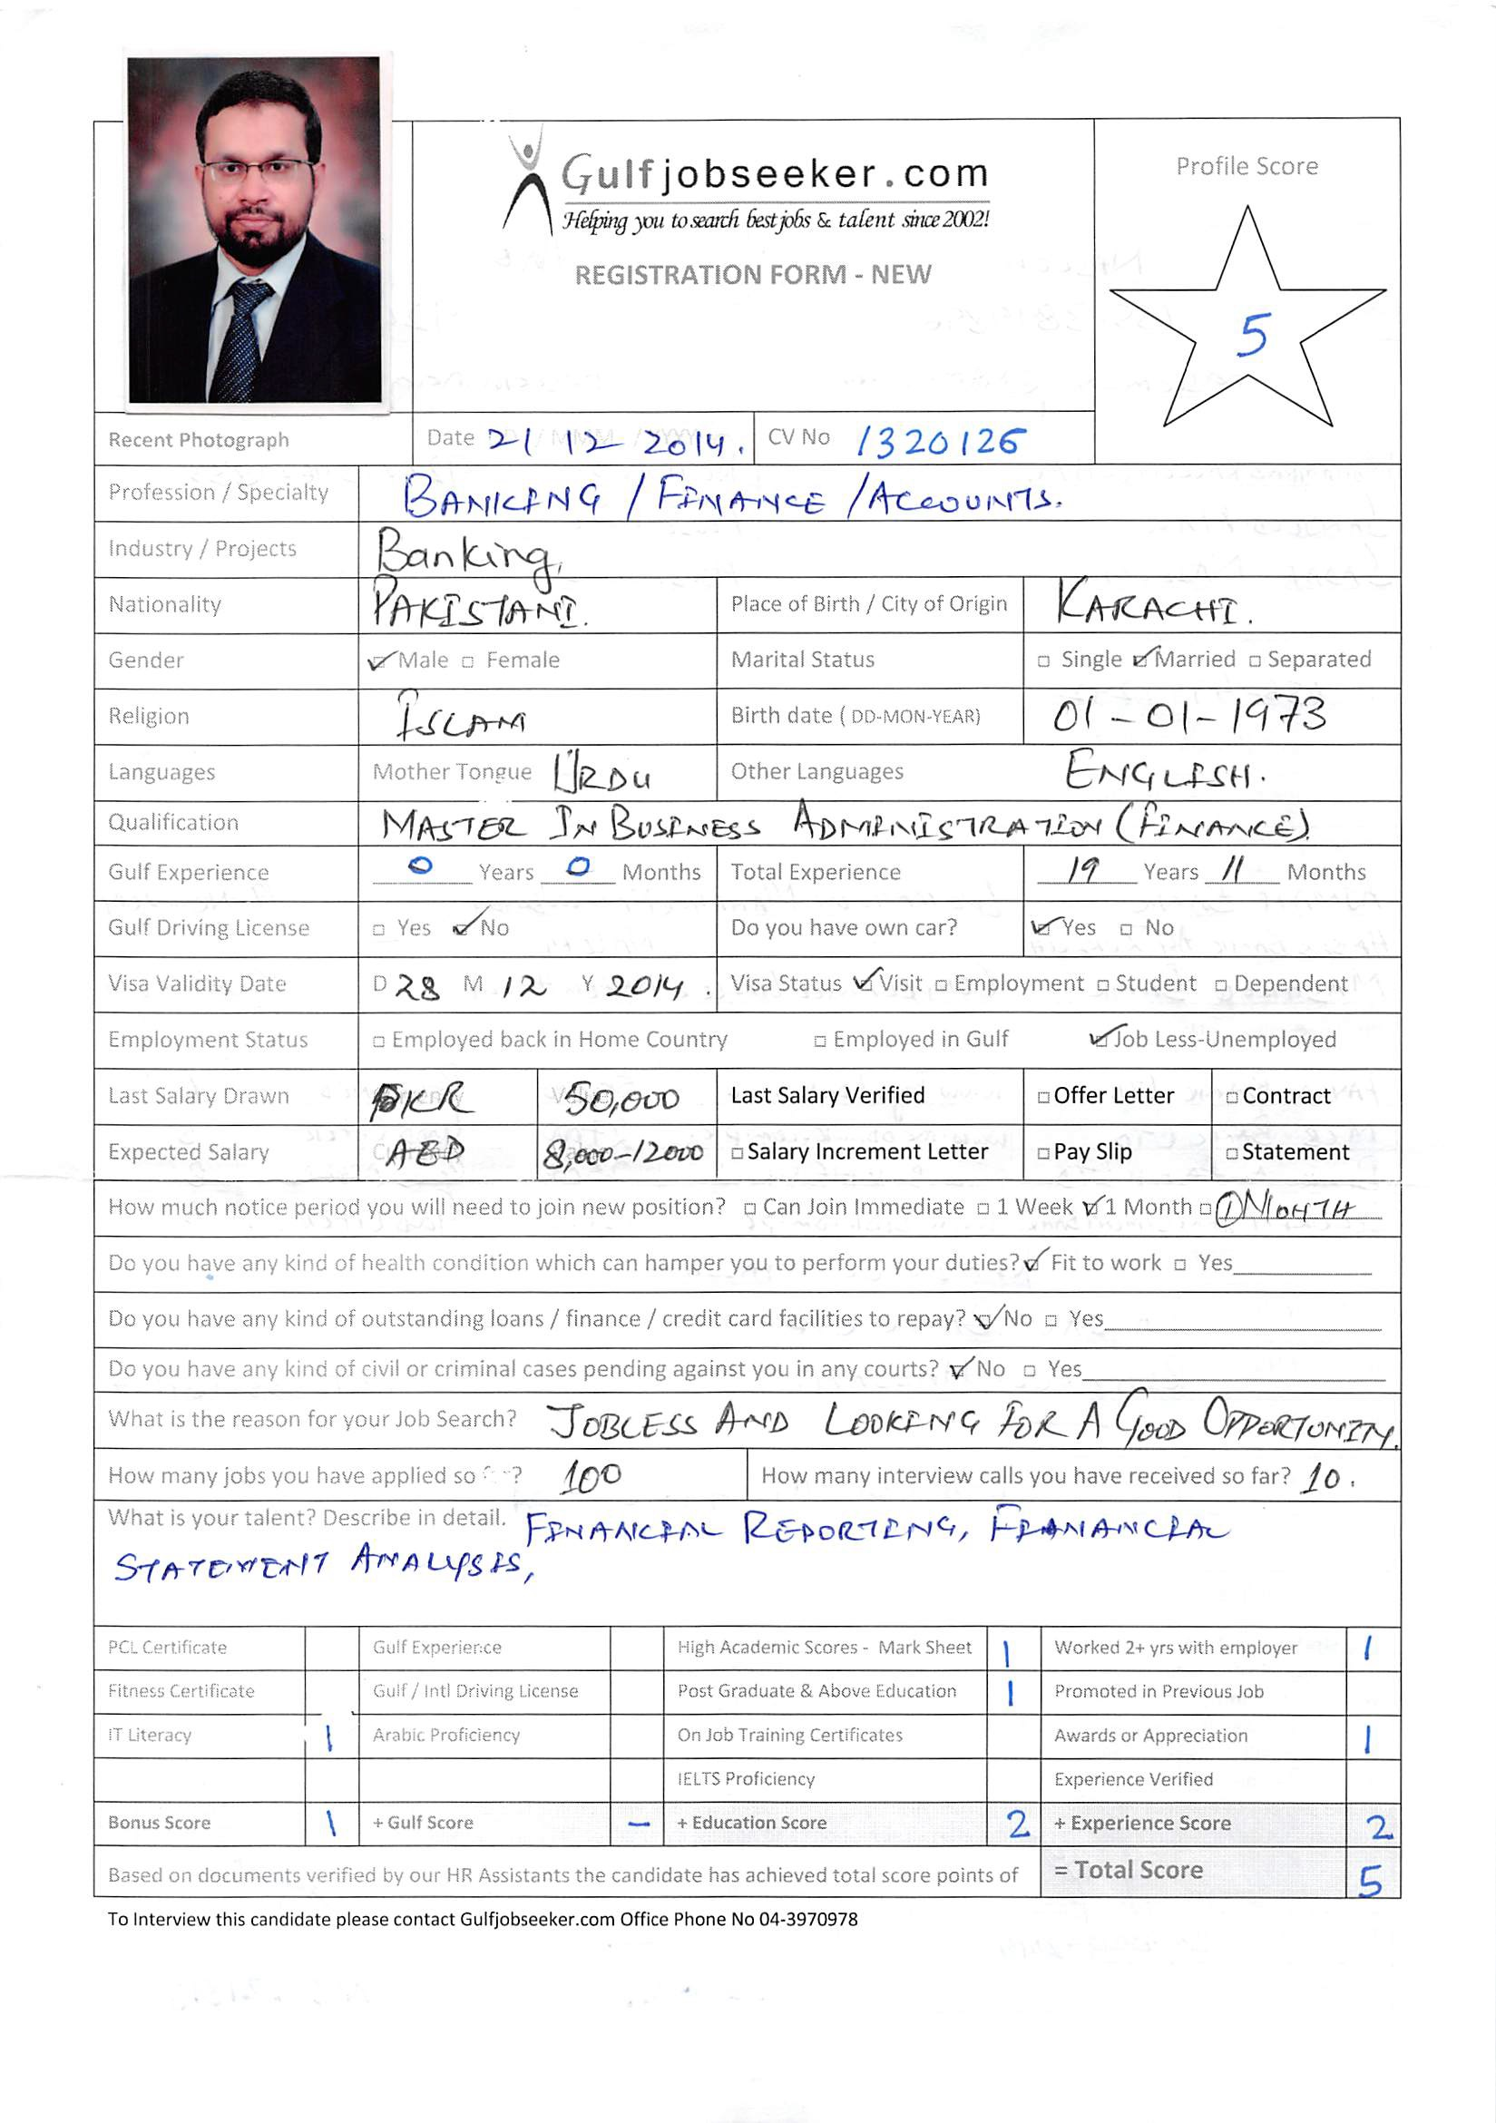



Objective: To utilize and enhance my experience and skills by seeking a challenging and rewarding position in a progressive organization.
EXPERIENCE:

November 2010 to June 2014 Senior Branch Service Officer (Grade I) Remittance, GL
Responsibilities (Best Branch of the Year 2011 Pan Pakistan in Internal Controls)
Banking software symbols 8.2 & 8.5
- Foreign remittance (USD, EURO and GBP) and also generate the SWIFT code to ensure the amount is transfer to their respective account of the customer.
- Responsible for submission of Foreign Currency Returns to the State Bank of Pakistan.
- Act as a main contact point for all internal and external audits included the (SBP) audits.
- Developing, Monitoring, updating and maintaining the Anti Money Laundering (AML)/Combating Financing of Terrorism (CFT) policy and the procedure in line with any changes made to existing laws.
- Investigation of STR/ CTR cases and providing opinion on the cases referred by Operations Department.
- Perform surveillance and monitoring activities of internal practices and procedures to ensure compliance.
- Ensuring that departmental activities are carried out strictly in accordance with the laid down procedures/policies, and Central Bank guidelines.
- Preparation, submission and analysis of reports relating to withholding tax, Suspense accounts, inter branch reconciliation, commission income activity and all other information.
- Custodian of ATM Keys and responsible for ATM reconciliation & balancing.
- Review of systems and controls on a regular basis, identifying bottlenecks and control weaknesses with a view to achieving improvement and timely reporting to Branch Manager.
- Quarterly proofs & verifications of critical General Ledger accounts as told by ICD.
- Responsible for Stop Payment Procedure, Zero Balance and Dormant Account Activation.
- Maintain records and balancing of all respective heads on weekly, fortnightly & monthly basis.
- Monitoring of overdrawn accounts & daily transaction lists.
- Backup of Operation Manager.
March 2008 to October 2010 G.B.O (Grade III) Remittance, GL, Clearing
Responsibilities Officer in MCB Bank Limited, which is one of the largest banks in Pakistan
Banking software symbols 8.2
- To supervise all formalities regarding account opening & closing amendments in accounts and also handling of deceased and unclaimed account.
- Maintain records and balancing of all respective heads on weekly, fortnightly & monthly basis.
- Review of systems and controls on a regular basis, identifying bottlenecks and control weaknesses with a view to achieving improvement and timely reporting to Branch Operation Manager.
- Quarterly proofs & verifications of critical General Ledger accounts as told ICD (Internal Control Division)
- Preparation, submission and analysis of reports relating to withholding tax, Suspense accounts, inter branch reconciliation, commission income, ATM.
- Act as a main contact point for all internal and external audits included the (SBP) audits.

December 2004 to February 2008 Supervisor Officer Range II Collection Department
Responsibilities MIS Reporting
Banking software Card Pro
- Review client accounts and discuss the status of slow paying or delinquent accounts with the partners and management as applicable.
- Designs and implements credit card operations policies and procedures and recommends changes to increase efficiency.
- Manages the daily activities for the company's credit card operation group.
- Ability to research client history and account details in order to understand past and current situations prior to reaching out to client.
- Supervise & guide a team of 30 persons to achieve their respective targets.
- Planning out strategies to keep the delinquency under control.
- Daily/weekly updates of MIS reporting showing progress of the officer and give manager for their comments of the delinquent accounts.
- Responsible for managing collection calls, reconciling and resolving account payments and disputes, negotiating payment plans and documenting all contacts with clients and partners utilizing the Firm's collection software.
- Must own projects and take responsibility for collections from start to finish; i.e. initial calls to client through receipt of payment.
- Forecast and track the daily collections of aged accounts.
- Manage portfolio of customer accounts and initiate phone calls to past due residential and commercial accounts - average 300 calls per week
- Initiate action on 60 and 90 past due accounts: generate dunning letters, cancellation notices and notifications
- Interact with install, sales and service departments to resolve customer billing issues
- Follow-up on all assigned accounts through final resolution
- Generate and mail certified cancellation letters where necessary
- Prepare and maintain monthly MIS of South Region.
- Prepare Collection Manual for new hiring
ACHIEVEMENT
Bank Al-Falah Limited Outstanding performance in the year 2006

December 2001 to November 2004 Assistant Manager Capital Market Operation
Responsibilities: MIS Reporting & Financial Accounting
- Settlement of shares of regular market and Carry over Transaction through (Central Depository & National Clearing Company Limited).
- Verification of Letter of Placement and Borrowing, Deal Tickets, Brokers Notes, Brokerage House Invoices.
- Assisting in managing of Portfolio around Rs 1.0 Billion.
- Monitoring of the equity portfolio, which range over Rs. 100 Millions to Rs. 500 Millions.

July 1994 to November 2001 Junior Manager Finance & Accounts
Responsibilities: MIS Reporting, Financial Accounting, Cost Accounting, Budgeting, Internal & External Audit.
- Prepare monthly results for vital information to facilitate higher management in decision making process that includes sales volume, trading summary, and factory operating expense, factory efficiencies and working capital.
- Prepares cash positions on a daily basis, prepares and reviews periodic cash forecasts and allocate cash to be transferred at the beginning of each period to cover operational needs.
- Continuously monitors the liquidity position and its profit centers and highlights the projected funds positions on a regular basis.
- Responsible for direct bank relationship management.
- Analyzes bank fees as related to cash and investments and make necessary recommendations to control costs. Negotiates financial terms with banks and finds appropriate work flows to reduce bank charges.
- Assists the Treasury Manager in maintaining the appropriate level of foreign currencies as per the needs.

- Prepares report that presents excess cash investments position and management fees earned on a periodic basis.
- Prepares variance cash flow analysis report and highlight major variances. Ensures treasury management reports, agreements and all other required documentations are reviewed and stored for record keeping.
- Provides recommendation to enhance treasury policies and procedures.
- Liaises regularly with treasury management and divisions in order to understand ongoing changes in business activities and developments.
- Provides the Treasury Manager with adequate information to carry out his/her responsibilities. Undertakes other related tasks and duties as assigned by Treasury Manager
- Prepare and analysis of departmental budget within the location.
- Prepare and analysis manufacturing cost for individual’s items, distribution cost on product, cost allocation on products.
- Monitored project expenditure worth up to Rs 100 million.
- Prepare cost statement for cost auditors.

CERTIFICATES

Online Compliance Essentials Training August, 2012
Online Training – Liability Products November, 2012
Online Client Acceptance & AML Training August, 2013
Online Training for Consumer Finance – Auto Loan April, 2014

ACADEMIC QUALIFICATION:

MBA from INSTITUTE OF BUSINESS MANAGEMENT (IoBM). CGPA 3.04

WITH Major in Finance Year 1999

Bachelor in Commerce Year 1994

PROFESSIONAL QUALIFICATION:

- Computer Diploma in Computer Science 1994 Petroman

- Oracle Associates Diploma 1998 Sun Educational Centre

- E-Commerce Professional Developer 2000 NCR

PERSONAL DATA:
- Date of Birth : 01-January-1973
- Marital Status : Married

REFERENCE: Will be furnishing upon request.

