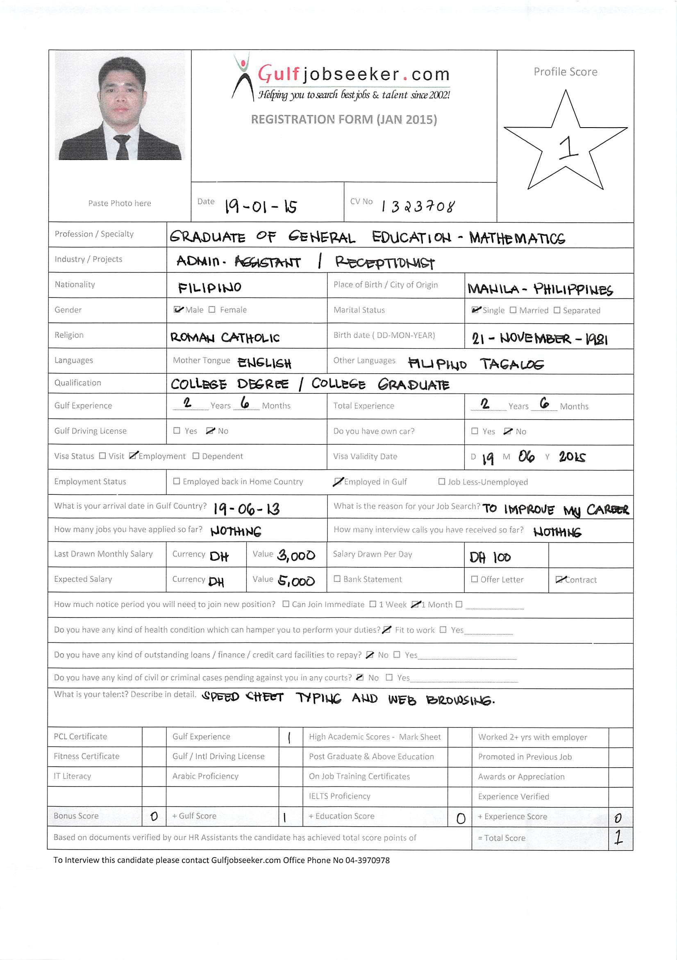

SUMMARY

Profile: Male, 32, Single
Nationality: Filipino
Educational Attainment: Bachelor’sDegree
Current Location: Dubai
Current Position: Front Desk Receptionist
Preferred Location: Dubai
Salary Expectation: Not Specified/Negotiable
Educational Attainment: College Graduate

WORK EXPERIENCE

June 2013 to Present

- Provide office support services in order to ensure efficiency and effectiveness within the main office activities.

- Receive, direct and relay telephone messages and fax messages.
- Pick up and deliver the mails.

- Maintain the general filings and file all correspondence.

- Assist in the planning and preparation of the meetings.

- Provide word-processing support and secretarial support.

- Develop and maintain a current and accurate filings system.
- Monitor the use supplies and equipment

- Coordinate the repair and maintenance of office equipment.

April 2010 to November 2012 Marketing Executive Wiseman Books
Philippines
- promotional activities

- information

- writing reports

- monitoring performance analyzing and investigating price, demand and competition

- devising and presenting ideas and strategies

- Compiling and distributing financial and statistics information

- Writing reports

- And monitoring performance

__________________________________________________________________
_

SKILLS

- Team building

- Analytical and problem solving

- Decision making skills

- Effective verbal and listening communication skills

- Computer skills including the capacity to spreadsheet and word processing program at the high proficient level (MS word, Excel).

- Stress management skills

- Time management skills

- Personal attributes

- Honest and trustworthy

- Possess cultural awareness and sensitivity

- Flexible

- Demonstrate sound work ethics

Educational Attainment:

Graduate Studies
Mary Hill School of Theology
Manila, Philippines
General Study of Christology Batch 2006 to 2009
Graduated!

Associate Study
St. Vincent School Theology
Manila, Philippines
Associate in Philosophy Batch 2006

College
Saint Theresa College
Tandag, Surigaodel Sur. Philippines
Bachelor of Elementary Education Batch 2003
Graduated!

High School
SSPSC at Sto. Nino
Sto. Nino, San Agustin, Surigao del Sur. Philippines
Batch 1995 to 1999

Elementary
Sto. Nino Elementary School
Sto. Nino, San Agustin, Surigao del Sur. Philippines
Batch 1989 to 1995

_____________________________________________________________________________________

Personal Data Age: 32

Birthdate: 21 November,1981 Nationality: Filipino, Asian Sex: Male

Speak: English (fluent), Filipino (native)

