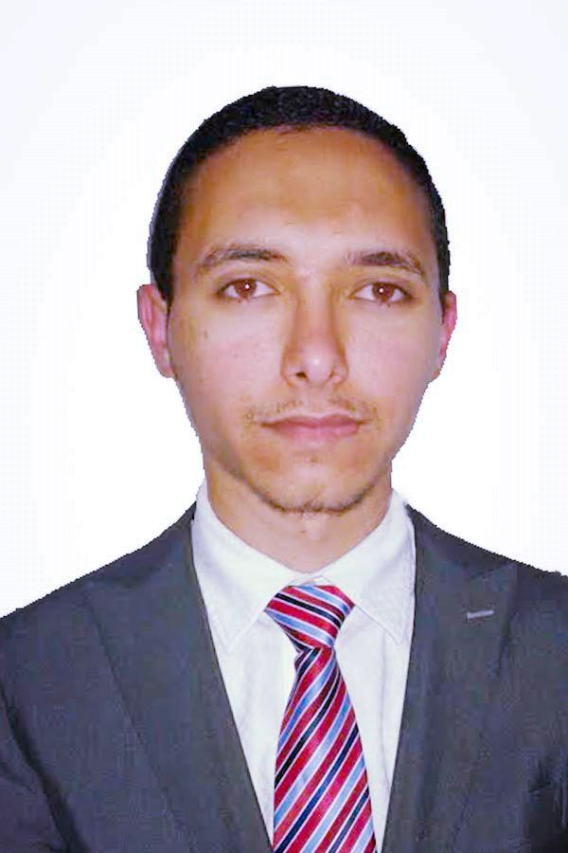
CURRICULUM VITAE

Gulfjobseeker.com CV No: 1324578
Mobile +971505905010 / +971504753686

To get contact details of this candidates
Submit request through Feedback Link
http://www.gulfjobseeker.com/feedback/submit_fb.php

OBJECTIVE
Contribute to a dynamic growing organization where my strong analytical, interpersonal skills and hard work will have a significant impact. The optimal position will provide professional growth and opportunities to contribute.

PROFESSIONAL SKILLS
- Continuous desire for learning
- Proficient in using Ms Office.
- Hardworking and sincere to organization
- Well Experienced in Customer Interaction

EDUCATIONAL QUALIFICATIONS
- Bachelor of Science in Tourist Guiding, Tourism and Hotel Management.
- Faculty of Tourism and Hotels, Mansoura University, 2011. (Grade: very good)

TECHNICAL PROFILE

Travelport /Galileo portugal LTD ABU DHABI - U.A.E. ( 2014 )
- Hands on training in Galileo system.
Reem Travel …….MANSOURA- Egypt ( 2012)
- Hands on training in Galileo system.
Egyptian Center..... MANSOURA- EGYPT (2011)
- Hands on training in Human Resources Development.
Egyptian Center..... MANSOURA- EGYPT (2011)
- Hands on training in MS Office "Word - excel - power point - outlook "

Worked as a Sales executive at Marina Group of Company Dubai UAE
( FEB 2013 to MAR 2015 )

Duties of Salesman:

- Provides smile to the customer always
- Present our product to the customer
- Provides appropriate action to different kinds of problem arising from the shop
- Arrange stock room for newly arrived stocks
- Counter check the selling price and unit cost of each item of stock.
- Recording the orders received by the cashier and forwarding them to culinary workers.
- Answering questions and resolving problems and service issues for existing customers.
- Offer a wide range of varieties of Items to the customers.
- Customer service including assisting with Items choices and styling on the floor in a friendly and efficient manner
- Having good merchandising experience.
- Helping the customers in selecting the best matched Items out available ones in the stock.
- Stock management - restocking sizes from the stockroom, assisting with inventory stock takes
- Changing windows displays every week for good sales

- Dealing with Customer and resolving customer complaints.
- Keep good relationship with customers by giving good service
- Work as a team in attaining target/ promotional sales.
- Answer Customer queries in a polite and helpful manner.
- Receiving daily sales order verifying with the replenishment report and entering in to the system

Worked as a Customer Service & Call Center
Almorgan Travel MANSOURA- EGYPT 2011 to 2012

- Using Sabre system.
- Travel bookings and developing travel itineraries.
- Marketing & selling tour packages to customers with the help of the marketing department.
- Responding to customer queries, processing payments, issuing receipts and able to answer questions about travel times .

PERSONAL PROFILE

Age & Date of Birth : 01-March-1990
Sex : Male
Marital Status : Single
Nationality : Egyptian
Height : 174 cm
Weight : 65 Kg
Language Known : English, Arabic

DECLARATION

I do here by declare that the information furnished above to the best of my knowledge and belief.

