­­­­­­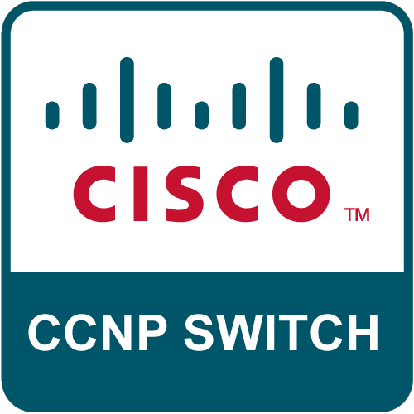 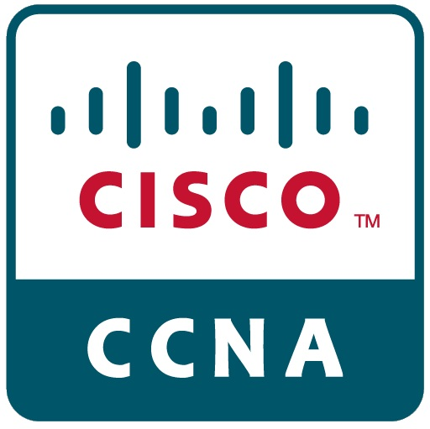 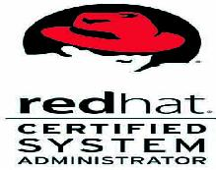 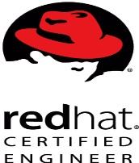  

Gulfjobseeker CV No: 1330554

To interview this candidate call: 971505905010

Or email us back filled up Vacancy Form

<http://www.gulfjobseeker.com/Free_Job_Posting_Form.doc>

**An adaptable and efficient team player with excellent Technical/Management skills at all levels. looking for a role where I can develop, research technologies with new challenges.**

**AN OVERVIEW**

* A Computer Science Engineer and IT Management Analyst. Offering **over 3+ years** of expertise in the areas of Network, Linux, Windows Administration, which include Technical Support, IT Management Support.
* A team player with distinguished abilities in motivating team members to maintain deliverables as per SLAs. Team-based management style and excellent interpersonal & communication skills.
* Adept in Monitoring Servers, Networks using different monitoring tools such as RMS, Espy (Nagios-Tool), Nimsoft.
* Hands on Experience on Various ticketing tools Eventum, HP Service Manager.
* Providing Support for Oracle DBA on Oracle Enterprise Linux -5 Platform.
* Insightful experience in Active Directory Management via active role server involving creation/management of user accounts, share permissions, assignment of active directory groups to users/ workstation IDs etc.
* Monitoring VMware Virtual infrastructure spread across geographical locations in NOC Support.
* Good Technical Skills on SAN - EMC, HP storage for Virtual Environments
* Strong experience in administrating the exchange servers 2007,2010 Including Backup Monitoring and Disaster Recovery.

**EDUCATIONAL QUALIFICATIONS:**

* **Master of Business Administration** (*MBA*) from Osmania University, INDIA, Approved by All INDIA Council of Technical Education.
* **Bachelor of Engineering** (*Computer Science Engineering*) from Jawaharlal Nehru Technological University, INDIA, Approved by All INDIA Council of Technical Education.

**Certifications**

* Cisco Certified Network professional: Switching **( Cisco ID: CSC012153885)**
* Cisco Certified Network Associate **( Cisco ID: CSC012153885)**
* Red Hat Certified System Administrator **(ID:140-107-228)**
* Red Hat Certified Engineer **(ID:140-107-228)**
* Microsoft Certified Professional **(ID: 11500267)**

**Experience**

**Organization Redcentric PLC, Hyderabad, INDIA.**

**Position Support Analyst**

**Duration Jul 2014 to Jan,2015**

**Key Deliverables**

* Direct all IT deployments and job scheduling with oversight for vendor and consultant management.
* Coordinate internal IT Management tickets ensuring that implementations are ready as required by client deadlines.
* Proven ability to resolve complex problems, quickly diagnosing and identifying issues and determining the proper resolutions.
* To perform regular checks in the server logging into them Remotely and sending the Daily, Weekly and Monthly reports according to the customer requirements.
* Monitoring data backup software's such as Symantec, Asigra , Veritas.
* Analyse, prepare and document operational procedures and technical guidelines.
* Plan, develop and deploy change management initiatives for technical implementation including productivity software, systems, technical application and hardware release.
* Configure, test and troubleshoot various networking devices before deployment, including Linux-base Servers, Routers, switches, firewall etc.
* Monitor servers and networks infrastructures using Nagios, IT 360 , Cacti etc.
* Schedule and perform maintenance and system upgrades of network infrastructure.
* Create, open, resolve and close escalated trouble tickets using RMS and HPSM ticketing system.
* Analyse the root cause for the technical issue and co-ordinate with clients on that issue.
* Dispatch field technicians on various sites, and provide guidance for network devices connections, configuration and troubleshooting.
* Investigate, analyse and document technical issues, then provide recommendation to upper management.
* Document all network-related activities in ticketing system.
* Variety of systems, applications and tools background in NOC environment.
* Serve as primary initial responder within the Network Operations Center in identifying, troubleshooting, and resolving network problems.

**Organization City Pages Kuwait**

**Position IT Engineer**

**Duration October 2012 to January 2014**

* Providing Support for Network, Windows and Oracle Enterprise Linux(Oracle Data Base)
* Managing File System, Partitions, Logical Volume Manager- Increasing size on production Server as per requirement.
* Kernel installation and up gradation
* Implementing IP-tables, TCP Wrapper, for security purpose.
* Configured NFS server and mounted the file systems at clients through Auto mount.
* Trouble shooting issues such as Disk space utilization, CPU utilization, Memory utilization.
* Swap space management.
* Managing Red-Hat Package Manager - Yellowdog Update Modified server.
* Basic knowledge about Scripting and Crontab.
* Ensuring connectivity across LAN. Blocking of Ports on Switches as required.
* Switches: Basic Configuration & VLAN setup on Cisco 1900, 2950, 2960 Switches.
* Router: Basic Configuration of Cisco 2500, 2600, 1800
* V-Lan: configuration, Inter Vlan Routing, trunking etc.
* Back-up and restore of all critical resources including router & switches IOS.
* Experience in Active Directory Management via active role server involving creation/management of user accounts, share permissions, OU, User Profile Management etc.
* Managing security level permissions on files and folders over Network on Windows Operating System.
* Adding New Work Stations in the Local Area Network.
* Hardware and software Installation, configuration and Up gradation.
* Work Stations Assembling maintenance and troubleshooting of PC’s & Peripherals.

**Organization SU Tech Services Pvt Ltd**

**Position Technical Support Engineer**

**Duration June 2011 to September 2012**

* Establishes network specifications by conferring with users; analyzing workflow, access, information, and security requirements; designing router administration, including interface configuration and routing protocols.
* Maintains network performance by performing network monitoring and analysis, and performance tuning; troubleshooting network problems; escalating problems to vendor.
* Establishes network by evaluating network performance issues including availability, utilization, throughput, good put, and latency; planning and executing the selection, installation, configuration, and testing of equipment; defining network policies and procedures; establishing connections and firewalls.
* Secures network by developing network access, monitoring, control, and evaluation; maintaining documentation.
* Prepares users by designing and conducting training programs; providing references and support.
* Upgrades network by conferring with vendors; developing, testing, evaluating, and installing enhancements.
* Updates job knowledge by participating in educational opportunities; reading professional publications; maintaining personal networks; participating in professional organizations.
* Protects organization's value by keeping information confidential.
* Accomplishes organization goals by accepting ownership for accomplishing new and different requests; exploring opportunities to add value to job accomplishments.

**PERSONAL DETAILS:**

DATE OF BIRTH : 21st Sep 1989.

FATHER’S NAME : Mohd Sadiq

GENDER : Male

NATIONALITY : INDIAN

LANGUAGES KOWN : English, Urdu, Arabic (Beginner)

References will be provided on Demand.