AWAIS | AWAIS.22269@2freemail.com  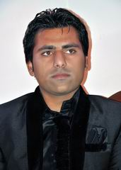

Career Objective ▼
Seeking a position as an Architect, Interior Designer or Exposure to a challenging and good working environment that enables to harness one’s skill and potential in the most productive way enhancing the organization’s reputation with better career prospects.

Education Profile ▼
Degree | University/ Board
Graduation  (Bachelor of -ARCHITECTURE) | (UNIVERSITY Of Sargodha) Oriental College Of Arts 36-L MM Alam Road Gulberg 2 Lahore Pakistan (2007 To 2012)
Intermediate  (FSC) | F.G. Degree College For Men Kharian Cantt (Islamabad Board) (2003 To 2006)
Matriculation | Govt. High School Thutha Rai Bahadur (Gujrat Pakistan) (2001 To 2003)

Professional Expertise ▼
Professional Software’s | - AutoCAD (Working Drawings, Sections Details, Elevations)  - Sketch Up 2D and 3D (Architecture)  - Microsoft Office  - Adobe Photoshop  - Sketching, One Point Perspective, Two Point Perspective, Model Making.
Areas of Expertise | - Interior Designing, Site Surveys, Free Hand Perspectives, Landscape planning, Housing Projects, Space Utilization,
Languages | - Urdu and Punjabi  - English

Professional Experience▼
Jobs  Duties & Responsibilities | Experience in Architecture Firm Such as:  - Job in NFRD Developers and Builder (Pvt) Limited Rawalpindi in Pakistan (26 July 2012 to 10 Sep 2014)  - 2 year Part Time job in office (Architiser) in Faisalabad in Pakistan (June 2012 to August 2014). Company constructs housing societies (Rehman Garden in Pind dadan khan, Canal Garden in Rahim yar khan, Paradise in Chistian, Al-falah in Choonian) in Pakistan.  - During Studies 3 month work in Blue brick Interior & Architect in Pakistan.  - Involved in the Planning, Design and Construction of Building.  - Preparing Layouts, Drawings, and preliminary Sketches.  - Providing clear and unambiguous direction to members of the project team.  - Writing reports, Site Visits and small scale Project Management.  - Developing & sustaining working relationship with public and private sector partner.  - Carry out 3D Design and 2D design as required.  - Visiting Sites and building relationship with site manager.  - Advising on planning Application.

Major Achievements ▼
Projects | 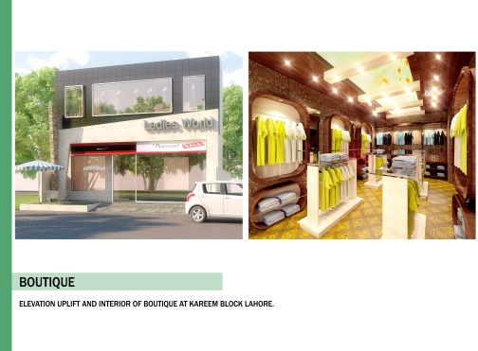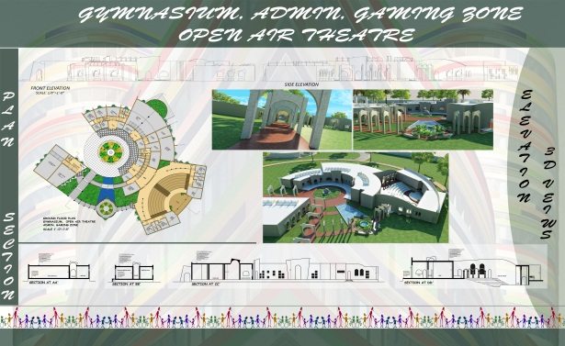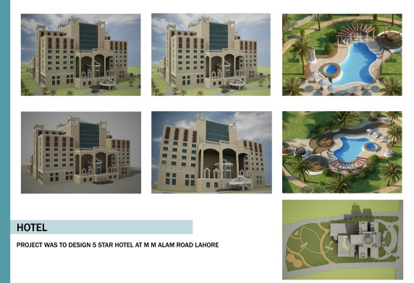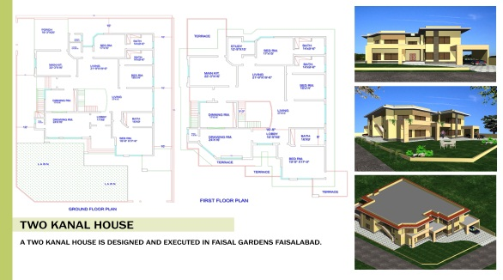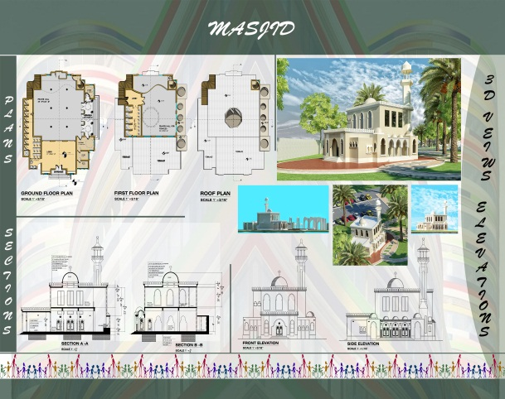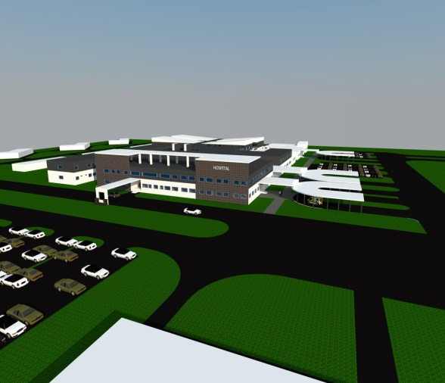
Skills | - Self-starter, Disciplined, Confident, and Goal Oriented  - Likes to take initiative.  - Able to Relocated/Travel as needed
Personal Information | D.O.B 03-08-1987  Marital Status Married  Religion Islam  Visa Status Visit visa.

References▼
References | Will be furnished on Demand

