Wisawak
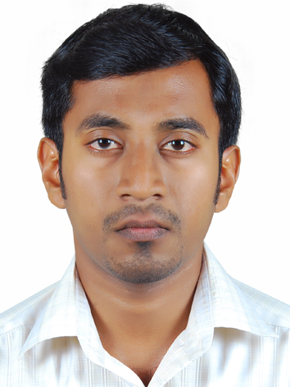
Qualification:
B-TECH in Mechanical Engineering.
,
Personal Profile
Birthday: 18/11/1988.
Nationality: Indian.
Mother Tongue: Malayalam.
Religion: Hindu.
Material Status: Single.
Qualification: BTECH in Mechanical Engineering.
Language Known.
English, Hindi, Malayalam.

wisawak.222207@2freemail.com
Mechanical Engineer.
CARRIER OBJECTIVES
Seeking an Engineering position where my experience and knowledge can be utilized and further developed fully.
EXPERIENCES
07th July 2013- Present.
Location: Adearest Electromechanical LLC, 3979484, P.O. BOX: 123107, Bur Dubai 2/1/122071.
Job title: Mechanical Engineer.
Description:
Junior Engineer
- Supervising refrigeration rack side.
Design Engineer.
- Preparation of piping and Instrumentation diagram.
- Load Calculation.
- 3D modeling.
- Preparation of item list and operation maintenance manual.
Field Mechanical Engineer.
- Follow-up the drawing.
- Executing the work.
- Interacting with the client and consultant.
23rd July 2012
Efforts Electrical Engineers and Contractors, Sreeshankara shopping centre, first floor, Room no: 225h, Kecheri, Thrissur-680501, Kerala, India.

QUALIFICATION
Degree: Bachelor of Technology.
Discipline: Mechanical Engineering.
University: Calicut University.
Institution: Vidya Academy Of science And Technology, Thrissur, Kerala, India.
Higher Secondary School: Science group.
Discipline: Computer science.
University: Kerala University.
Institution: DE-Paul Higher secondary school, Choondel, Thrissur, Kerala, India.
Secondary School:
University: Kerala University.
Institution: V.R. Appu Master Memorial High School, Brahmakulam, Thrissur, Kerala, India.
CERTIFICATION
- Short term course on marine engines and associated system.
This is the course related to Marine Diesel Engines and Associated System conducted at Central Institute of Fisheries And Nautical And Engineering Training, Kochi, Kerala, India.
- Mechanical hi-end design engineering.
Is the certificate course in Auto CAD 2D (Drafting and Plotting) 3D (Modeling and Rendering), Solid works, MS Project.
- Fire and safety course conducted by Keltrone and Norka roots.
Is a Fire And Safety Course Norka roots Cener, Undertaking Government of Kerala, Thycaud, Thiruvananthapuram, Kerala, India.
- HVAC-Design and Drafting.
Is a curse conducted By Dhanush Engineering India Pvt.Ltd. Hyderabad, India, Including the basics if refrigeration, Cooling Load calculation, Duct Sizing, Basics of Auto CAD.
- Refrigeration Basic Course.
Which is the course conducted by the Adearest service Department U.A.E. Including Refrigeration Basics Industrial Refrigeration Equipment- Type and Functions.

PARTICIPATED PROJECTS
- Adearest LLC
As Mechanical Engineering Trainee.
Assembly of Refrigeration Racks Al-Abdi Holding Company, Barakhath, Sadco and Alba tech.
- As Design Engineering Trainee in Office.
Preparation of piping and Instrumentation diagram, Load Calculation., 3D modeling. Preparation of item list and operation maintenance manual Of refrigeration projects in Middle east, DRC, Spins, AL-Khair, Modification project of NDTE.
- As field Mechanical Engineer.
Refrigeration plant room erection of DRC, Plant room and cold room erection of mani foods, Cartoon Freezer (GEA refrigeration equipment) erection of Brazil foods (present).
ACADEMIC PROJECTS
- Automatic Fuel Regulation system.
- Low Cost Harvesting Machine.
KEY STRENGTH
- Ability to work under pressure situation.
- Positive attitude and straight forward.
- Holds ethical and moral value.
- Technical and environmental adaptability.
- Willingness to learn.
- Team facilitator and hard worker.
COMPUTER SKILLS
- High experience in using Auto CAD 2D.
- Good experience in Auto CAD 3D.
- Good knowledge in using Solid Works and Autodesk Inventor.
- Good experience in using MS office and Photoshop.
- Good experience in using internet and internet applications.
LANGUAGE SKILLS
- Malayalam: My native language.
- Hindi: National language can read, write and speak.
- English: Read, write and speak.

DECLARATION
I hereby declare that all the statements are true and complete to the best of my knowledge and belief. I have not suppressed any information. I understand that head of office / department take against me if I am found guilty of any of misconducts/ suppression of any information as mentioned above.

