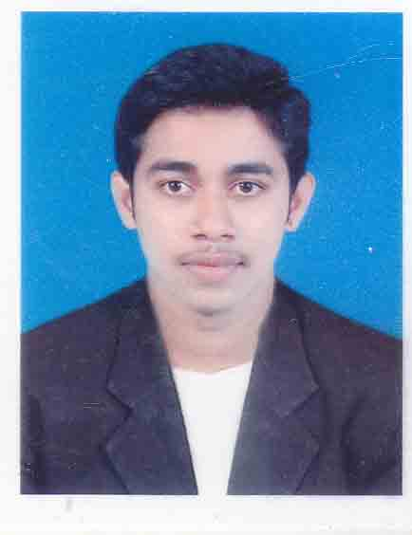
RESUME

Nilesh
Nilesh.223391@2freemail.com
Application for the Post of Customer Service, Facility coordinator. Or Office Administrator

OBJECTIVE:

A dynamic professional with 3 years’ experience in operations, hospitality and Facilities. An efficient planner in creating and implementing effective processes, introducing cost saving methods and ensuring compliance to achieve an Organizations obligations and objectives.

STRENGTHS

- A track record that demonstrates efficient organizational skills, self-motivation and the initiative to achieve both personal and corporate goals
- A Proactive, hardworking and committed team player
- Accustomed to working in fast paced environments with the ability to think quickly and successfully handle demanding situations
- Multi-tasking responsibilities with accuracy and patience

EDUCATIONAL QUALIFICATION:

- B.A., Certification in Business Administration in year 2012.
- B.H.S Bachelors in Hospitality Science. Affiliated to Mangalore University completed in year 2011.

COMPUTER PROFICIENCY:

DIPLOMA IN COMPUTER APPLICATION:

- Office: (Word, Excel, Power Point, Internet, Paint brush, Word pad).
- Tally ERP9 ( Accounting purpose )

WORK EXPERIENCE

MANGALORE AS A FACILITY COORDINATOR

Key Objectives of Job:
- Reporting to Banquet Manager.
- Daily proactive maintenance of conference rooms, i.e. equipment, security and all other aspects of office services
- Particular emphasis to Customer conference area.
- Conference rooms maintain in to high standards, proactive checks and timely reactive responses
- On stand for faults to AV equipment’s.
- Responding to calls from guest for facility help conference room support for meeting teams.
- Reporting all facility faults to maintenance departments.
- Supporting to for all issues i.e. Network, Phones and other user problems.
- Responsible for the repair and fast return of projectors, liaising with our services contact with maintenance team.
- Reporting any facility improvements if needed.
- Working closely with housekeeping teams to maintain a clean and tidy hotel.
- Air-conditioning control temperatures monitor and report if faults (set at ambient temperature of 23 degrees) when requires.
- Reporting technical and general repairs around the hotel.
- Escorting guests/contractors visiting the hotel for routine maintenance.
- Assisting project manager with internal office projects

FLOORZ BUILDING MATERIALS AND TRADING COMPANY MANGALORE – as office in charge (Part Time).

Job Description:

- Effective co-ordination with other branches
- Sales co-ordination.
- Efficient handling of administration job.
- Typing data’s to daily materials sales and purchase of products
- Client servicing: attending them, solving their queries, adhering to their suggestions. Attending their complaints, providing quotation.
- Maintaining all the confidential correspondence of various departments.
- Submitting sales report monthly wise, book wise regularly to managements.
- Effective financial advice to customers.
- Demo of new products to the market.
- Maintaining technical department.
- Delivering goods or products upon request.

PERSONAL DETAILS:

Date of birth : 23rd July 1990
Marital Status : Single
Nationality : Indian
Religion : Roman Catholic
Languages known : English, Hindi, Konkani, Kannada, Tulu

PASSPORT DETAILS:
Place of Issue : Bangalore
Visa Status : Visit visa

I hereby declare that all the above particulars furnished by me are true to the best of my knowledge.

