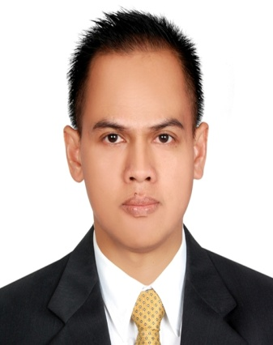
HAKIM (Indonesian)

Spa Therapist
Indonesia
Mobile: C/o 971503718643
Email: hakim.223659@2freemail.com

EDUCATION, Formal: 1. Indonesian Open Learning University – Diploma in English, Jakarta.
2. High School – Jakarta, Indonesia
3. Junior High School – Depok, Indonesia.

Course: 1. Bali International SPA Academy – Award in Body Massage (CIBTAC).
2. Bali International Spa Academy – Swedish massage.
3. Oriental Reflexology Jakarta – Reflexology.

JOB EXPERIENCES: 1. Al Afiya Health Centre as Massage Therapist – Abu Dhabi, UAE. ( 2011-2017 )
2. Foot Haven as Massage Therapist – Jakarta, Indonesia. ( 2006-2011 )
3. Oriental Reflexology as Reflexologist – Jakarta, Indonesia. ( 2001-2006 )

AREA OF EXPERTISE: Swedish Massage, Balinese Massage, Thai Massage, Head and Neck Massage, Foot Massage, Hot Stone Massage, Deep Tissue Massage, Body Scrub,

SKILL: Computer literate (0ffice, internet and software), English (advanced both written and oral), Arabic (simple daily conversation), Indonesian (fluent).

