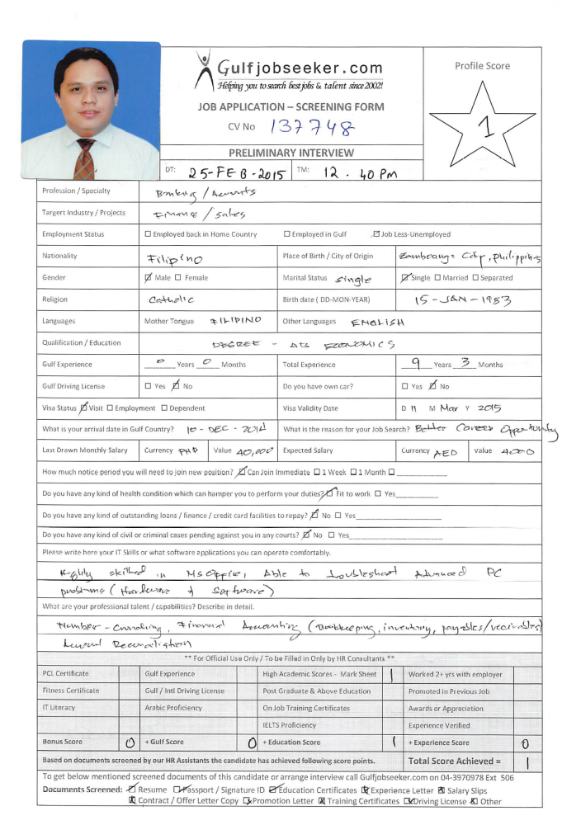
Gulfjobseeker CV No: 1343748
To interview this candidate call: 971505905010
Or email us back filled up Vacancy Form
http://www.gulfjobseeker.com/Free_Job_Posting_Form.doc

PERSONAL SUMMARY
An adaptable, resourceful and highly skilled professional who has extensive experience of having a wide level of general responsibility for monitoring and reconciling accounts. A strong communicator with excellent interpersonal skills and passion for number-crunching. Contributing extensively to team work and always display a willing and helpful manner when resolving, analyzing and investigating various customer-related concerns.
In search to further an already successful career by working in the sales/marketing or finance department of an ambitious and expanding company.
KEY SKILLS AND COMPETENCIES
- Excellent Customer Service and communication skills. Excellent interpersonal, communication and relationship-building skills. Listen attentively, communicate persuasively and follow through diligently.
- Extensive experience in Banking, Financial Accounting, Cash Management and Debt Collections
- Well-organized and highly efficient working in a multi-tasking dynamic environment.
- Ability to plan, organize and make sound decision when necessary.
- Public Speaking and Complaint Handling
- Fluent in English (verbal and written) and willing to learn Arabic and other related languages.
- Ability to do extensive research.
- Extensive knowledge of MS Office and ability to troubleshoot advance software, hardware and network related PC problems.
- Background in sales of bank products such as insurance, consumer loans and cards, and acquisition of deposits.
SALES-RELATED ACCOMPLISHMENTS
- Earned consistent commendations for exemplary service delivery. Regularly singled out on comment cards for "going above and beyond expectations" and "providing outstanding service and attention to clients."
- Recognized for ability to quickly establish rapport with customers, up-sell products and build a loyal clientele.
- Proved the ability to multitask, handle crowds, resolve customer issues and excel within a demanding, high-volume setting.
- Regular Promotion due to no. of marketed clients.
WORK EXPERIENCE
- Collections Officer
Banco De Oro Universal Bank
(January 2, 2014 – June 30, 2014)
- Remind clients with past due payments on their responsibility thru SMS, e-mail and phone calls.
- Examine delinquency reasons of past due account and provide resolution for technical past due accounts.
- Responsible for the evaluation of past due portfolio and assures that total delinquency rate of assigned bucket is maintained at a minimum and acceptable level.
- Davao Cash & Clearing Center – Cashier/Accountant
- Philippine National Bank
(May, 2011 – December, 2013)
- Monitoring of Over-all operations of Davao Cash & Clearing Center
- Monitoring of Clearing Operations and daily cash requirements and excess CIV’s. South Mindanao Area Branches.
- Bank’s Liaison to Central Bank’s Regional Office.
- Approving of transactions beyond Teller’s limit.
- Branch Operation Specialist (Branch Accountant)
(April 24, 2009 – April 2011)
PHILIPPINE NATIONAL BANK - Davao Branch
- Monitoring branch expenses and income
- Monitoring and zeroing out of branch floats
- Maintaining subsidiary ledger on temporary and contingent accounts and reconciliation of said accounts versus branch books.
- Conducting Inventory on Stationaries and Supplies and Furnitures and Fixtures
- Preparation of payables
- Assisting internal/external auditors with queries.
- Preparation of Monthly/Quarterly and Year-end Reports.
- Cross-selling of Bank Products
- Financial Management Specialist
(February 2007 – January 2009)
PHILIPPINE NATIONAL BANK - Bajada Branch
- Verifies signatures on check encashments.
- Processing of Time Deposits Placements and Termination
- Processing of Remittances (advise and pay or account opening)
- Processing of Trust Deposits and Treasury related transactions
- Handling and processing of Corporate Accounts concerns (e.g payroll)
- Processing of Remittances
- Cross-selling of Bank Products
- Assist the Sales and Service Head on variety of business roles.
- Sales & Service Associate
(Feb. 10, 2005 – February 2007)
PHILIPPINE NATIONAL BANK - Bajada Branch
- Attends to client’s needs: deposits, withdrawals and queries.
- Turns-over to the Branch cashier excess cash and balances cash on hand.
- Prepares/run-ups total transactions for the day and validate other teller’s transactions.
- Cross-selling of Bank Products
- Performs other duties as may be assigned from time to time.
- Administrative Assistant
(June 1999 - March 2003)
CERVINI RESIDENCE HALLS – Ateneo de Manila University
Answers telephones and directs the caller to the appropriate resident.
- Greets and directs visitors to the residence halls. - Takes and retrieves messages for various residents.
- Provides callers with information such as residence hall address, directions, fax numbers, website and other related information.
- Receives, sorts and forwards incoming mail. Maintains and routes publications.
- Coordinates the pick-up and delivery of express mail services
- Assists with other related clerical duties such as photocopying, faxing, filing and collating.

ACADEMIC QUALIFICATIONS
Elementary: Secondary:
Marian Grade School (1996) Arturo Eustaquio Memorial Science High School (1999)
Ipil, Sibugay Zamboanga City
Philippines Philippines
Class Salutatorian Class Valedictorian and Leadership Awardee
*Scholar
College:
AB Economics (2003)
Loyola School of Social Sciences
Ateneo de Manila University
Philippines
*Scholar
Contact References are available upon request.

