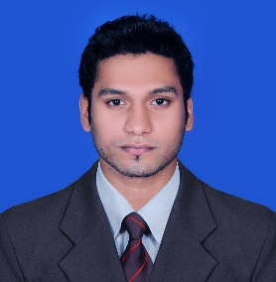
MUNEEB
MUNEEB.224405@2freemail.com

PROFESSIONAL OBJECTIVE

Seeking a challenging position in a progressive organization offering a challenging job that commensurate with my qualification and experience whereby I can utilize my talents and skills acquired for enhancing career prospects and also to contribute a lot more for the betterment of the organization employed

EXECUTIVE DIGEST
- An astute professional with 1 year 8 monhs experience in Accounts as Accountant
- Profound knowledge of the Accounting processes and procedures
- An effective communicator with decent supervisory skills and strong analytical abilities
- Equally comfortable in interacting with people across hierarchical levels
PROFESSIONAL EXPERIENCE

- Rainforest Resort (Group of Avenue hotels Pvt. Ltd) - Athirappally

Job Profile: Accountant (Apr 2014 – Jan 2015)

Responsibilities:

- Maintain Sales / Purchase Register
- Management of Account payables/ Receivables
- Bank Reconciliation
- Tax preparation
- Reporting to Finance Manager

- Crayon Builders & Interiors Pvt. Ltd - Ernakulam

Job Profile: Assistant Accountant (May 2013 – Feb 2014)

Responsibilities:

- Maintain Day Book
- Posting Journal entries
- Book Keeping
- Management of Account payables/ Receivables
- Finalisation of Accounts

ACADEMIC QUALIFICATIONS

- Pursuing MBA (Finance Management) - Bharathiyar University
- Bachelor of Commerce - Calicut University, Kerala (March 2014)
- Diploma in Indian and Foreign Accounting
- IAB (International Association of Book keepers) certification

PROFESSIONAL APPLICATIONS KNOWLEDGE

- Tally ERP9
- Peachtree
- Exel Accounting
- MS Office Tools

CORE COMPETANCY

- Good communication and interpersonal skills
- Efficient in self-correspondence
- Ability to handle pressure and to work with Goals
- Smart working and fast learner
- Hard working and Good team player
- Effective communication and time management

PERSONAL MINUTIAE

Date of Birth : February 13, 1993
Languages Known : English, Hindi, Arabic and Malayalam
Visa Status : Visit Visa (Valid until May 19, 2015)
Nationality : Indian
References : Available upon request

