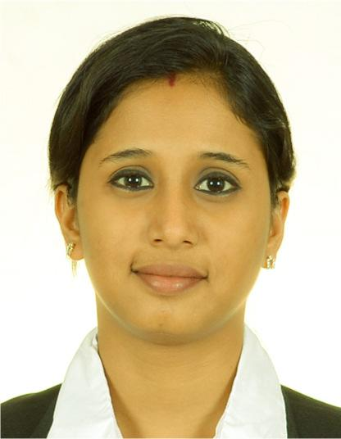

Natasha.225422@2freemail.com

Natasha

C A R E E R O B J E C T I V E

To work for an organization that provides the opportunity to improve my skills and knowledge to contribute towards organizational & individual growth.

W O R K E X P E R I E N C E

Organization: GOA, INDIA

Designation: Back Office Associate

Duration: Sept. 2014 to Dec. 2014

Job profile:

- To maintain inward and outward registers of cheques and DD

- New account creation / modification using Finnacle

- Updating customer account passbooks

- Initiating internal & third party NEFT & RTGS transfers

- Preparation of cheque clearing procedures

- Assisting customers in day to day core banking activities

Organization: GOA, INDIA

Designation: Logistics Executive

Duration: June 2013 till Sept. 2014

Job Profile:

- Preparing material receipts & Delivery Challans

- Preparation of material requisitions

- Conducting dispatch vehicle inspection audits.

- Conducting daily Storage Location Reconciliation in SAP

- Computing daily Finished Goods confirmations in SAP LO

- Generating fortnight bills for packing, downtime, rework etc. based on SAP reports

- Preparing Excise Challans and Annextures

E D U C A T I O N A L Q U A L I F I C A T I O N S

Exam. & | Board/University | Institute | Year of
Specialization |  |  | passing
B.A (History & | Goa university | PES College of Arts & Science - | 2013
Political Science) |  | Ponda
H.S.S.C. (Arts) | Goa Board | GVM's St.Nelly Joildo Aguiar H.S.S. | 2008
 |  | - Ponda
S.S.C. | Goa Board | GVM’s Almeida High School - | 2006
 |  | Ponda

I T S K I L L S

- SAP

- Tally 7.2

- Finnacle for Banking

- MS Office (Word, Excel, Powerpoint)

P E R S O N A L D E T A I L S

Date of birth: 17th February 1991

Place of birth: Goa, India

Religion: Hindu

Nationality: Indian

Marital Status: Married

Visa Status: Residence Visa (Family Visa)

Languages known: English, Hindi, Marathi & Konkani

R E F E R E N C E S

Professional references available upon request

Page 2

