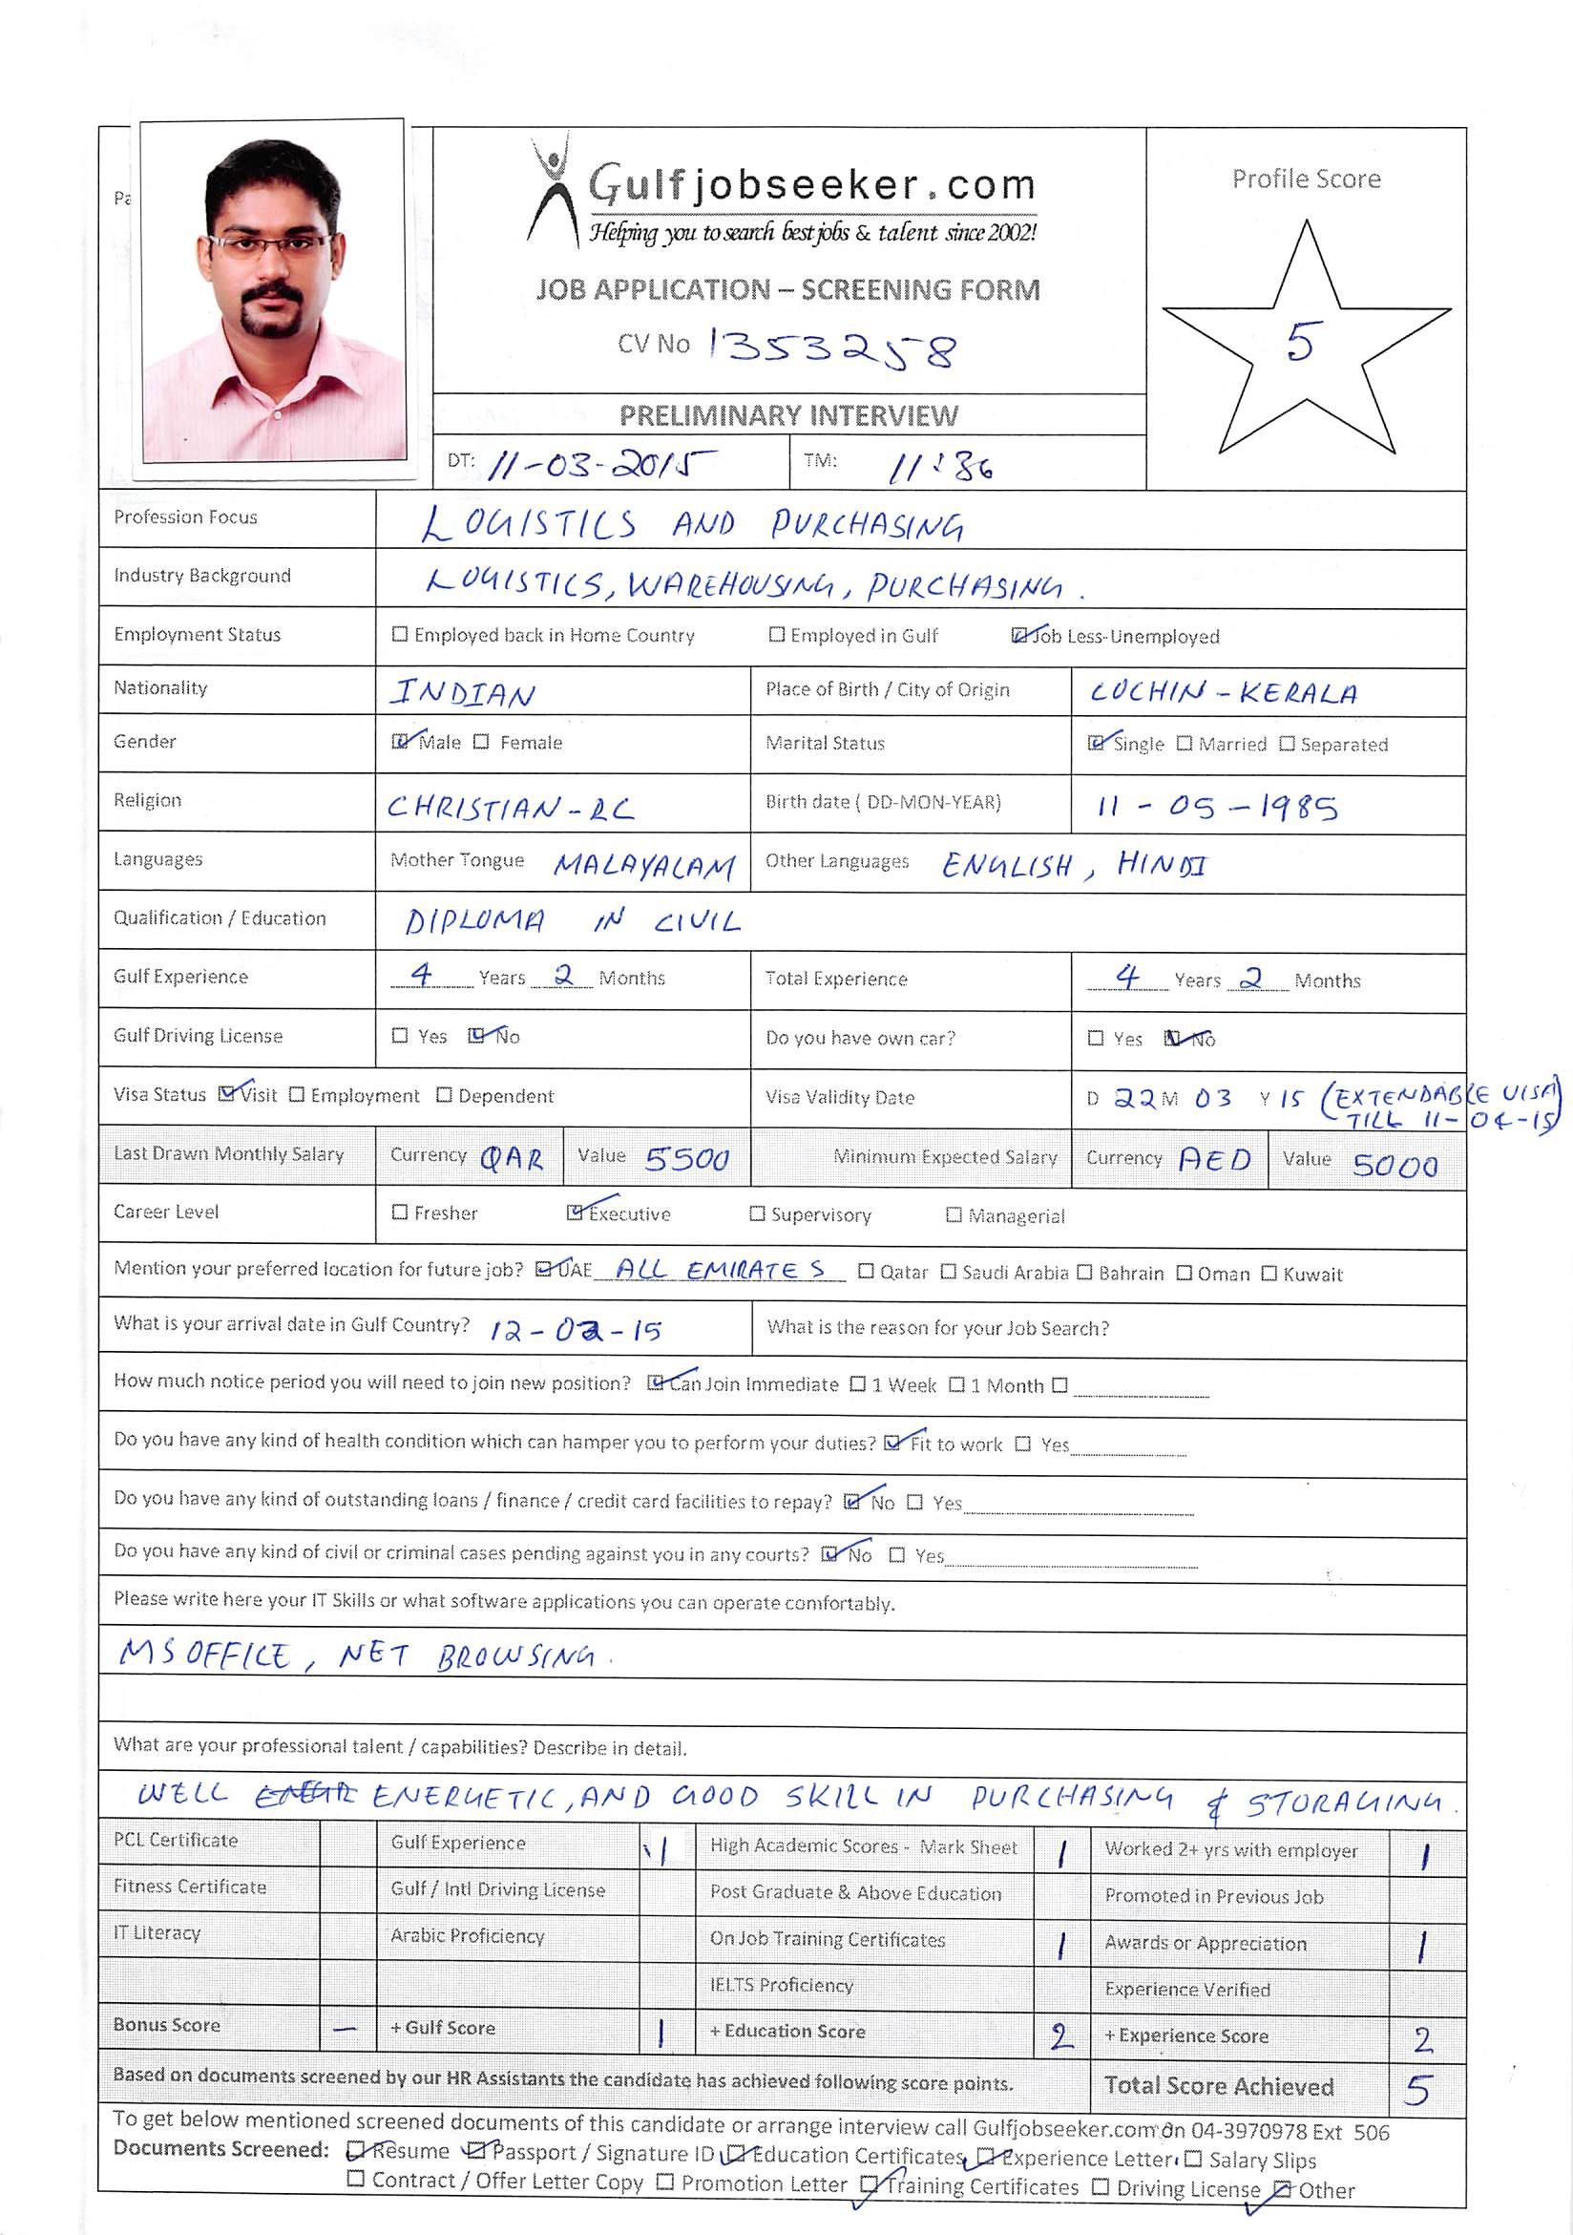

Objectives
Seeking to handle increasing responsibility and challenging assignments to harness my technical skills knowledge and achieve recognition. I want to be part of an environment that promote team effort and provide opportunity for value based growth as well as career advancement while making a significant contribution of employer organization.
Professional Experience
Worked as Procurement - logistic Coordinator in an MNC UK based. Total 4 years working experience with my qualification as Supply Specialist in (Supply & Storage Logistic department of US ARMY in Kuwait and Afghanistan)
(Doha Qatar)
Logistic/Procurement Coordinator (From 1st Feb 2013 to 30th August 2014)
- Coordinates with site engineers for their requirements of materials for the dewatering purposes.
- Checks with Material request form and give order for the suppliers.
- Prepares the local Purchase orders for the suppliers and gets approvals from the managements.
- Submits the PO to the Accounts departments and proper file keeping of the PO/DO
- Coordinate with the clients and the follow up the supplier details.
- Do the shipping manifests for the UK and Dubai shipments.
- Keeps Updated contacts with the shipping companies.
- Maintain the proper inventory of the incoming, outgoing and the stocked materials.
- Give Safety and tool box talks to the team workers.
- Ensure the safety measures in the stock area as well as in site areas.
(Bagram Air Base, Afghanistan)
Supply Specialist (logistic specialist) CL IX Section Aug 2011 To March 2012

- Conducted receiving, shipping, issue, storage, and stock control functions at unit and battalion levels.
- Issue parts from Location to more than a few job orders with picking ticket. Maintain stock Record.
- Receive parts from SSA (Supply Support Activity) for stock.
- Doing 10% Inventory weekly basis.
- Participate 100% Inventory quarterly all shop stock parts

(camp Arifjan) (U S Army Contractor)
Receiving Documentation Associate (logistics Specialist) Jan. 2009 to Feb 2011
- Strong understanding of military and government supply and logistics terminology
- Identifies material through the use of FEDLOG, cross referencing part numbers to NSNs, and processing Receipts into SARSS system.
- Participate 100% monthly inventory of stored items and parts
- Documentation for all the shipping process in a timely basis when an M R O is generated.
Tracking and ensuring the cargo is reached in destination DODAAC in a timely basis

Educational & Professional Development
3 years Diploma in Civil Engineering Govt. of Kerala India

HSC from Board of Higher Secondary Examination Govt. of Kerala India
SSC from Central Board of Secondary Education in 2003

Languages Known
- English, Hindi, Malayalam

Computer Proficiancy
M.S Office

Skills and Training
- Well knowledge in Computer Basic (Windows, MS Word, MS Excel, Power Point) and internet research, data entry
- Hold INDIAN Driving License
- Hold US ARMY License(forklift up to 10k)
- IOSH-Managing Safely
- Certified First Aid-CPR,AED,FIRST AID

PERSONAL DETAILS
Date of Birth : 11/05/1985
Sex : Male
Cast : Christian
Nationality : Indian
Marital Status : Single

