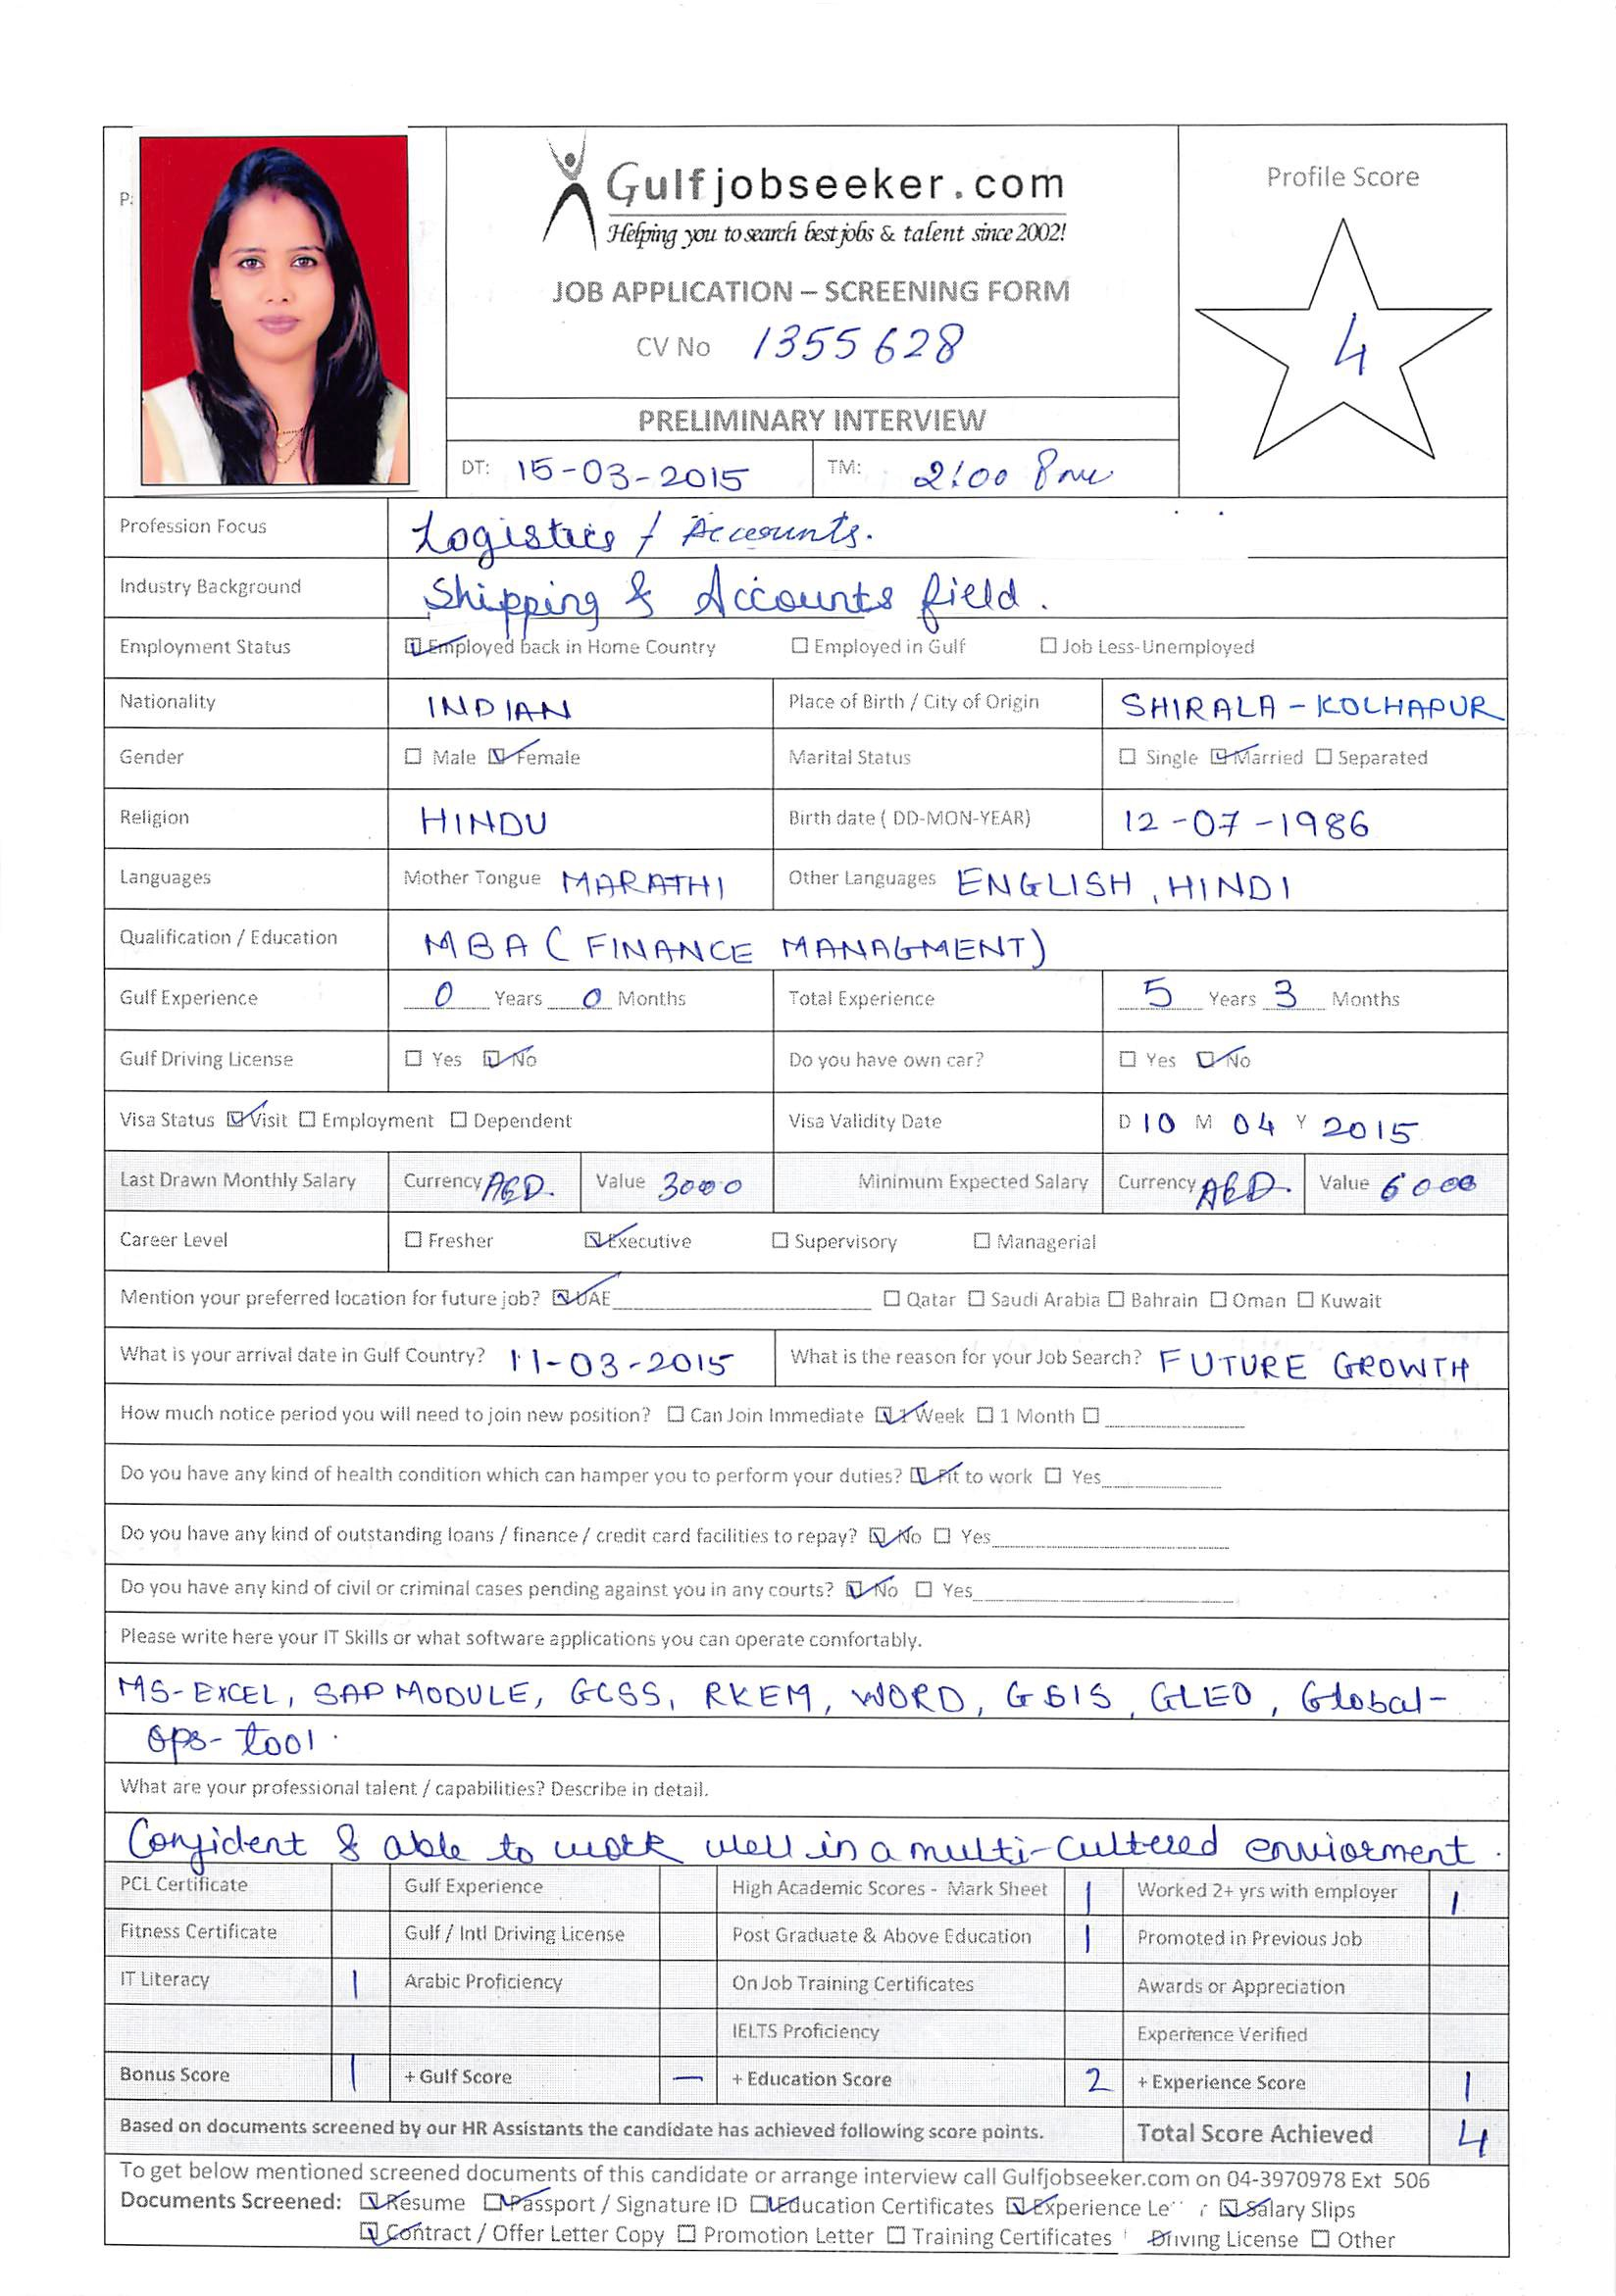


Date of Birth : 12TH July, 1986
Marital Status : Married
Nationality : Indian
Languages : English, Hindi and Marathi

CAREER OBJECITVE

Seeking a position to utilize my skills and abilities in industry that offers professional growth while being resourceful, innovative and flexible.

QUALIFICATIONS:

Education Qualification Year | Academics | College
2012 | MBA (Finance Management) | Indian School of Business Management & Administration
2010 | Graduation (Bachelor In Management Study) | Indian School of Business Management & Administration
2006 | H.S.C. | Maharashtra State Board, Mumbai
2004 | S.S.C. | Maharashtra State Board, Pune

WORK EXPERIENCE:

- Current Job :
- Duration : 17th March, 2014 to Till Date
      - Job Position : Senior Associates

- Maersk Shipping is a subsidiary of The A.P. Moller - Maersk Group which is a worldwide organization with global headquarters in Copenhagen, Denmark. In addition to owning one of the world’s largest shipping companies, it is also involved in a wide range of activities within the energy, shipbuilding, retail and manufacturing industries.

- Job profile

OPERATIONS :

- Coordinating with terminal/port authorities to make sure right cargo is loaded/ discharged, updating terminal sites.
- Helping Partner shipping lines load their cargo to our vessel.
- Sending Forecast, Initial, Scope & Final Loading & Discharging list to mother vessels/feeder vessels.
- Knowledge of Maersk systems RKEM, GCSS, Global ops-tool, GLEO, GSIS.
- Ensuring proper follow-ups done with stakeholders in case of any pending activities at their end.
- Keeping track of day to day activities and ensure apt DQ and adherence to deadlines at all times.
- Work Force management and work load distribution.

- Performing System updates after Vessel sails i.e keeping records of actual containers loaded & discharged.
- Handle customer complaints and ensure corrective actions are initiated
- Performing all gate moves related to Container shipment.

Key Responsibilities:

- Verification of customer file, checking all the details & after assurance log in all this details on LOS. Discussion with credit manager for decline or approval.

- Keeping continuous communication with DSA channels
- E-Master services performs at four Mellon sites- Chicago, Dallas, Las Angles & Corporate headquarter in Pittsburgh.

- Worked for 62 clients in e-Master.
- Handling a file of daily accounts, Keep track of daily receipts and payments.

Duration : 10 months, 07th December, 2012 to 03rd October, 2013
Job Position : Process Executive Ban - 2

- Job profile

- Reconciliations are prepared monthly.
- Mathematically accurate & timely preparation of variance reports.
- Prepared within 30 calendar days from custodial account cutoff date.
- Resolve all reconciling items within 90 calendar days.
- Reviewing and Approving monthly remittance due to investors.
- Verify amounts allocated and remitted to investors.
- Updating productivity logs & internal quality tracker on daily basis.
- Ensuring that all the tasks assigned are completed well before turn-around time.
- Doing the Quality Analysis & Quality Control of the loans processed by the team.
Duration : 3 Years 8 months, i.e. 07th April 2008 to 14th December 2011.
Department : Financial Markets and Treasury Services.
Job Position : Operation Executive

- Job profile

- Verification of customer file, checking all the details & after assurance log in all this details on LOS. Discussion with credit manager for decline or approval.
- Keeping continuous communication with DSA channels
- E-Master services performs at four Mellon sites- Chicago, Dallas, Las Angles & Corporate headquarter in Pittsburgh.
- Worked for 62 clients in e-Master.
- Handling a file of daily accounts, Keep track of daily receipts and payments.

STRENGTHS

- I have a very optimistic and positive can-do attitude to life in all its aspects.
- I am a very firm believer in effective teamwork and am a complete team player.
- I believe that an integral part of success is hard work and persistence.
- I am a very fast learner.
- Dedicated and committed.
- Confident and able to work well in a multi-cultured environment.

OTHER INFORMATION
- Operating System : Windows XP, Windows 7, Typing Speed : 25 w.p.m.
- Tools: MS Office, good in Excel, Power point, Word & Outlook.
- Net surfing

HOBBIES

- Listening to music.
- Traveling.
- Interacting with people.

