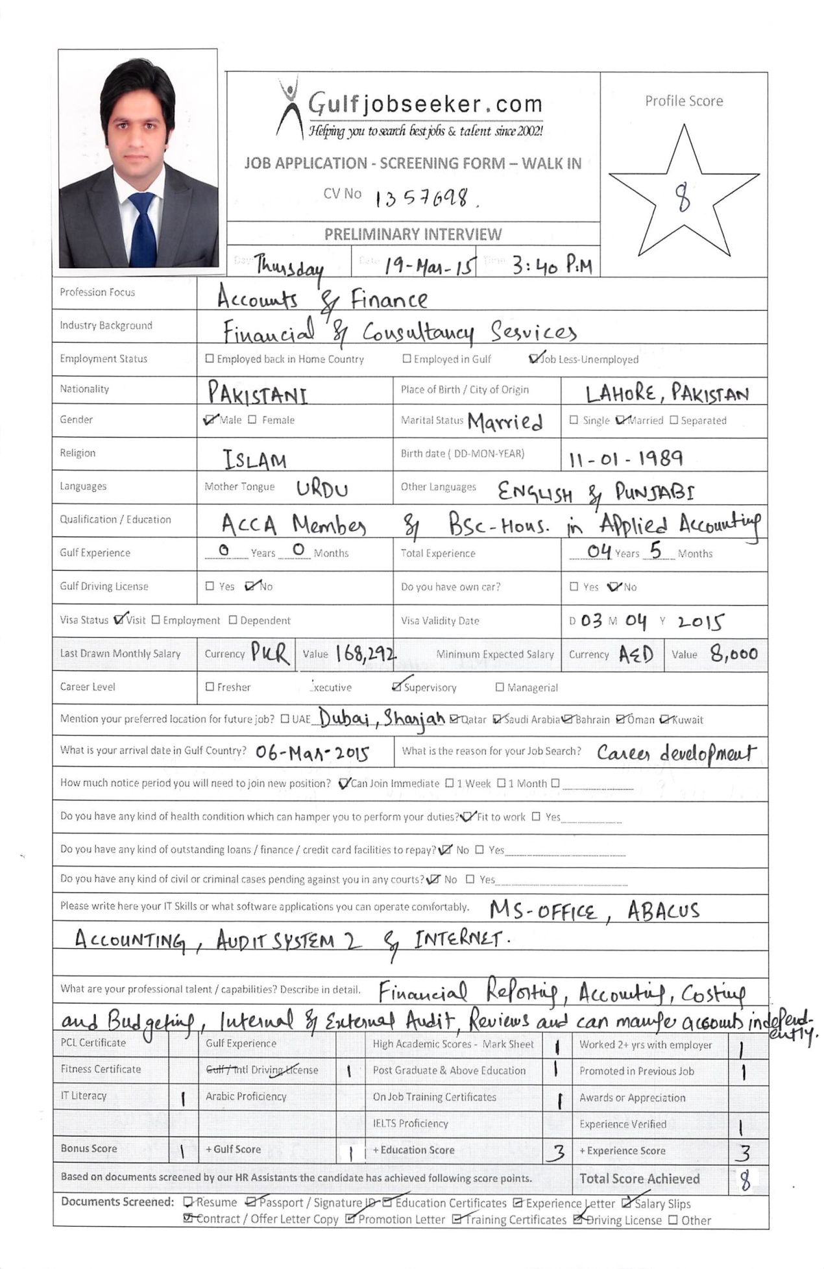

Gulfjobseeker CV No: 1357698
To interview this candidate call: 971505905010
Or email us back filled up Vacancy Form
http://www.gulfjobseeker.com/Free_Job_Posting_Form.doc

objective:

To leverage my team management skills and financial analysis expertise in a financial supervisory position.

professional Profile:

Detail-oriented Finance professional with over four years of experience in internal audit, external audit, financial reviews, fraud prevention trainings, budgeting, financial reporting, accounting, payroll processing, drafting financial statements and able to prepare and handle company’s financial statements independently. Possess excellent communication skills and excel at processing and articulating information. Consistently works to the highest professional standards and thrives when working as part of a cohesive team to deliver projects that yield multiple business benefits. Can efficiently solve problems and work effectively in both collaborative and self-directed endeavors.

Key Contribution Areas:

- External Audit  - Financial Reporting  - Internal Audit | - Financial Statements  - Budgeting  - Payroll Processing | - Internal Controls  - Financial Reviews  - IFRS
WORK EXPERIENCE:

CHEMONICS INTERNATIONAL INC. | USAID FIRMS Project

Feb 2014- Nov 2014 Worked as Financial Analyst
Job Responsibilities:
- Responsible for the preparation and processing of monthly payroll for employees.
- Responsible for monthly, quarterly and year-end accounts closings in compliance with IFRS.
- Responsible for monitoring the budgets and reporting for thresholds.
- Provide assistance to other departments in the formulation of quarterly and annual budgets including all necessary documentation needed.
- Responsible for the preparation of interim and annual financial statements.
- Controlling compliance with established USAID and Chemonics policies and procedures.
- Responsible to conduct periodic forensic audit of the expenses and the suppliers to identify any fraudulent activities.
- Liaison with the external auditors and responsible for timely completion of audits.
- Responsible for verifying the accounting and book keeping of the transactions.
- Responsible to train the staff regarding application of internal controls.
- Responsible for managing and reporting the project’s funds effectively.
- Conduct compliance reviews on all fixed price subcontracts, blanket purchase agreements and purchase orders prior to approval.
- Conduct Compliance and Financial Reviews of FIRM’s subcontractors.
- Training staff regarding Fraud Awareness and prevention techniques.

CHEMONICS INTERNATIONAL INC.| USAID FIRMS Project

Nov 2012- Feb 2014 Worked as Senior Compliance & Finance Associate
Job Responsibilities:
- Review and report on the accuracy, timeliness and relevance of the financial and other information that is provided for approvals.
- Give attention to details and address the short comings before the voucher is approved.
- Checks, corrects and maintains a variety of financial and other business records and documents.
- Accounting and Book keeping of the transactions in ABACUS.
- Manage all invoices and prepare monthly and weekly reports for the same.
- Preparation of Bank Reconciliation Statements and reconcile from the Bank’s personnel regarding any differences.
- Evaluate all travel expense reimbursements submitted by employees.
- Keep a full track of the Sector-wise budgeting in collaboration with the Technical teams supervised directly by the COP.

Delloite Touche Tohmatsu

June 2010 - Nov 2012 Worked as Audit Senior at Muhammad Yousuf Adil Saleem & Co. Chartered Accountants, a member of Deloitte Touche Tohmatsu.

Job Responsibilities:
- Conducted assignments like Internal Audit, Annual Audit, Interim Review and Stock Counts of listed and private limited companies.
- Verify application of Financial Reporting Standards (IRFS) on various account heads of financial statements using AS 2.
- Perform substantive testing to verify Financial Statements Assertions
- Prepare and finalize interim and annual financial statements
- Perform test of controls and completed risk advisory services for various clients.

Clients Served:
- National Transmission and Dispatch Company
- First Women Bank Liberty Branch
- Prosperity Weaving Mills Limited
- MIMA Cotton Mills Limited
- Sui Northern Gas Pipelines Limited
- Sitara Chemical Industries Limited Textile Division
- DALDA Foods Pvt. Limited
Qualifications:

- BSc (Hons.) in Applied Accounting, Oxford Brookes University, UK.
- ACCA, Member of Association of Chartered Certified Accountants, UK.
- CAT, Certified Accounting Technician, UK
- HSSC Examination - Pre-Engineering.
- SSC Examination – General Science.

Achievements& CERTIFICATIONS:

- Performance based Promotion from Senior Compliance & Finance Associate to Financial Analyst. (USAID FIRMS Project).
- Training workshop on Withholding Tax regulations under FBR Laws at Recknor’s Training Institute.
- Procurement Policies Training (USAID) at USAID FIRMS project.
- Pakistan Security Awareness Induction Training (P.S.A.I.T) Certification from IOM (International Organization for Migration), Islamabad.
- MS Office Certification by EDGE Systems International.
- Adventure based Camp at PAF Air Base Kalabagh.
LANGUAGES:

- English (Excellent in written & verbal)
- Urdu (Excellent in written & verbal)

