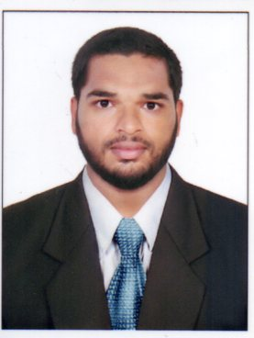
AHMED
Ahmed.226322@2freemail.com

DUBAI, UAE.

Career Objective
Ambitious to work in an organization where I can develop myself both personally and professionally and rendering the best of my efforts with utmost sincerity for the development of organization
Career Experiences
Position : senior accountant
Company : KBR FISH MERCHANT
Location : Mangalore (INDIA)
Period : from 1stapril2015 to 31st may 2017

- Maintains general ledger by transferring subsidiary accounts; preparing a trial balance; reconciling entries.
- Maintaining cash ledger
- Summarizes financial status by collecting information; preparing profit and loss, and other statements.
- Produces payroll by initiating processing; printing cheques, analyzing and scheduling general ledger accounts
- Secures financial information by completing database backups.
- Protects organization's value by keeping information confidential.
- Updates job knowledge by participating in educational opportunities; reading professional publications; maintaining personal networks; participating in professional organizations.

Position : Accountant
Company : SAPNA ENTERPRISES
Location : Mangalore(INDIA)
Period : from 1st DECEMBER 2013 to 31st MARCH 2015

- Preparing of Trading, Profit &Loss A/C
- Maintaining Journal, Ledger and Day Book
- Filing and Documentation
- Ensure company accounts and tax returns are prepared and filed correctly and on time.

Position : BUSINESS DEVELOPMENT EXECUTIVE
Company : TOUCH POINT SERVICES
Location : Mangalore (INDIA)
Period : from 11st JUNE 2013 to 30TH NOVEMBER 2013

- Identifying new sales leads
- Managing the customer journey (customer relationship management)
- Provide monthly product updates to management.
- Contacting potential clients phone to establish rapport and set up meetings
- Achieve monthly sales target assigned

Education Qualification
2016 academy
Completed MASTER IN BUSINESS ADMINISTRATION (MARKETING MANAGEMENT)degree under DDE programme from ANNAMALAI UNIVERSITY
2013 academy
Completed MASTERS IN BUSINESS MANAGEMENT degree from MANGALORE UNIVERSITY
Trained in TALLY EPR 9 from THE INSTITUTE OF COMPUTER ACCOUNTS AND FINANCE
Certified diploma in COMPUTER TEACHER’S TRAINING from ELECTRONIC CORPORATION OF INDIA LIMITED

PERSONAL SKILLS
Hardworking
Willingness to learn
Commitment towards work
Initiative and enthusiasm
Good communication skill

PERSONAL DETAILS
Marital Status : Single
Nationality : Indian
Language Known : English, Hindi, Kannada.
Visa Status : Visit Visa

