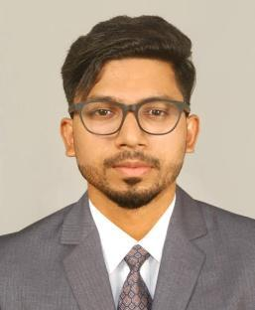
SAHAD

Sahad.226361@2freemail.com

Professional Objective

My professional aim is to become a Safety officer of a well reputed company in Middle East.

Seeking long term association with a growing organization in the area of HEALTH SAFETY ENVIRONMENT management, so I wish to be in a challenging work environment where I can effectively utilize my valued experience and working skills which enable me to work with a progressive attitude and promise me a good career.

Summary

Holding of NEBOSH IGC-UK, Diploma in industrial safety and construction safety engineering, HSE Engineering Techniques, Bachelor of commerce and 1 year experience of a Assistant safety officer. Holder of valid Indian license and also have good computer knowledge………….

Professional Experience

1. Company- JOYTHOMAS ENGINEERING PVT.LTD.

(Reliance industry hazira Gujarat)
Period – (03-07-2016 to 24-07-2017)

Duties done at worksite
- HSE policy implementation
- Safety training to all staff and labors (i.e. .safety induction, tool box talk etc…)
- Ensure the use of PPEs of all the staff and labor
- Maintain healthy and hygienic working environment

- Ensure good welfare facilities for the workers at site

►Ensure worksite are HSE compliant with company policies and safety standards. ► Maintain all safety documents files and Develop good safety culture. ►Responsible for working at construction sites.

Training & Education

Bachelor of Comme rce

Diploma in Industrial and Construction Safety.
NEBOSH- Managing Safety – IGC1, IGC2, IGC3 certificates.
HSE Engineering Techniques, BSS, Government of India.

HSE Engineering Techniques ID Card.
Fire Watch Training Certificate.

Mind Powe r Training Certificate.
Business Correspondent and Business Facilitator, Government of India.

Computer Education

M S word, excel, PowerPoint, Adobe Photoshop, Tally, Internet, email

My Skills

Strong interpersonal skills and self motivated, flexible, readily adoptable to any changing conditions. Self confident and not easily discouraged and capacity to lead, supervise, train, and develop others.

Language proficiency

English, Hindi, Malayalam, Tamil (Both spoken and written)

Passport details

Passport number | : Z1971910
Place of issue | : Cochin, Kerala, India.
Date of issue | : 19.10.2012
Date of expiry | : 18.10.2022

Other achievements

Winner of collage youth festivals (2013-2014) Winner of business quiz competition
Winner of business correspondent and Business Facilitator, Government of India.

Personal Details
Date of birth |  | : 27.11.1993
Sex |  | : Male
Marital status |  | : Single
Nationality |  | : Indian
Father’s name |  | : P A Badharudheen
Driving license |  | : 46/320/2012
Place | : Thrissur.
Date | : | Yours Faithfully
 |  | Sahad PB

Availability: immediately

