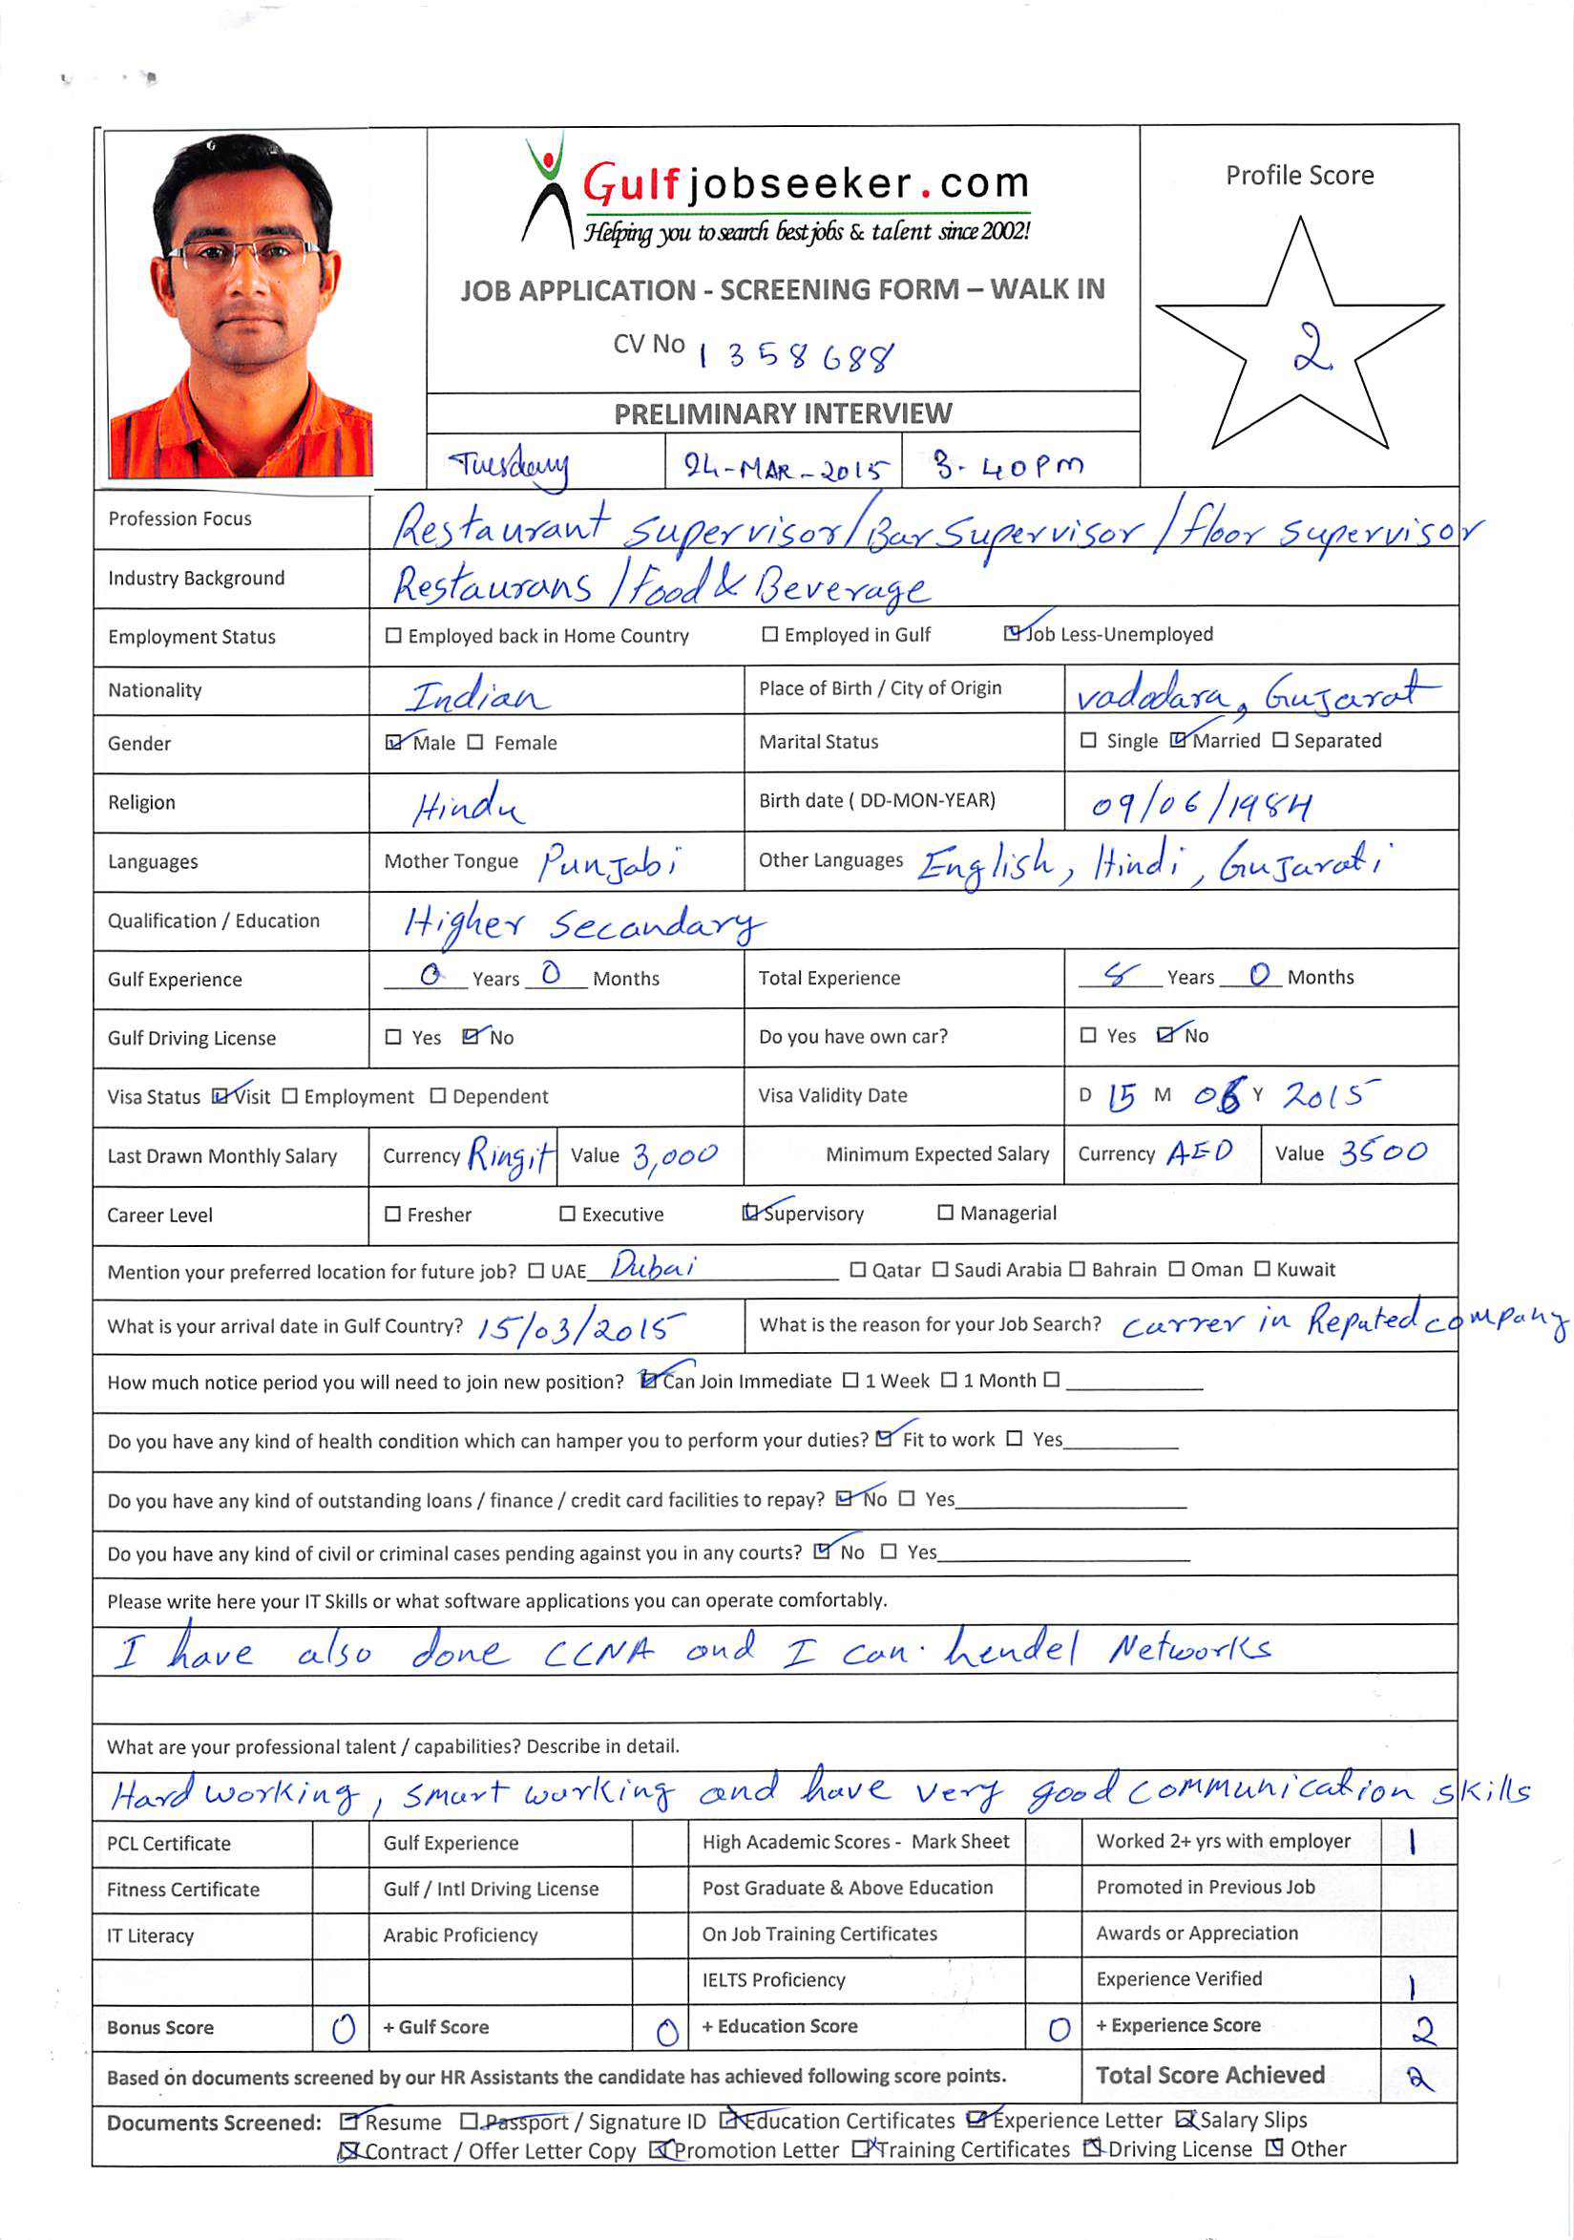
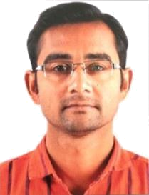

Career Objective

To work in a challenging and result oriented position, which can give me better opportunities to utilize my present capabilities, enhance my knowledge base and skill for future establishment with continual improvement of organization.

Work Experience

Sep 2012 to Mar 2014

Designation | : | Bar Supervisor
Location | : | Cheras, KL, Malaysia
 |  | Responsibilities

- To assist bar manager in controlling wage costs in line with budgetary requirements.

- To support bar manager in the implementation and following the procedures concerning recording of stock movements e.g. correct charting of items, billing etc.

- To ensure security, functionality and proper handling of company property in the department.

- To assist the bar manager to ensure smooth running of the department.

- To ensure stock items behind the bars are always within expiry date.

- To ensure guest drinks are prepared and served according to company standards.

- To ensure accurate stock-takes are carried out to company policy.

- To be involved in the setting of service and quality standards, and to monitor and strive for their achievements

- To monitor, anticipate and react to customer needs consistently to ensure maximum guest satisfaction.

✓
- To build positive relationships with clients/guests to ensure customer satisfaction.

- To ensure high standards of cleanliness throughout the bar and to lead team by example.

- To coach individual team member to develop their skills and maximize performance.

- To give clear direction and guidelines to team members.

- To assist in the resolution of performance problems as necessary and in line with company policy.
Feb 2006 to July 2012

Designation | : | Floor Supervisor
Location | : | Vadodara, Gujarat, India
 |  | Responsibilities

- It was my father`s restaurant, I was working as a flour supervisor.

- To lead the team on each shift and ensure the restaurant service standards are upheld.

- Explain how various menu items are prepared, describing ingredients and cooking methods.

- I used present menus to customers and answer questions about dishes and make recommendations.

- Remove dishes and glasses from tables or counters, and take them to kitchen for cleaning.

- Check customers are enjoying their meals and take action to correct any problems.

Key Strengths

Hard working, smart working and sincere with good communication skills.

I have ability to satisfy Customers and convincing power and also have strong belief in god and have a positive attitude.

Understanding the situation and making a plan to come up with success and glory in difficulties.

Educational Qualification
✓ Higher Secondary | Vidya Kunj High School (Baroda) | 2008-09
✓ Secondary | Vidya Kunj High School (Baroda) | 2003-04
✓ Primary | Vidya Kunj High School (Baroda) | 2001-02
Technical Qualification
✓ Networking N+ | IANT Ahmedabad | 2014
✓ CCNA | ACIT Mumbai | 2014
 | Personal Details
Date of Birth | 9th June 1984
Languages Known | English, Hindi, Gujarati

This information and facts stated till date are true and correct of the best of my knowledge and belief.

