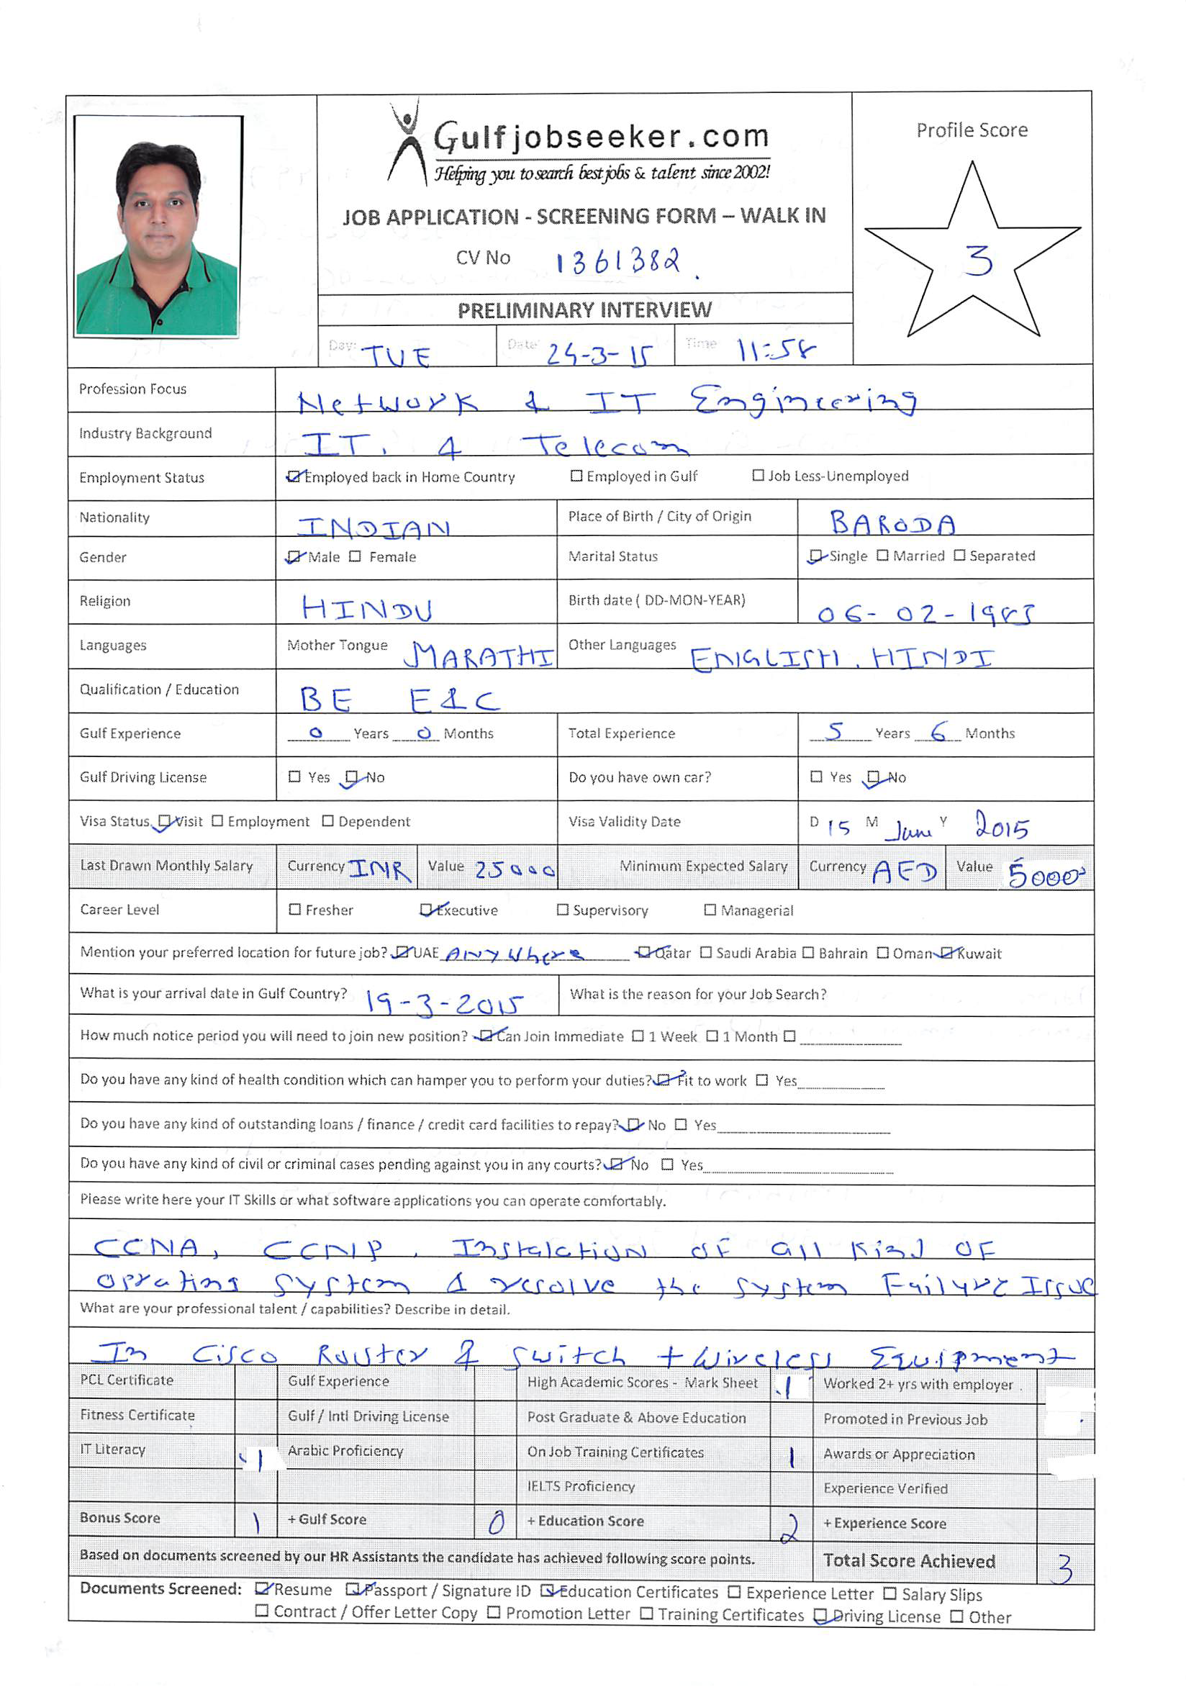
(Network Engineer)

Career Goals :

An enthusiastic network engineer with the necessary drive and determination needed to resolve complex networking issues. Possessing effective organizational skills and excellent working knowledge of networking technologies and having a commitment to keep up to date with the latest developments. Experienced in providing motivation, guidance and a up to date networking service to both colleagues and clients.
Now looking for a new and challenging network engineer position, one which will make best use of my existing skills and experience and also further my development.
TOTAL IT EXPERIENCE: 5 Year & 6 Months
Career Summary :

- 4 year & 6 month of experience as Network Engineer & System Administrator
- 1 year of experience of O&M RF Engineer
- CCNA,CCNP Certified Engineer
- Experience on layer3 routing and layer2 switching
- Excellent experience in Network planning, Implementing, Configure, Troubleshooting & Testing of network system
- Ability to explain technical issues clearly to non technical colleagues

KEY ATTRIBUTES:
Protocols | : | TCP/IP, Static, RIP, EIGRP, OSPF,BGP
Switching | : | VLAN, VTP, STP, MSTP, RSTP, Ether channel
Networking Tools | : | Putty, Whatsup Gold, Econ
Operating systems | : | Installation of Windows XP, Windows7, Window8, Server 2003 & 2008 & 2012.  Set up new desktop & Laptops also & resolve system failure issues like reformatting the system as well as install any kind of software in system.
Application Packages | : | MS-Office 2003/2007/2010
PROFESSIONAL QUALIFICATIONS:
- CCNA Certified – * CCNA ROUTING & SWITCHING [Cisco ID: CSCO12478835 ]
- CCNP Certified – * Implementing Cisco IP Routing [ ROUTE V1.0 ]
* Implementing Cisco IP Switched Networks [ SWITCH V1.0 ]
* Troubleshooting and Maintaining Cisco IP Networks [ TSHOOT V1.0 ]
[Cisco ID: CSCO12478835]

WORK EXPERIENCE:

Designation: Network Service Engineer

Sept 2010–Till Date (4 year & 6 months)

Responsible for maintaining and installing wireless networks for all Gujarat Government offices in Vadodara district & taluka.Working as part of Team Leader and operating in a fast paced, changing and challenging 24x7 environment.

Nature of Job:
- Maintaining all Government Wireless link (USE VIP RADIO 110-24 & VIP RADIO 110-58 ) in Vadodara District & Taluka
- Working with Cisco routers 1800,2600 series and switches 2900,3550 series
- Resolving customer’s network technical issues
- Troubleshooting Network issues and new survey for government offices [like feasibility testing]
- Technical analysis of problems, reduce them to targeted levels and documentation of resolution
- Administering & designing LANs, WANs internet/intranet
- Network connectivity troubleshooting, ping, tracert, telnet
- Investigating, diagnosing and resolve all network problems
- Cisco switch configuration in particular VLAN configuration/troubleshooting
- Giving technical support to end-users
- Carrying out day-to-day administration and monitoring network use
- Planning & implementing future developments
- Troubleshooting of complex LAN infrastructure including routing protocols EIGRP,OSPF & BGP
- Network redesign for district & taluka location

August 2009–September 2010 (1 year)
O&M Engineer - Vadodara
I am working as Data Network Support Engineer (R.F.) in Technical Service Dept. (T.S.D.) of GEMINI Communication Ltd. in Baroda region (Includes 7 Dist.). Gemini Communication Ltd. is on contract of Tata Communication.
Responsibilities:
- My job profile includes testing of new Wi-MAX sites, feasibility (point to point, RADWIN, PROXIM WIRELESS) including reporting & mentoring with client interaction & maintaining SLAs.
- I am also involved in O&M activity of TATA Communication’s Wi-MAX BTSs.
- Handling team and troubleshooting of WiMAX customers of Baroda region

Software Exposure & Key Skills:
- Winlink-1000 & RADWIN Manager.
- Proxim Wireless
- Wimax
- Radwin – RF

EDUCATION QUALIFICATIONS:

B.E Electronics & Communication from Acharya Institutes of Technology at Bangalore in 2009.

STRENGTHS:
- Attitude with Goal Oriented positive approach to complete tasks in time
- Good at interpersonal communication, managing time and lead people effectively
- Can work either in team or independently, building and maintaining excellent relationships
ACHIVEMENTS & AWARD:
- Represented the kabaddi team in college level in 2007-2008
- Secured best player award in volley-ball from college level in 2005
- Secured best cricketer award in ‘KIRAN MORE ALEMBIC SPORTS ACADAMY’ in 2001

PERSONAL INFORMATION:
Date of Birth | : | 6th Feb 1985
Marital Status | : | Unmarried
Gender | : | Male
Nationality | : | Indian
Languages Known | : | English, Hindi, Gujarati ,Marathi

