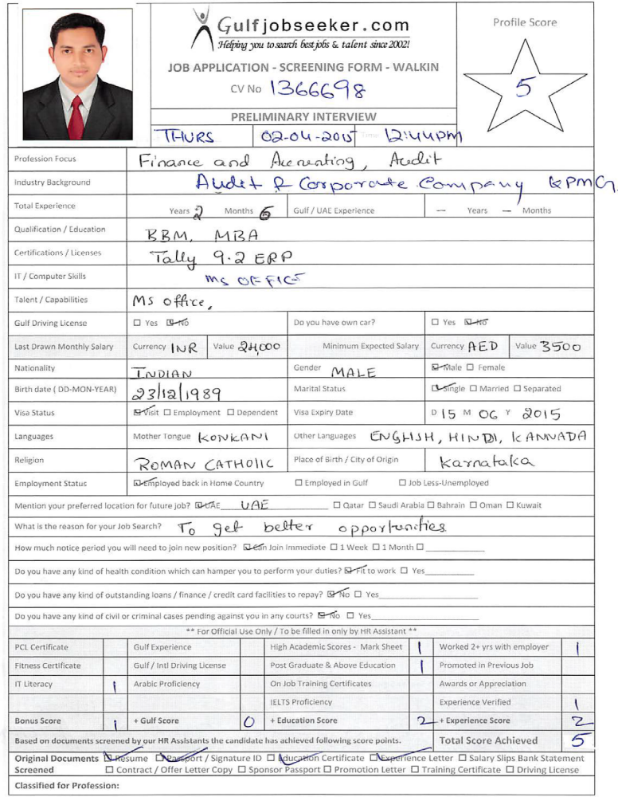
RESUME

Gulfjobseeker CV No 1366698
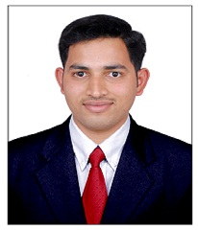
To get contact details of this candidate call +9714-3970978
Or leave message on following link http://www.gulfjobseeker.com/feedback/submit_fb.php

SYNOPSIS

A MBA professional with 2.5 years of Experience in Finance/Accounts, Tax & Audit looking for challenging role in an organization which can offer opportunity to learn, excel and contribute in organizations’ success.

Strong computing and analytical skills ranging from programming languages to database management systems.

Core competency across functional areas of Accounting, Auditing and Corporate Tax.

Proficient at motivating staff through clear communication and organizational skills.

- Proven ability to forge new creative ideas, setting challenges for myself, builds, organizes and synergizes teams through continuous improvement & interpersonal sensitivity.

WORKING EXPERIENCE

Organization: KPMG Global Services Pvt. Ltd. - Bangalore.
Tenure: October 2012 to March 2nd 2015.
Designation: Associate –Audit & Corporate Tax.

JOB PROFILE

- Performing various auditing functions for KPMG for its US firms.
- Preparation of United States Corporate Tax returns (Federal and State) for clients to file with IRS.
- Preparation of Various International Tax Forms.
- Analyzing various Financial Statements from Trial Balance to Balance Sheet.
- Checking the Mathematical Accuracy of Financial Statements.
- Performing the procedure of transferring tick mark from hard copy to soft copy for Electronic Audit.
- Checking the versions of financial Statements provided by the client.
- Verifying the accuracy of the statements, published in Securities Exchange commission (SEC)
- Checking the invoices of the clients for the audit purpose.
- Performing the tasks required by the clients as per their deadlines.

EDUCATIONAL QUALIFICATION

Course | Board/University | Year of Passing | Percentage (%)
M.B.A.  (Finance) | Visvesvaraya Technological University, Belgaum | 2012 | 64
B.B.M. | Mangalore University | 2010 | 60.96
P.U.C. | Karnataka Pre-university Board | 2007 | 68
S.S.L.C. | Karnataka Secondary Education Board | 2005 | 53

PROJECT UNDERTAKEN

Project Work on ‘Application of EAGLE Model with reference to Mangalore Catholic Co-operative Bank’

ADDITIONAL QUALIFICATION

- Undergone Internship Program in ‘Reliance Capital Asset Management’ Ltd.,
- Diploma in Computer Application.
- Tally – ERP 9.2.
- Attended MSME entrepreneur development training program.

STRENGTHS

- Strong MS Office Knowledge.
- Good Auditing and Accounting Knowledge.
- Financial Statements Analytical Skills
- Interpersonal and conflict management skills.
- Team player.
- Win-Win Attitude.
- Understanding and Adjustable & Quick learner.
- Time Conscious.

COMPUTER SKILLS

- Tally – ERP 9.2
- MS - Word, MS - Excel, MS – PowerPoint.
- Operating Systems - Windows XP, Windows Vista, Windows 7.
- Applications used by KPMG.

PERSONAL INFORMATION

Age as on 1.1.2015 & DOB : 25 Years, 23-12-1989
Visa Status : On Visit up to June 15th 2015.
Languages Known : English, Hindi, Kannada and Konkani.
Interests : Reading news papers and Magazines, Watching
News, listening to music and Travelling
Reference : Will be provided on request.

DECLARATION

I hereby declare that the information provided above is true to the best of my knowledge and belief. I am also confident of my ability to work in a team spirit with integrity.

PLACE: DUBAI Signature:
DATE:

