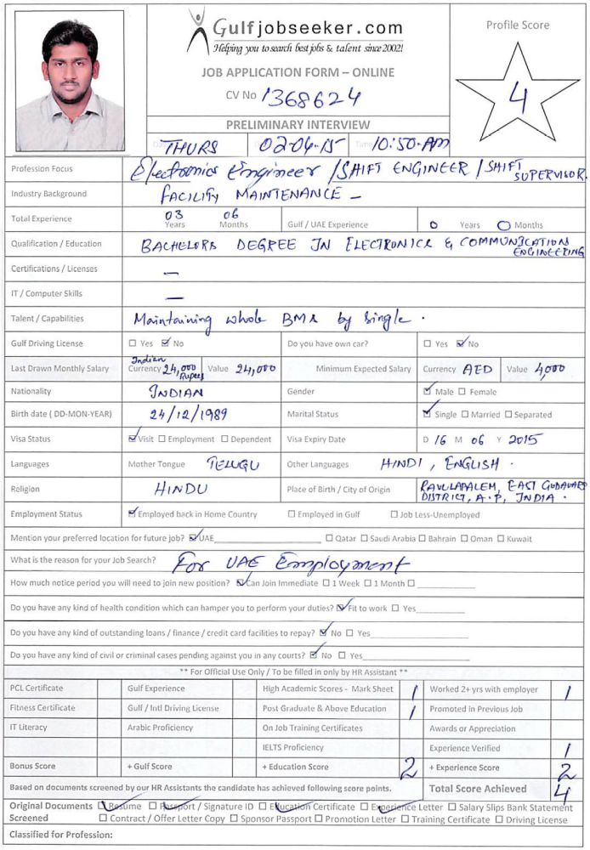

CURRICULUM VITAE

Gulfjobseeker CV No 1368624
To get contact details of this candidate call +9714-3970978
Or leave message on following link http://www.gulfjobseeker.com/feedback/submit_fb.php

CAREER OBJECTIVE:

To associate myself with an organization that has the potential for future growth and ample scope of learning. I would be able to deliver the best of my knowledge and utilize the skills and implement and contribute towards the new technologies.

EDUCATIONAL QUALIFICATION:

- B.TECH, in ELECTRONICS AND COMMUNICATION ENGINEERING with 58% from TRR Engineering College, affiliated to JNTU, Hyderabad, A.P. in the year 2007-2011.

- INTERMEDIATE, with 74% from Narayana Jr.College, Hyderabad, A.P. in the year 2005-2007.

- SSC passed in First class with 71%, from Nagarjuna Grammar High School, A.P. in the year 2005.

PROJECTS:

- Main Project: Security architecture using RFID controlling home appliances.
TEAM SIZE – 4
- Mini Project: 1. STREAM TURBINES
2. BRUSHLESS DC MOTOR
TEAM SIZE – Independent.

WORK EXPERIENCE:

- Work as a BMS Executive at Meenakshi Tech Park, ARC Property Solutions Pvt. Ltd from August 2011 to August 2012 after that promoted to Shift Engineer.

- Currently working at Meenakshi Tech Park, ARC Property Solutions Pvt. Ltd as a Shift Engineer from August 2012 to till date.

TECHNICAL EXPOSURE:

- O & M of HVAC and Ventilation system.
- O & M of AHU’s, PAHU’s & PAC Units.
- O & M of Split Ac, Vertical Split Ac & Ductable Split Ac Units.
- O & M of PLANT Manager and IBMS (Access, CCTV, HVAC, Fire Alarm, Ventilation system).
- O & M of UPS up to 400 Kva.
- O & M of HT and LT breakers ( VCB, SF6 & ACB’s)
- O & M of DG sets up to 2500 Kva HT & LT.
- O & M of Step down Transformers up to 4MV.
- O & M of R.O plant and Building Raw water management system.
- O & M of STP management system.
- O & M of Elevator management system.
- O & M of FHS and FSS systems.

DOCUMENTATION SKILLS:

- LOTO Management system.
- PPE Management system.
- Work Permit Management system.
- Vendor Management system.
- PPM tracking system.
- Maximo Service Management system.
- Material Management System.
- Safety Trainings.
- GHG & MIS Reports.
- Annual Base Line Budgets.
SOFT SKILLS:

- Chemical Management.
- Land Scape Management.
- Deep cleaning schedules.
- Environment Health & Safety trainings.

SYSTEM SKILLS:

Packages : MS Office
Operating Systems : Linux, Windows XP, Windows7 & Windows8
Languages : C, Adv. java, Core java, j2ee

Personal-Attributes:

Quick Learner, Team Player, Positive Attitude and Zeal to learn new things.

Personal Details:

Languages Known : English, Hindi, &Telugu
Gender : Male
Marital Status : Single
Nationality : Indian
Visa Status : On visit visa up to 16/06/2015

Declaration:

I hereby declare that the above details furnished by me are true to the best of my knowledge.

Date:

Place:

