Mohammed
Mohammed.228270@2freemail.com

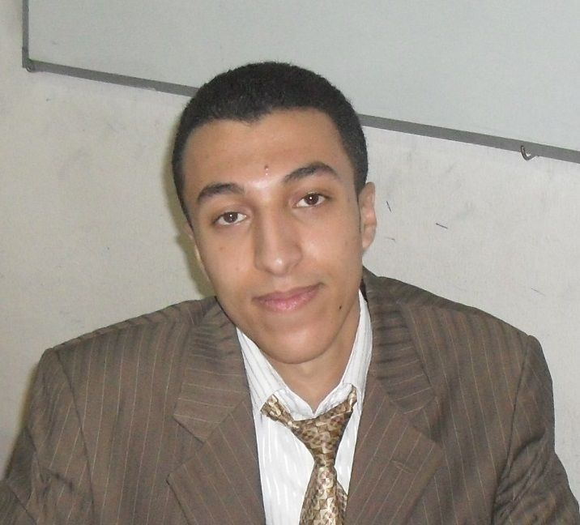

Objective

An active & ambitious career in a position relevant to:

- Information Technology Vacancies
- Networks
- Seeking for a career in a well organized and established organization where I can develop expertise and analytical skills.

education

- IT Diploma: October 2012 to July 2014
- Grade: Good
- Faculty: Faculty of Computers and Information
- Major: Information Technology
- Grade: Good
- Graduation year: September 2007 to Julie 2011

CERTIFICATES

- CCNA
- Certificate in Dale Carnegie (Character Development)
- Certificate in ICDL (Windows - Word – Excel – Access – PowerPoint-Internet –IT)

courses & TRAINING

- Networks
- Language Courses: English Berlitz Egypt 2014
- Dale Carnegie (Character Development) 2014
- Maharaty Skills 2014
- Road map to Career Success 2014
- From April 2012 to October 2014, I was an officer at The Egyptian Armed Forces in the IT office.

computer skills

- Microsoft Office skills (ICDL Certificate).
- Computer network and internet skills.
- PC maintenance SW and HW.
- Familiar with Internet configuration & Maintenance (ADSL).

personal skills

- Challenging person, love the hard problems and have good communication skills.
- Able to learn new technologies and programming languages.
- Ambitious, Cooperative, Self Motivate and Leadership skills.
- Ability of working under pressure.

personal information

- Gender: Male
- Birth date: 14/4/1990
- Marital Status: Single
- Military Status: completed
- Holding: Visit Visa

References furnished upon request

