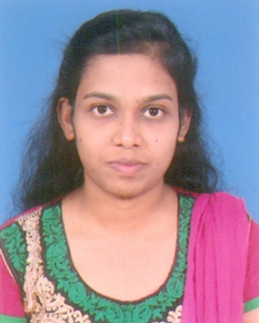

Jesmi
Jesmi.228386@2freemail.com

Career Objective

To seek a challenging and creative career in a progressive organization that will provide an opportunity to learn. Seeking a quality environment where my knowledge can be shared, enriched and to grow professionally by strengthening my management skills while contributing my best to put in all my hard work and sincerity for the success of the organization.

Employment Chronicle

Office Admin& Coordinator at VGP Housing Pvt Ltd., India (Jan 2013-Dec 2013)

Responsibilities:

- Handle inquiries from existing and new customers and to provide details about our products over the phone, via e-mails or in person.

- Acts as a primary customer resource for calls & emails.

- Created Filing system for maintaining files and databases up-to-date.

- Provide support and assistance to team members in order to meet company goals.

- Research required information using available resources

- Preparation of sales reports, proposals and submitting to the management.

- Manages day-to-day operations of office.

XML Coder at C&M Digital Pvt Ltd., India (Feb 2014- Nov 2014)

Process:
- Resolves common Word formatting errors.
- Properly handles symbols and special characters in a wide variety of fonts.
- Imposes a journal’s house style for commonly used terms, abbreviations, and units.
- Automatically copyedits bibliographic references to any preferred editorial style.
- Links references to online databases such as CrossRef and can correct references in Word with data retrieved from these resources.
- Checks references against in-text citations, and objects (such as figures and tables) against in-text callouts.
- Renumbers out-of-order reference citations.
KEY COMPETENCIES

- Resilient
- Confident
- Communicative
- Sincere
- Punctual

ACADEMIA

B.Tech in IT 2012
PSN Engg College., Tamil Nadu, India. First Class.

PERSONAL DETAILS

Date of Birth : August 23, 1990
Religion : Christian
Marital Status : Single
Nationality : Indian
Visa Status : Tourist Visa
Na I would like to hereby declare that all the above details furnished are true to the best of my knowledge.

