CURRICULAM VITAE
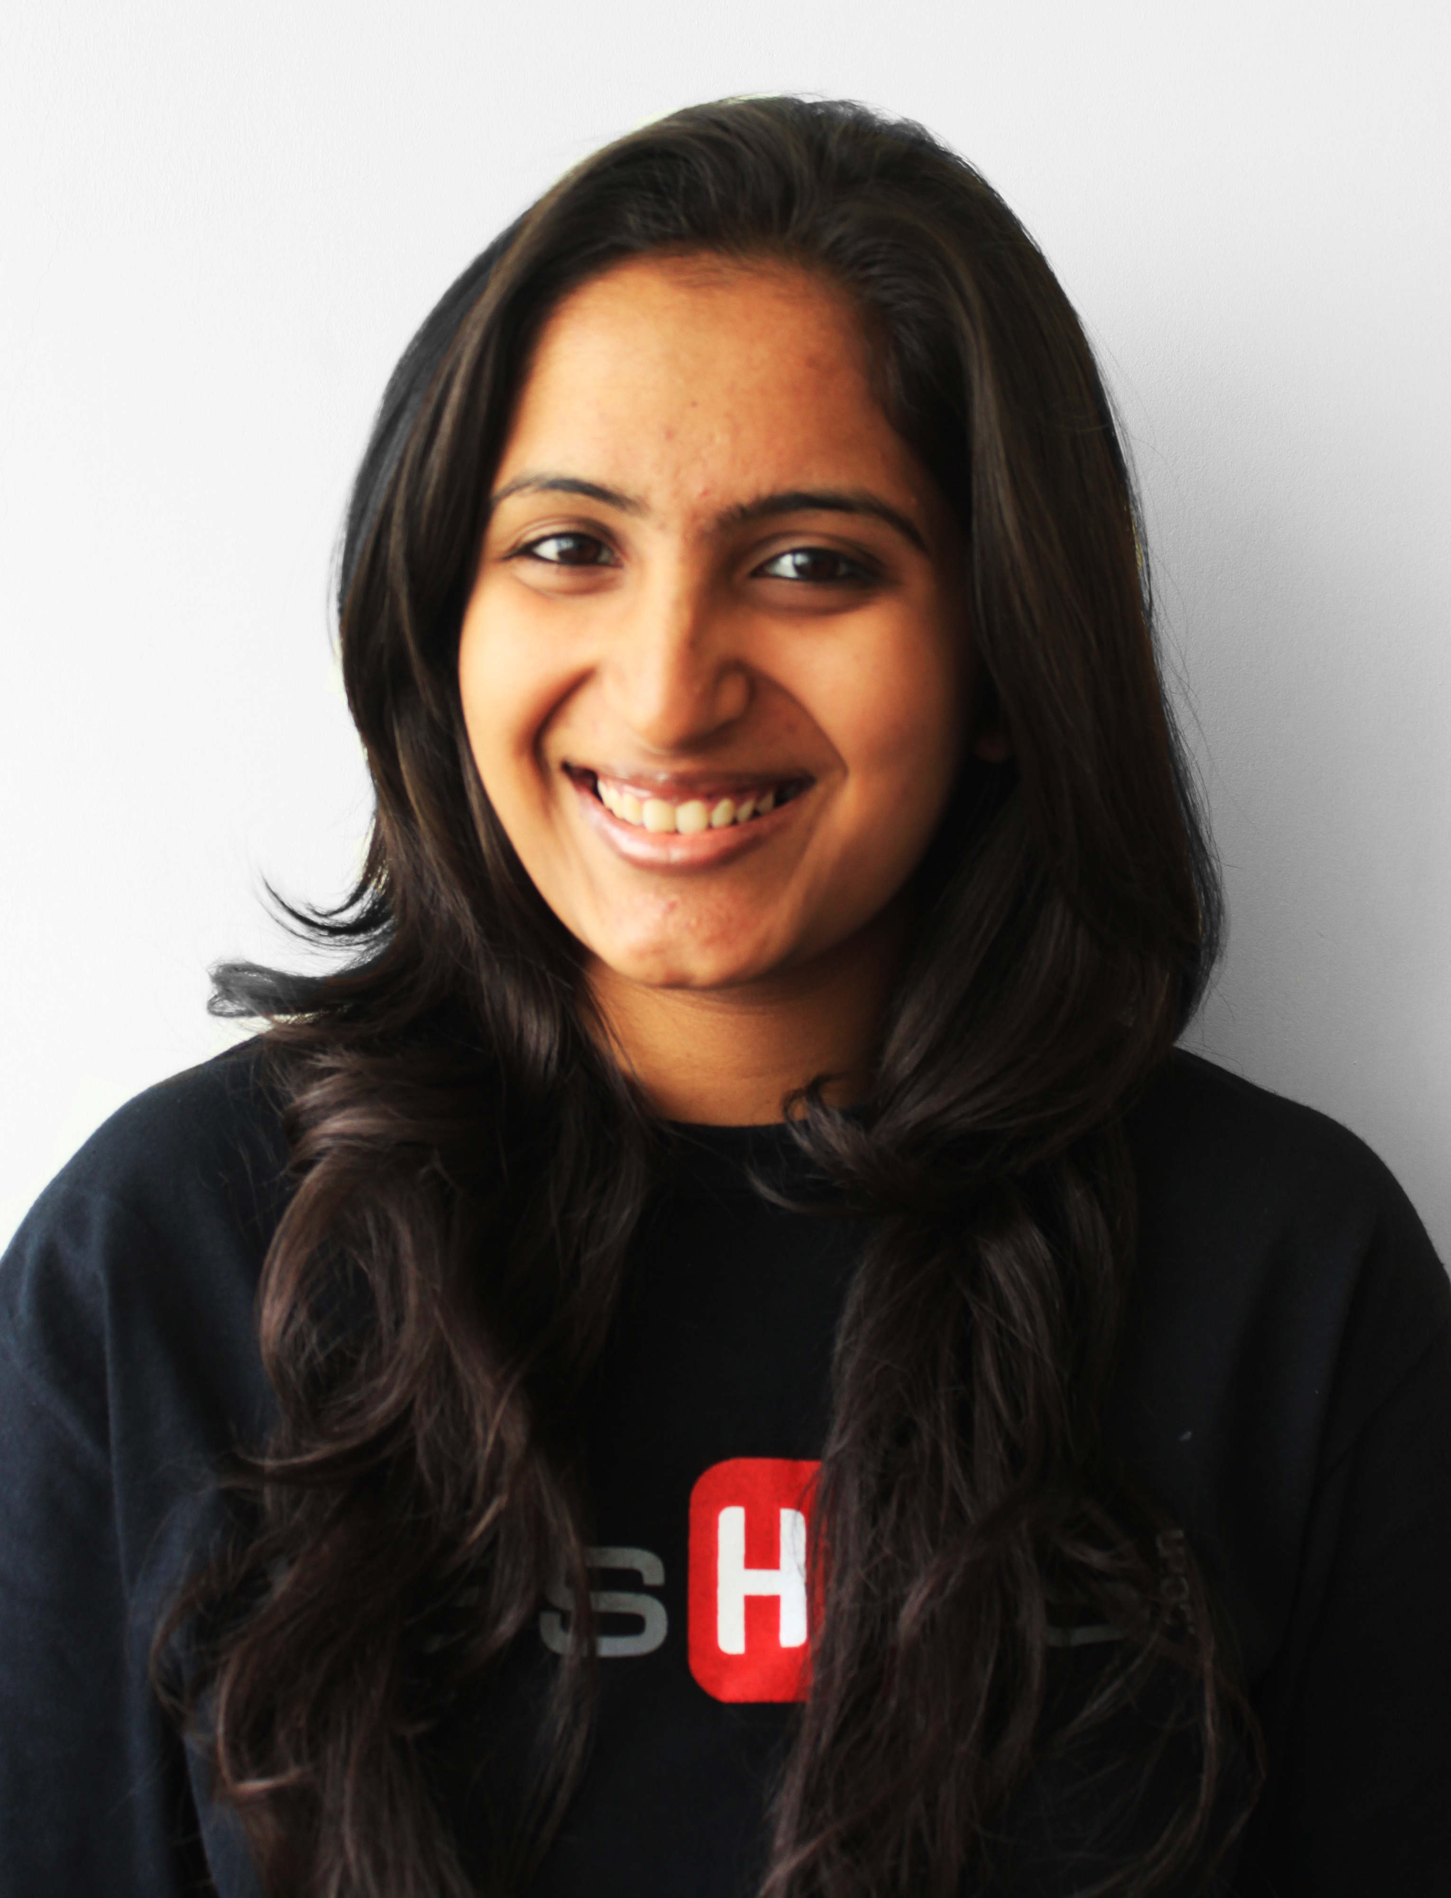
Gulfjobseeker CV No: 1370778
To interview this candidate call 971505797566
Or email us back filled up Vacancy Form
http://www.gulfjobseeker.com/Free_Job_Posting_Form.doc

CAREER AIM
A dynamic, innovative and ambitious mass communication candidate aspiring for challenges in the media sector which will utilize my skills and abilities in an organization that offers professional growth.

EDUCATION

Secondary education (April 2006)

Name of institution: Our Own English High School, Abu Dhabi, U.A.E (C.B.S.E)

Pre university program (June 2006-April 2008)

Name of institution: Jyothi Nivas College, Bangalore, India

Area of study: Humanities - History, Economics, Sociology, Psychology

Under graduate program (June 2008-April 2011)

Name of institution: Christ University, Bangalore, India

Area of study: Bachelor of Arts in Media, Psychology and Literature

INTERNSHIP

Company: Deccan Chronicle (Bangalore, India)
Duration: April – May 2009
Area: Print Media

Responsibilities: As I worked under the Political and Features Department, I attended a number of political campaigns, press conferences and various social events. I had the privilege of working with top professionals and took on various tasks successfully such as editing, writing and reporting.

Company: Bangalore Film Society (Bangalore India)
Duration: April – May 2010
Area: Broadcast Media

Responsibilites: My passion for cinema grew during my time at BFS. I had the honor of meeting eminent figures in the field and also successfully scripted and directed a documentary on the growing scarcity of the lakes in the city of Bangalore. As a part of my research, I had the privilege of working with a highly creative team and also attended various film conferences.

Company: Avaroha (Bangalore, India)
Duration: July – October 2011
Area: Event Management

Responsibilites: As an artist manager, I met with a number of well known individuals from the industry. I also assisted in organizing events which required me to handle publicity and marketing for each event predominantly on social media platforms.

WORK EXPERIENCE - 3 years

Designation: Content Producer
Duration: January 2012 till date

Responsibilities:
- Produced multimedia content to achieve mission value and audience reach
- Moderation and review of content
- Designed and produced items of promotional and communication content
- Up-to-date understanding of industry terminology, aesthetics and production processes of creative equipment, software applications required for video editing, image manipulation, motion graphics and color grading
- Coordination and collaboration with external resources to execute creative briefs
- Involved in pre-production, production and post production processes
- Worked within designated budget and deadlines
- Maintenance, set-up and operation of complex camera, lighting, sound, editing, construction and electrical equipment
- Liaised with local authorities for the appropriate use of locations and facilities
- Up-to-date with several social media platforms, the requirement and relevance of a brand on respective platforms and to create content specific to each platform
- Good interpersonal and communication skills in consultation with cast and production personnel and to substitute for other personnel when required
- Undertaken tasks positively and professionally under the pressure of production deadlines
- Organization and supervision of equipment, scenery and all production assets
- Specialization in more than one skill such as scripting, photography, cinematography, editing, graphics, color grading, sound mixing etc.
- Maintenance and adherence to all company regulations, policies, procedures and guidelines

KEY SKILLS
- Interpersonal skills: Cultivated excellent interpersonal skills in the media environment which comprised of colleagues from different regions and external clients
- Communication skills: Possess excellent articulation capabilities and I consider this my strongest asset. Writing and collating my thoughts in a manner that conveys meaning to the audience, is my passion. Bringing clarity to thoughts that translate into words during communication is an area that I continue to work on and I am sensitive to the nuances that accompanies the art of communication
- Ownership & Responsibility: Have actively participated in various social activities in the educational and workplace environment
- Organizational & Time Management skills: I have developed effective skills in time management, organization, planning, execution and goal setting through my graduate schooling at Christ University, India. With three majors, I had to plan my time effectively in order to prioritize and ensure that all three subjects received the required attention. In order that there was no compromise on my academic affiliations, my execution skills were honed, while I was called upon to organize fests and other activities. This has added enormous value to my character and personal development. My organizational skills were also developed during my work experience at Avaroha and CVC Network India Private Limited, and I have been able to hone my goal-setting skills effectively since these jobs required me to handle multiple activities all at once
- Adaptability: With the work experience I have gained in different forms of media, I have been able to develop immense adaptability. I have been able to learn quickly and grasp the details that make each media so unique. My work at CVC Network India Private Limited also demands that I am adaptable enough to be able to take on any challenge that is thrown my way
- Global perspective: Having studied in the U.A.E and in India and also having worked in the Media industry has made me very open to new cultures. As a result I have been able to inculcate innovative thinking
- Teamwork: Team player with the ability to lead, manage and motivate others. I’ve actively participated in group discussion panels and debates and promoted a culture of working in cooperation and conjunction with my team members to achieve heights in academic, extra curricular and professional activities
- Computer Skills: Demonstrated proficient technical skills by grasping new concepts and understanding softwares such as Adobe Photoshop, Illustrator, Lightroom, Premiere Pro, Affer Effects and Audition. Good knowledge of MS Word, Excel, PowerPoint, Keynote and Numbers Have an excellent understanding and have worked on both iOS and Windows operating systems.

STRENGTHS
- Self Driven and dedicated
- Client Focussed
- Good Communication and Interpersonal Skills
- Excellent Team Player, Responsible and Accountable
- Energetic and self-motivated team player

INTERESTS
Creative writing, Theatre, Music, Photography, Design, Illustraton, Reading, Public Speaking, Cinema, Travel, Blogging, Social Media Interaction

LANGUAGES
Fluent in English, Hindi & Malayalam

PERSONAL DETAILS
Date of Birth : 1st June 1990
Marital Status : Married
Gender : Female
Nationality : Indian

