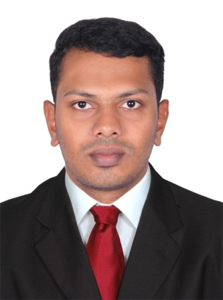
FUVAD

CAREER OBJECTIVE
An innovative, multi-disciplined and solutions-oriented IT Technical Support Engineer, having experience with a consistent track record of designing, implementing and integrating cost-effective, high-performance technical solutions, seeking opportunity to work in a challenging and creative environment towards the goals of the organization.

Fuvad.229224@2freemail.com
Dear Sir,
Regarding the subject post of IT Technical Support Engineer in your esteemed firm; please find my attached CV for your kind consideration.
During my career as an IT Engineer in Network and System Technical support, I have achieved good knowledge and experience in the Installation, Configuration and Maintenance of IT infrastructure and good in troubleshooting of both System and Network Issues.

I look forward to hearing from you soon.

PROFESSIONAL EXPERIENCE
- IT Support Engineer
Organization: MILLIMINDS SOFTWARE SOLUTIONS PVT LTD
Duration: December 2014 to Present
Job description and duties:
- Installing and configuring computer hardware operating systems and applications
- Monitoring and maintaining computer systems and networks.
- Adding and maintain new user accounts by Active Directory feature.
- Troubleshooting system and network problems and diagnosing and solving hardware or software faults
- Supporting the roll-out of new applications
- Providing support, including procedural documentation and relevant reports

- Network Engineer – Network Operations Control Room
Organization: SIFY TECHNOLOGIES LIMITED
Duration: May 2013 to June 2014
Job description and duties:
- Ensuring maximum possible service availability for Sify’s Kerala region network nodes.
- Analyze IP network performance and take proactive actions and preventive measures to monitor and enhance the network performance including hardware upgrades, new installation etc.
- Support engineering teams on new product/feature implementation, node deployment and technical support matters.
- Support the expansion, upgrades and roll-outs of new network infrastructure involving hardware such as routers and switches, associated software, network monitoring and management systems.
- Coordinate with BSO for implementation and commissioning of POI and infrastructure connectivity.

- Coordinate with the engineering teams and other teams for “Muthoot fincorp” project’s feasibility studies and installations.

- Performed various coordinating duties such as documenting, faxing, mailing, and
organizing filing system.
- Conducting operation & maintenance activities (CM & PM activities)
- Configuration of Cisco routers and Switches
- Hardware Trouble shooting skills
- Setting up of Access list to secure the network
- Configuration of RIP , IGRP ,OSPF
- Configuration of ADSL Router for Internet connectivity
- Setting up of VLANs
- Configuration of FORTIGATE firewall routers.

- System Administrator
Organization: XENIQ SCIENTIFIC SOLUTIONS
Duration: December 2012 to April 2013
Job description and duties:
- Provide general and routine technical support for installation, configuration, and updates to Operating Systems and non-OS vendor application
- Actively coordinates with team members and other groups to effectively perform
general and routine requests such as backup, restores, permissions changes, and testing.
- Provides basic Windows Server and administration support for daily operations.
- Develop and maintain installation and configuration procedures.
- Repair and recover from hardware or software failures. Coordinate and communicate with impacted constituencies.
- Perform ongoing performance tuning, hardware upgrades, and resource optimization as required. Configure CPU, memory, and disk partitions as required.
- Create, change, and delete user accounts per request.

TECHNICAL SKILLS

- Operating Systems : Windows XP, 7,8, Server2012
- Basics of C,C++
- Installation of windows XP,7,8, Server2012
- Knowledge in MS OFFICE
- Knowledge in Active Directory and other Windows Server tools
- Installation and troubleshooting of computer Hardware and software
- Knowledge in designing CISCO networks using packet tracer software
- Implementing access lists in routers to secure network
- Design ,Installation and Troubleshooting of LAN and WAN networks
- Configuration of ADSL router for Internet connectivity

EDUCATIONAL BACKGROUND

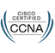
B.TECH - BACHELOR OF TECHNOLOGY - 2012
INFORMATION TECHNOLOGY
Mohammed Sathak Engineering College
Kilakarai, Tamilnadu
Anna University, Chennai

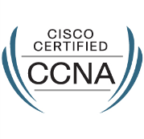
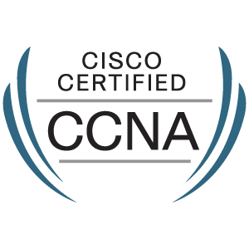
TECHNICAL - CCNA (Cisco Certified Network Associate)
MCSE (Microsoft Certified Solution Expert)
DCHN (Diploma in Computer Hardware and Networking)

