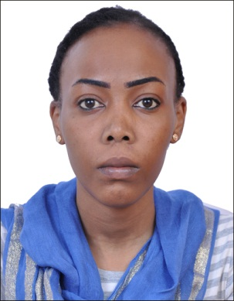
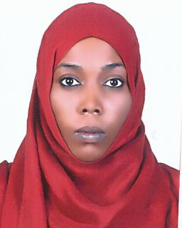

Fatima
Fatima.229364@2freemail.com
Education and Training:
- High School: Omdurman High school.
- Ahfad University for Women-School of Health Sciences. Food and Nutrition Option.
- Bachelor degree honour in food and nutrition with Distinction (81%).Year of graduate: November 2009.
- Master of sciences in human nutrition with Distinction (80%) at Ahfad University for Women. Year of graduate: April 2013.
Trainings:
- Ombada Teaching hospital: Training in the Department of Nutrition in the field of maternal and child care .Training period (15/11/2007 – 30/11/2007).
- Ahfad Family Health Center: Training in Nutrition, Family Planning Immunization, mother and child health and health education unit. Training period (29/10 – 14/11 /2007).
- First aid in the community. . Training period (1/6- 1/7/2007).
- International Hospital: training on diet therapy includes all related activates to nutrition management such as calculation of main meals, nutritional clinics and practical work in the main hospital kitchen. Training period (1/11/2008- 31/11/2008).
- Concept, management and financing of voluntary work. Training period (13/1/2010- 4/2/2010).
- Psychology of leadership, skills of emotional intelligence self-management and time management. Training period (25-26/11/2013).
- Human nutrition and dietetics internship program. Training period (10-23/11/2013).
Experiences:
- Work as dietitian on Rabat University Hospital from (16/5/2010 – 16/5/2011).
- Work on SOS children’s village Khartoum Sudan in the field of nutrition and nutrition counseling (17/4/2007 – 17/6/2007).
- Work as Nutritionist at ALmanar organization health center (15/2/2013 19/10/2014).
- Work as lecturer in Ahfad university for women (11/11/2013- 11/1/2015).
Additional Information:
- Eligibility Letter of DHA License.

