Alphin  Alphin.229692@2freemail.com  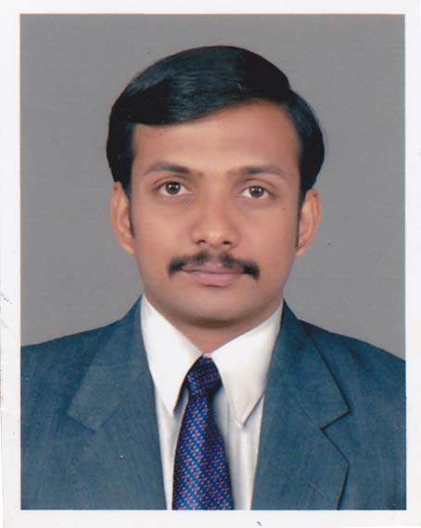  Area of Interest  - Casualty / Emergency.  Linguistic Proficiency  - English  - Arabic  - Hindi  - Malayalam  - Tamil |  | CAREER OBJECTIVES  To work with an organization which provides challenging opportunities and recognition where I can contribute towards growth of organization and vice versa through attaining excellence by taking initiatives, accepting responsibilities, decision making and team work.  CORE COMPETENCIES  - Ability to accept any challenges with an optimistic outlook.  - Teaming up with colleagues and willingness to learn.  - Task oriented with effective communication skills.  - Very friendly nature, ability to handle critical situations.  ACADEMIC QUALIFICATIONS  - 2004 – 2008 – Degree in Bachelor of Nursing – Rajiv Gandhi University Bangalore.  - 2002– 2004 – (Higher Secondary Schooling)- GHS, Kodakara, Thrissur, Kerala  TECHNICAL QUALIFICATIONS  - BCLS / ACLS Provider  - DHA (Dubai Health Authority).License no:DHA-P-0116374  PROFESSIONAL EXPERIENCE/ TRAINING  - Currently working as registered nurse in Al Noor Polyclinic-BR Of Gulf Health International, Satwa -Dubai  - Worked as Emergency and Trauma Care Staff Nurse at Oman Medical Complex, Ibri Sultanate Of Oman (from 12 June 2012 to 08 January 2015)  - Worked as Emergency and Trauma Care Staff Nurse at Mary Matha Hospital, Kottyam - Kerala (from 05 April 2010 to 03 March 2012)  - Worked as ICU Staff Nurse at N.G Hospitals Pvt. Ltd., Coimbatore – Tamil Nadu (from 25 March 2009 to 30 March 2010)
 | Personal Data  DOB: 30-05-1987  SEX: Male  Nationality: Indian  Marital Status: Single  Hobbies  - Knowledge Surfing.  - Making Friends.  - Reading. | PROFESSIONAL ACHIEVEMENTS  - Experience in Patient Counseling  - IV Cannula Insertion  - Use of Defibrillator.  - Tracheostomy Care and Suctioning.  - Endotracheal Intubation.  JOB RESPONSIBILITIES  - Emergency management for all cases  - Provide prescribed medications, drugs and other pharmaceuticals needed for adequate patient care.  - Conduct drug regimen review on all patients.  - Management of Emergency situations on priority base.  - Maintenance of proper records and reports.  COMPUTER PROFICIENCY  - Proficiency in Internet usage.  - Knowledge of using Power Point Presentations.  - Proficiency in MS Office Programs.  DECLARATION  I hereby solemnly affirm that all the details provided above are true to the best of my knowledge and belief and that at all times, I shall carry myself in a manner that lends dignity to the organization and worthy enough of the person.

