CURRICULAM VITAE
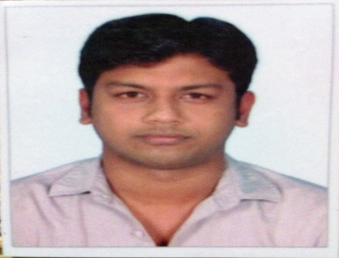

Yunus
Yunus.230316@2freemail.com

Objective:

To exhibit my technical skills with utmost sincerity and to learn more from my working ambience by grabbing opportunities that come my way.

Profile:

An astute M.C.A graduate with nearly 1 year of rich hands on experience in network security, desktop support and cryptography. Well trained professional with a track record that demonstrates self- motivation, creativity and diligence.

Academic Qualification:

- Completed M.C.A, Master of Computer Application in M.I.E.T Arts and Science College, Bharathidhasan University, Trichy in the year 2013 with CGPA 7.69(76.9%)

- Completed B.C.A, Bachelor of Computer Application in M.I.E.T Arts and Science College, Bharathidhasan University, Trichy in the year 2011 with CGPA 7.15(71.5%)

- Completed HSC in National Higher Secondary School, Karaikal in the year 2008

- Completed SSLC in St.Mary’s Higher Secondary School, Karaikal in the year 2006

Work Experience:

Amarprakash Developers Pvt Ltd Chennai, India., - (February 2014 – March 2015)
Designation : Jr. Desktop Support Engineer

Roles & Responsibilties:

- Periodic performance analysis of softwares and hardware components
- Test computers often to ensure proper functionality
- Setup Computers and install softwares for application and programs
- Achieve the maximum possible "ON TIME" and to offer client a non-interrupt network service

Key Performance Indicators:
- Capable of handling multiple simultaneous end user request with complete accuracy
- Instantaneous troubleshooting ability for desktop OS
- Tackling hardware and software breakdown response

Projects Accomplished:

- Accomplished a UG project in M.I.E.T Arts and Science College, Tiruchirappalli on “SECURITY BASED CRYPTO ANALYSIS"
- Accomplished a PG project in M.I.E.T Arts and Science College, Tiruchirappalli on “RI (REVERSE IMAGE) REPRESENT STREAM MARKING"

Rewards:

- Received "Best performing team of the month (SEPTEMBER-2014) excellence award" for successfully accomplishing launch activation of 2 township projects in Chrompet, Chennai.

Extracurricular Activities:
- Represented School at inter zonal volleyball tournament 2006.
- Participated in zonal cricket tournament in 2010.
- "Event Coordinator" for my college department Symposium.

Hobbies & Interest:

- Playing Volley Ball and Cricket
- Surfing the trending Technologies
- Travelling
- Assisting Short Films

Declaration:
I hereby declare that the above furnished details are true to the best of my knowledge and I bear the responsibility for the correctness of the above mentioned particulars.

