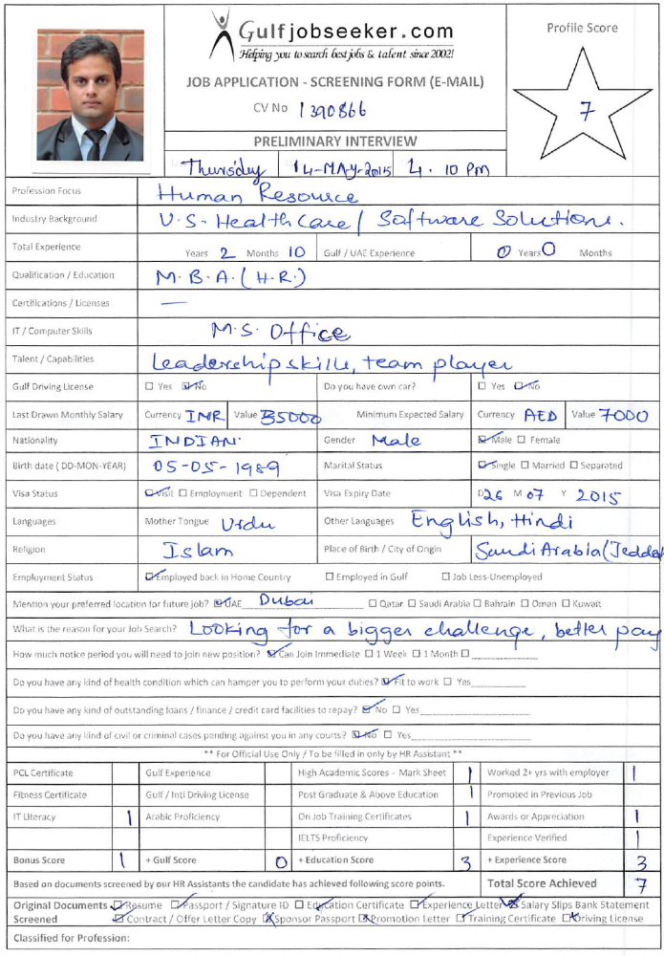
Gulfjobseeker.com

CV Number: 1390866
Mobile +971505905010 / +971504753686
E-mail: cvdatabase @ gulfjobseekers.com

To get contact details of this or many other candidates
Submit request on this link by writing all the short listed CV Numbers.
http://www.gulfjobseeker.com/feedback/submit_fb.php

Career Objective
To excel in various facets of Human Resource Management by applying my knowledge skilfully, thereby creating value for the Organization through sustained developments in my realm.

Educational Qualification
Year | Degree/ Certificate | Institute
2013-2015 | PGDM  Major: Human Resources  Minor: Marketing | Institute of Management Technology, Nagpur (IMT-N)
2007-2010 | Bachelor of Commerce | Aurora Degree College, Hyderabad
2007 | Board Of Intermediate Education (a.p.) | Nalanda Junior College, Hyderabad
2005 | CBSE | The Hyderabad Public School, Ramanthapur

Work Experience
- 8 week Summer Internship IT Services, Hyderabad(May-June, 2014)
Industry: Consulting
Title: Recruitment and Selection at Right Axis IT Services
Role: HR Recruiter

- InfoTech- 3s India, Hyderabad (2011-2013)
Service: Software Solutions
Role: HR Generalist
Responsibilities:
- Perform End to End Recruitment Process
- Employee Orientation, Development and Training
- Policy Development and Documentation
- Compensation and Benefits
- Employee Relations
- Performance Management and Performance Appraisal

- Deloitte, Hyderabad(2010-2012)
Industry: Health Care
Process: Extended Business Office Solutions (EBOS)
Role: HR Generalist
Responsibilities:
- Recruitment & Selection
- Orientation Training to new employees
- Performance Management and Improvement system
- Organizational Development
- Employment and compliance to regulatory concerns and reporting
- Compensation and benefits administration
- Employee Safety and Counselling

Projects
- Project on Organizational Citizenship Behavior (OCB) at IMT.
Involving Faculty and Staff at IMT, implemented BRM Techniques to ascertain relationship between OCB and performance of an organization
- Live Project at Ajmera Tyres Nagpur. Highlight the significance and Impact of Organizational Development (OD) in an organization. Involved staff members, Managers and Managing Director of the company.
- Successfully completed Leadership Essentials course designed by Harvard Business School ( E-Learning) (2011)

Extra-Curricular Activities
- SPOC, Milestone Committee at IMT. Organized Intra and Inter Business and Cultural Events at National level)
- Member of XploHRe (HR) Forum at IMT.
- Member of Mess Committee at IMT.
- Member of Placement Committee at Aurora Degree College
- Awarded Star Performer of the year at Aurora Degree College

Personal Interests
I play cricket and swim.I am a good dancer and love to workout at the gym. Also, I never miss an opportunity to travel, make new friends and try different cuisines.
Additional Information:
Nationality: Indian
Languages Known: English, Hindi and URDU

