RESUME
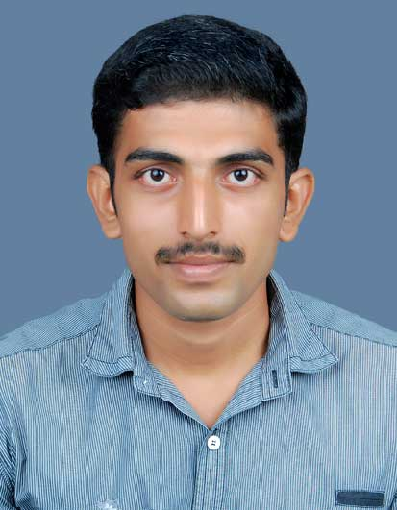
FREDIN
Fredin.232335@2freemail.com

CAREER OBJECTIVE

To work in a reputed organization where i can continuously learn through the challenging tasks assigned, contributing by applying my knowledge, skills and grow along with the organization.

PROFESSIONAL SYNOPSIS

Designation : Mechanical Engineer
Employer : M/s Veda Engineering Pvt. Ltd, Pune.
Duration of employment : 2 year.
Reporting to : Project manager.

JOB RESPONSIBILITES:

- Interaction with the technical team and the management to understand the project and corporate deliverables for execution of work in appropriate and timely manner.
- Coordinating with design team and get the drawing for site execution.
- Listing out the quantity of materials required as per IFC drawings.
- Getting the quotation for the materials from the suppliers and submitting the final materials list to consultant.
- Raise the PR request for the materials when the list of materials is approved by the consultant.
- The shop drawing has to be made coordinating with a draftsman and should be submitted to consultant for approval.
- The coordination and builders drawing has to made and handed over to consultant.
- Engineering assistance to manager
- Ensure work permits for the work.
- To produce an accurate plan of action for every project.
- Assigning work to supervisors and foremen and monitoring the work progress.
- Coordinating with the safety team to avoid accidents at site.
- To ensure work completion in regular interval of time and sending IR to consultant.
- Review the activities (plan v/s actual) at regular interval for every project

PROJECTS UNDERTAKEN

- Installation of Plumbing works in Marriot apartment, Pune.
- Installation of ‘Water piping’ and storage tanks at, Parkson Pune.
- Installation of Circulation pumps, booster pumps, transfer pumps and completed system for water circulation including plumbing at Avad properties, Pune.
- Erection of ‘Thermic fluid piping’ and Thermic fluid heater of capacity 4 lakes kcal/hr in tasty bites, Pune.
- Erection of Furnace oil system and storage tanks at Tata motors, Pune.
- Erection of ‘Furnace oil, Water and Steam Piping’ and Installation of sm-40dh boiler of capacity 4000 kg/hr steam at Tetra Pak india.pvt ltd, Amreli , Gujarat.

ACADEMIC QUALIFICATION

- Bachelor of engineering (mechanical) from v.s.b engineering college, karur, affiliated to Anna university-Chennai from year 2009 to 2013 with first class.
- 12th standard -higher secondary examination, Kerala state board from mar kauma higher secondary school vengoor from year 2008 to 2009with first class.
- 10thstandard - s.s.l.c, Kerala state board from Anita Vidyalaya higher secondary school Thannipuzha, Okkal from year 2006 to 2007with distinction.

TECHNICAL EXPOSURE

- Attended a workshop on “automotive engineering” from 16th to 18thseptember, 2011conducted in vit university, Vellore, Tamil nadu.
- Undergone an in-plant training at transformers and electrical Kerala limited, Ernakulum, Kerala from 09th to 11thmay, 2011.
- Industrial visit to lakshmi machine works, Coimbatore in the 5th semester

AREA OF INTEREST

- Project management
- Site management
- Project execution and monitoring.
- Business development.

SOFTWARE SKILLS

- Auto cad 2014
- Ansys 4.0
- Ms office

SKILLS & STRENGTHS

- Hard working.
- Good verbal and written communication skills .
- Diplomatically, problem solving abilities.
- Willingness to learn new technologies.
- Team facilitator.
- Completing tasks in time.

LANGUAGES KNOWN

- To speak : English, Hindi, Malayalam and Tamil.
- To read : English, Hindi, Tamil and Malayalam.
- To write : English, Malayalam.

EXTRA-CURRICULAR ACTIVITIES

- Member of sports committee in v s b engineering college.
- Member of event organizing team in school and college.

DECLARATION

I hereby declare that the above information is true to the best of my knowledge and i bear the responsibility for the correctness of the above mentioned particulars.

.

