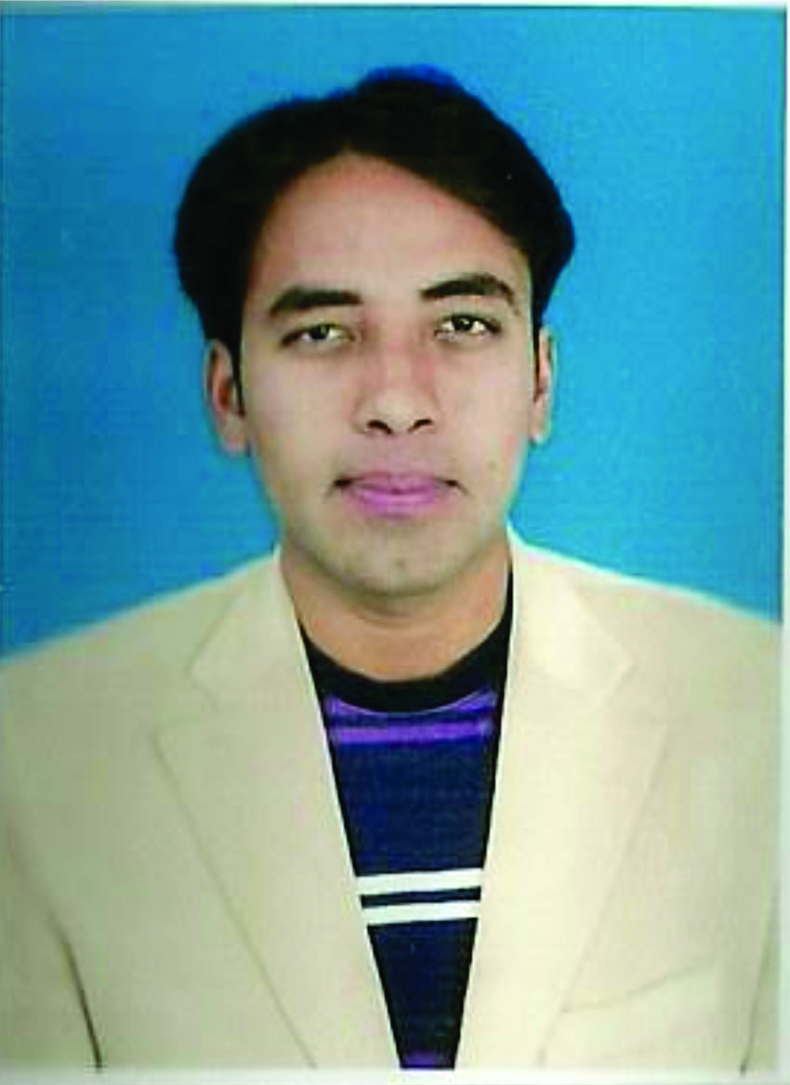
Hafiz Muhammad Faheem Khan
faheemk403@gmail.com
Visa Status: Employment Visa
Expected Salary : 7000

PERSONAL PROFILE
:

Nationality: Pakistani
Birth Date: 12-09-1989
Gender: Male
Marital Status: Single
Personal Objectives

I am Civil Site Engineer having Five years experience in Multi Story buildings from foundation to roof level. Objective to build a long they career in an organization which allows me to develop and utilize my skills, challenges and opportunities in what I strive for, be part of such an environment.
Strengths

- Proficient in AutoCAD 2009,2007,2004 (2D)
- Proficient in Ms Office Applications (Ms Excel, Power. Point, Word)
- Familiar with Quantity Surveying.
- Familiar with Quality Control Works
- Familiar with Interior Works
- Familiar with Site Work’s
Educational & Professional Status

Bachelor in Civil Engineering : Bahauddin Zakariya University Multan, Pakistan

Duration Time: (2012 to 2014)

Diploma of Civil Engineering : Punjab Board of Technical Education Lahore.

Duration Time: (2005 to 2008)

Company Name: Thaeem Construction Company Private Limited, Multan

Duration Time: January 2008 to November 2012

Company Name: Five Star Corporations (Govt Contractor)

Duration Time: July 2013 to September 2014

Company Name: Mawaride Contracting Company, Dubai

Duration Time: 28 feb 2015 to 30 April 2015

Designation: Site Engineer

Key Professional Skills:

I have more than 5 years of experience as Site Engineer (Theme Construction Company Pvt Ltd). I did have work in industrial building plus special construction like silos, Asia Feed Mill, Agha Steel Mill, Denim Textile Mill, Islamabad Hatchery, Strong Shell’s. I am expert in layout, RCC Design, Bar bending schedule, construction of Commercial& industrial buildings, (survey , leveling) of building’s , road’s , pipe line’s Drawing’s reading & working with specifications of any kind of structural drawing & designing of building structure. I Know that how to control (with morality, intelligence, softness, peace & understandings each other) the site. I have a good problem solving ability, able to work without Supervisor as an individual or as part of a team.

Duties and Responsibilities

- Write daily report, measure work done & supervise site test.
- Closely monitor concrete pours and check continuously concrete materials delivered to site, ensure compliance with QA/QC procedure, & ensure all concrete tests are carried out as per contract requirements.
- Regular visit to stores to make sure that storage, handling and preservation activates are carry out as per manufacture recommendation.
- Review all shop drawing, method Statements and As- Built drawings as Submitted to Consultants and make sure that all site conditions are properly addressed.
- Preparation of work schedule and working drawing.
- Preparation of bar bending and cutting drawing.
- Preparation of material quantities required for construction.
- Prepare Measurement Books as per site.
- Checking Contractors drawing for steel and RCC structures.
- Preparation of bill of quantity for bid.
- Execute any related duties as many be request by immediate supervisor.
Short Experience, Training, Workshops& Languages

Institute Name: Cholistan institute of Technical education (LTV Driving)

Duration Time: (9th Jun to 8th Aug 2014)

Company Name: Agha Khan University Hospital, Karachi

Duration Time: (5th May to 5th June 2013)

Company Name: Sunder Trading Company Sokia, Lahore.
Duration Time: (13th Aug to 13th Oct 2010)
- 02 Months Experience in Sokia Total Station, (Set 630 RK)
- Participated in 6th Module implementation workshop (LPP) in bwp 2008
- Participated in 13th National Scout Jamboree in Islamabad in 2004
- Rediscover yourself Through Self-Motivation

- English - Good (Written, Spoken & Listen )

- Urdu - Excellent (Mother tongue)

