
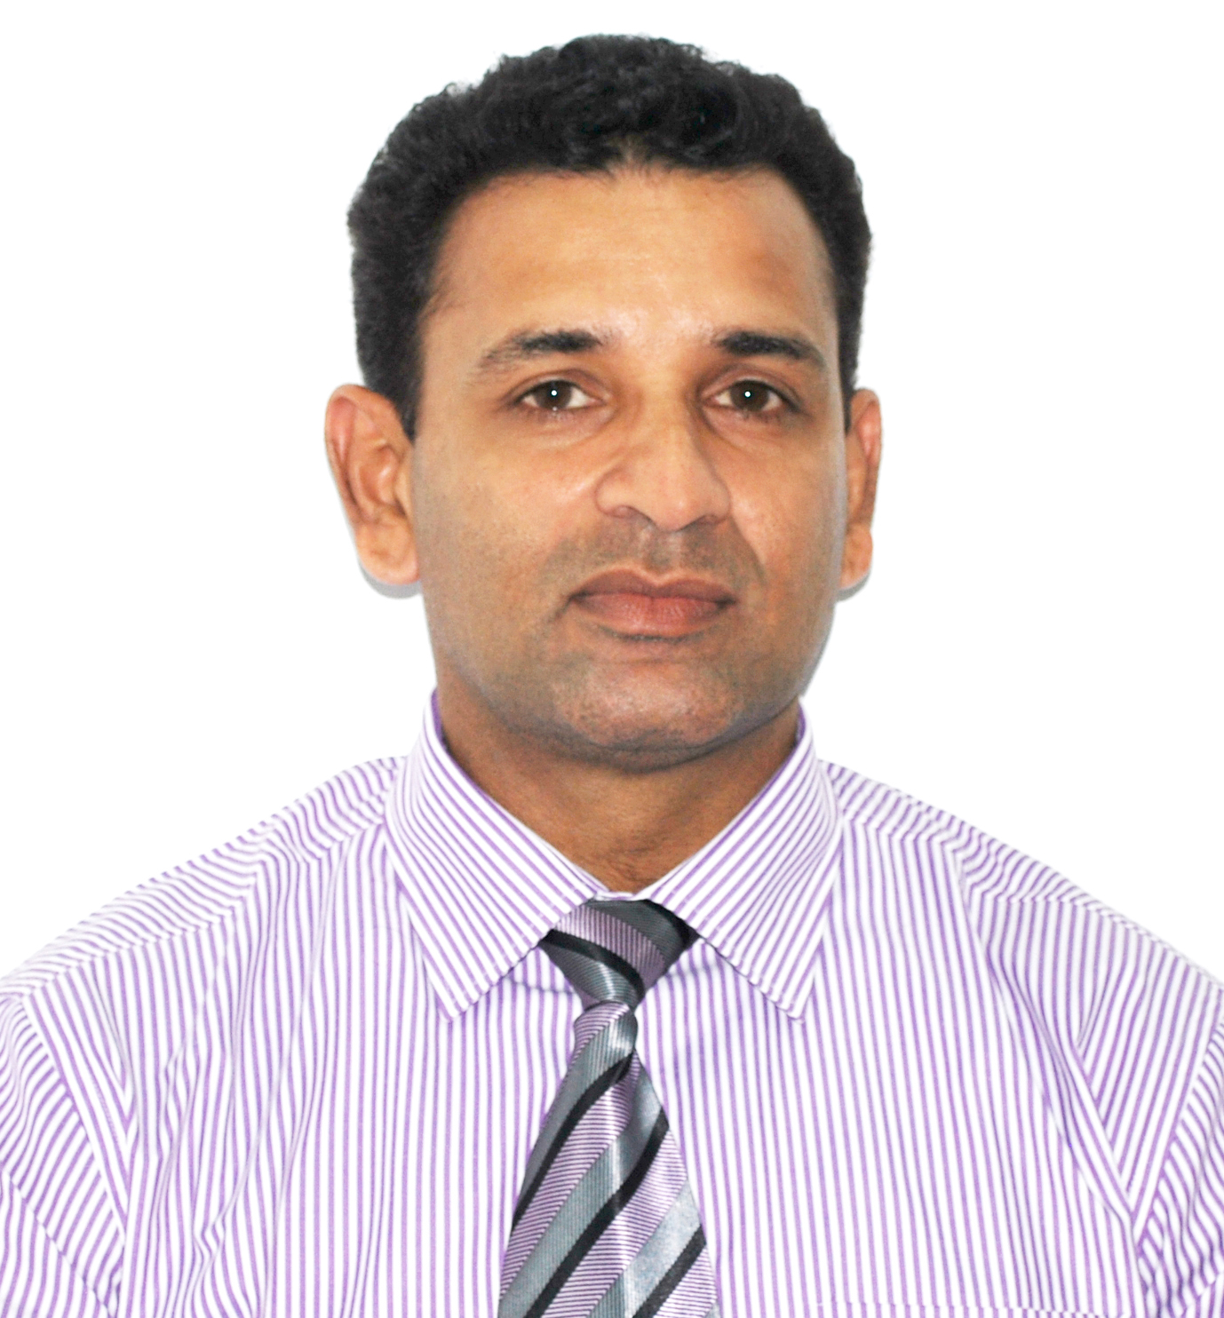

CV No: 1398456
Mobile +971505905010 / +971504753686
To get contact details of this candidate
Send request to cvdatabase @ gulfjobseekers.com

CURRICULUM VITAE

CAREER SUMMARY
Graduate in commerce (B.Com ) with over 17 years of professional accounting, finance and auditing experience including reporting and management accounts. Working on complete accounting cycle, accounting verification and follow ups, recovering receivables and working directly with suppliers

PROFILE

    - Have 17 years of experience in the field of accounting, finance and audit.
    - Professionally qualified with Bachelor of Commerce (B.Com ) and have sound knowledge of working in computerized accounting software using Quick Books, Inbank System, Sasia Net System.
    - Efficient in handling accounts up to finalization
    - Energetic and capable of working independently and a good deal of autonomy.
    - Have excellent time management skills & can meet the deadlines without compromising on quality.
    - Highly dependable & can prioritize and organize tasks.

Areas of Expertise
Finalization of accounts Day to day book keeping Accounts receivable/payables
MIS reporting Reconciliation of accounts Team supervision
Inventory management Office administration

PROFESSIONAL EXPERIENCE

Previous Employments

(1) Accountant - UB Finance Company Limited.
(From June 1999 to March 2015 )

Company Profile

UB Finance Company Limited is a subsidiary of Union Bank, which is a large conglomerate in Sri Lanka with more than 9 Branches. It is a finance company approved by the monetary board of the Central Bank of Sri Lanka and offers a range of services, which includes fixed income investments, leasing, hire purchase, loans and property development.

Responsibilities

- Maintaining of the Finance Lease and Loan portfolios and preparation of the monthly reconciliation of the same and acting as the coordinator from the Finance division for product related issues.

- Preparation of Monthly Financial Statements in accordance with Sri Lankan Accounting Standards & Sri Lankan Financial Reporting Standards.

- Preparation of all reporting requirements including Weekly, Monthly and annual reporting to the Central Bank of Sri Lanka (CBSL) as per the CBSL guideline.

- Monitoring the Accounts Receivables, Accounts Payables, Payment vouchers & Invoices.

- Liaising with the external auditors.

- Preparation and implementation of strategic financial and operational management information systems, internal controls to improve the efficiency of finance operation.

- Optimizing the effective use of working capital, ensuring effective financial planning and fund management systems.

- Handling of all tax matters of the company in VAT, ESC, and VAT on Financial, NBT, Stamp Duty, WHT and Crop Insurance.

- Acting in the role of an authorized signatory of the company.

- Disseminating information to senior management, subordinate staff through periodic discussions, meetings and reviews in order to facilitate effective financial and working capital management.

- Preparation of Bank Reconciliation.

(1) Accounting Officer - Central Bank of Sri Lanka.
(From June 1997 to June 1999 )

Responsibilities

- Balancing C and C3 forms, Checking of Housing Loans and attending to Refunds.
- Participating the Fund Management of the EPF Department.

ACADEMIC QUALIFICATIONS:

Bachelor Of Commerce (B.Com.) Special - 1997
University Of Sri Jayawardenapura, Sri Lanka.

G.C.E. (Advanced Level) – 1990

PROFESSIONAL QUALIFICATIONS
_______________________________________________________________________________
Successes fully completed Licentiate Level Exam in Institute of Chartered Accountants of Sri Lanka (ICASL).

Successes fully completed Strategic Level Exam in Chartered Institute of Management Accountants of UK (CIMA). I am a final stage student of the above institute.

Member of Association of Accounting Technician of Sri Lanka (MAAT).

Diploma in Accountancy [UK]
Member of Institute of Chartered Business Administrator (ICBA).

OTHER QUALIFICATIONS
_______________________________________________________________________________

I have good working Experience in following Accounting packages.
- InBank System
- Sasia Net System
- Quick Book System

I have good working Knowledge about computer application given bellow.
- Microsoft Power point
- Microsoft Word
- Microsoft Excel

PERSONAL PROFILE
Profession : Accountant
Present Employment : UB Finance Company Ltd. Sri Lanla
Visa Status : Visit Visa
Date of Birth : 30-05-1969
Nationality : Sri Lankan

REFERENCES
Will be provided if required

