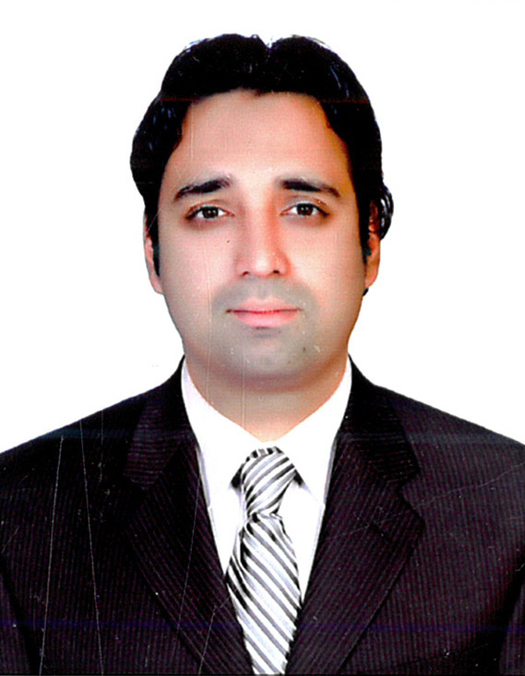
SYED
Syed.233591@2freemail.com

.

PROFILE

MBA qualified, Talented, self motivated, enthusiastic financial management and accounting professional possessing a proven record over total of 9 years of working in private sector with small enterprises to large groups with diversified businesses, and making a significant contribution within financial administration / accounting and office management including HR issues.

CORE COMPETENCIES

•Financial Accounts •Tally Software • Microsoft Office • Peachtree Software

PROFESSIONAL EXPERIENCE AND SIGNIFICANT ACHIEVEMENTS
THREE YEARS WORK EXPERIENCE AS AUDIT OFFICER (2008 till 2011)

Javaid Chaudhry & Co.
Certified Public Accountants,Auditors, & Tax Advisors

Duties & Responsibilities:
My role at Javaid Chaudhry & Co.
as an Audit Officer are as follows:-

- Engaged in the audit of small and medium scale organizations.
- Co-ordinate audit work with client and organize for staff to perform the audit
- Supervise and develop junior members of audit team.
4 Reports on the findings, conclusions and recommendation resulting from an audit or other investigations

THREE YEARS WORK EXPERIENCE AS ASSISTANT MANAGER ACCOUNTS (2012 to 2015)
UDL MEDICINE COMPANY

- Management of all the receivable and payable accounts.
- Preparation& maintenance of receivable and A/P vouchers.
- Checking the stock according to the purchase order.
- Allowing credit facilities to the customers.
- Monitoring Aging of the accounts payable.
- Tele the bank statements with the company records.
- Handling cash and posting the sales into the sales ledger.

TWO YEARS EXPERIENCE AS ADMIN OFFICER (2004 to 2006)
Punjab Highway Patrol

- Monitoring the duties of Punjab Highway Patrol officers.
- Managing and maintaining all duty schedules of patrol officers.
- Reporting the duty performances to the Superintendent of Police
- Maintaining the record of casual n medical leaves taken by patrol Officers.
- Giving necessary commands to patrol officers in emergency cases

ONE YEAR EXPERIENCE AS ASSISTANT MANAGER HR (2007 till 2008)
Punjab Highway Patrol

- Managing transfer postings of Punjab Highway Patrol Officers.
- Training and motivating the staff members.
- Managing Seminars to educate and train the staff members
- Determining applicant qualifications by interviewing applicants; analyzing responses; verifying references; comparing qualifications to job requirements.
5 Interviewing the applicants
6 Staff training.
PROFESSIONAL EDUCATION

MASTERS IN ECONOMICS (2012-2014)
islamia university bahawalpur
MBA( Banking & Finance ) 2010 -11
Allama Iqbal openUniversity,
Islamabad. Pakistan

PERSONAL INFORMATION

Skills: Communication skills & Management skills,
Interests & Pastimes: Travelling, Dinning out, Listening Music, Outing with family.
Born: Feb 24, 1985
Marital Status: Single

