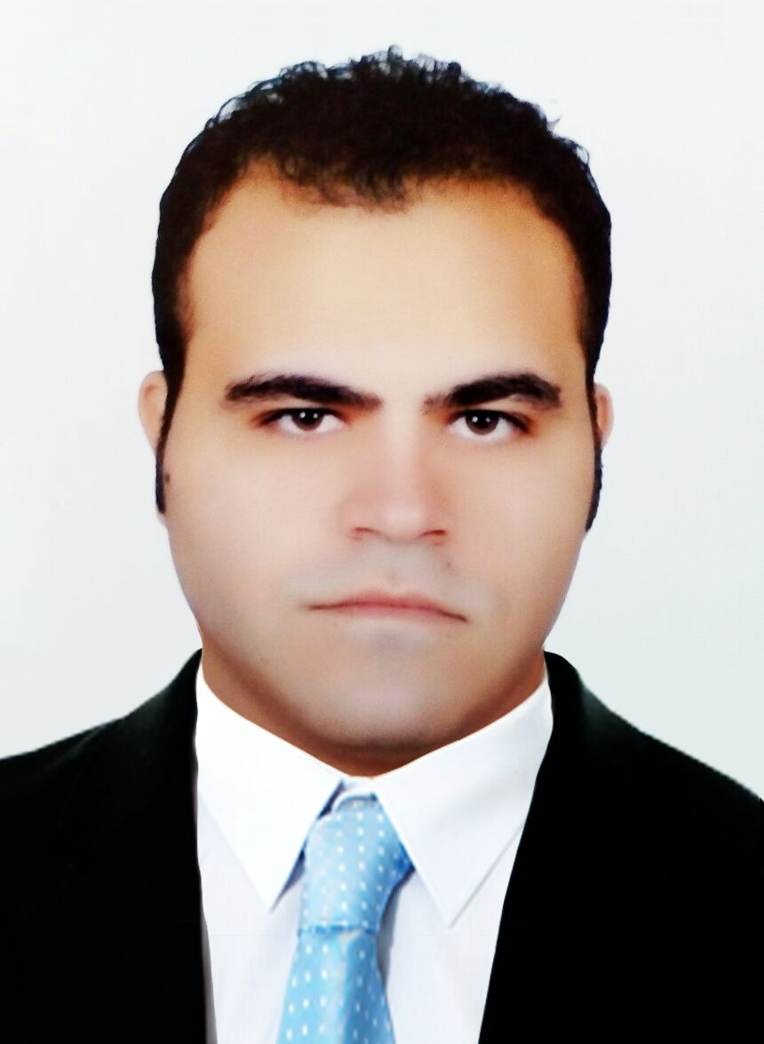
Mohamed
Mohamed.235121@2freemail.com

Jobs Experience:
1) At Ahcc Company for Computers Service:
from 2003 to 2005. As IT Coordinator -Sales
2) At Gamma Company for Computers Service:
from 2005 to 2007. As IT Support -Sales
3) At Al Hallal cooperation for Computers, Internet & media Service:
from Dec 2007 to Feb 2009. As IT senior coordinator- Customers service -Sales
4) At TEdata Company for internet Service:
from Mar 2009 to Oct 2009. As IT Support - Customers service
5) At Leader packaging Royal Turkey Company for Trading &Medical instruments.
from Nov 2009 to Jan 2010. As Advertiser
6) At Concorde El Salam Sharm El Sheikh Hotel:
from Mar 2010 to Sept 2011. As IT network support
7) At Ridgewood Egypt- for water desalination (American Company):
From Nov 2011 to Oct 2014. As I-T specialist , data analyzer& Customers service, programmer Vb2010,Ms DB Access2007, teaching ICDL courses for staff & responsible of: < troubleshooting, maintenance & installations > for : Networks - Routers - windows system - Emails system configuration - C panel - Emails configurations (outlook, IncrediMail, etc…..) - CCTV/Cameras system - alarms system - maximo system -installations (GPA) Program – communications H.W , multimedia. At Cairo Head office, sites: Sinai area "Taba-Dahab-nweiba-Ras matarma- Sharm el sheikh & Hurghada".
Obtained Courses:
1) Visual basic6, C++, MCSA 2003 at Technology high school.
2) Microsoft Office Access 2007: Microsoft certified
3) (Windows XP, MS Word & Excel) 2007 - KOICA (Korea international cooperation agency) Egypt Office.
4) C#.net 2008 Programming-Database Design-Ms SQL Server2008
-ASP.NET 3.5 -ADO.NET 3.5 at COMPUTEK Training Center.
5) OSHA 30 hours Training course.
Skills:
1- A vocational studies at the mentioned the advanced high school for 5 years in field of computer technology, software and hardware.
2- Multimedia devices installations .Exp for 10years
3- Windows application Programming. VB6 – vb2010.Exp for 6years
4- Network structure-installations-IP-troubleshooting .Exp for 10years
5- Electronics circuits .Exp for 7years
6- Database SQL-MS ACCESS structure .Exp for 10years
7- Cameras structure, installations &repairs. Exp for 5years
8- Quality management (ISO) Processes System.
9- Typing skills: English 40 wpm.
10- Operating Systems: MsDos / Windows XP / 2000 / vista / Seven / Eight.
11- Maintenance and Installations Hardware & Software (desktop, workstations, laptops, switches, routers, storage, access points, electronic circuits) Exp for 10years
12- Internet: searcher &advertiser.
13- Servers knowledge.
14- Office tools: MS office from 97 to 2007 (Word, Excel, Power Point, Access, Outlook)
15- Windows system troubleshooting – Spy wares-viruses - System check.
16-Routers configurations –DHCP-DNS-MAC.AD/IP SECURITY/FILTERS-FIREWALL/NSM.
17-MAILS configurations-SMTP-Income/Outcome mail sever- Etc…
18-NAT,PAT,AAA,VPN.
19-SQL sever 2008
20- All Cables processes – CCTV-LAN-PHONES-RCA-Audio-Video-USB-Etc…
Languages:
·Arabic (mother language)
·English (Fluent command of spoken and written)
Education:
1- High School: computer technical diploma - Graduate 2006
From: The Technical Advanced high school for Computer Technology
at Al Ismailia-EGYPT. - 5 years classes, Hw-Sw of Germany curriculum.
2- BACHELOR degree in Information systems-Graduated May 2010
Degree: Good
University of Future Academy Faculty. Cairo-Egypt.

Personal Qualifications:

·Being able to work in a stress-laden environment.
·Strong negotiation and interpersonal skills.
·Self Confident.
·Straight, persistent and clear about my objectives.

Other Information:
Birth date: 17.March.1985
Age: 30 years.
Gender: male.
Status: Single.
Visa: Tourist.

