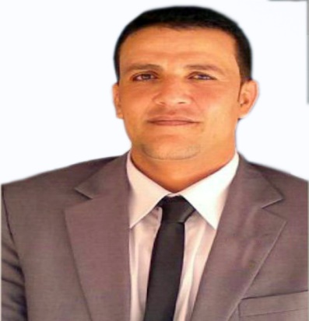
Ahmed
Ahmed.235561@2freemail.com

Objective | To get a challenging Librarian position in leading organization  To become a successful personality in the corporate world and give my hundred percent for the success of the organization  .
Education | - Bachelor of Libraries & Information Science  - Faculty of Arts --- Tanta university ( Egypt ) – May 2001
Professional Experience | - Authority - Feb 2013 to Present  Duties & Responsibilities :  • Ordering new materials  • Processing new library materials  • Copy cataloguing of library materials  • Staffing the reference desk & answering reference enquiries  • Staffing the circulation desk  • Providing library instruction as required  • Faculty materials processing and documentation  • Ensuring an atmosphere conducive to study is maintained  • Explaining and enforcing library rules and policies  • Providing technical and clerical support for serials and faculty materials  • Recording statistics and preparing statistical reports  • Responsible for opening and closing the library as required  - Emirates College of Technology (Abu Dhabi ) Feb, 2010 to Feb 2013  Duties & Responsibilities :  • Technical processing of the library’s informational material including skills such as cataloging, classification according to Library of Congress  • Classification according to the latest edition of the Dewey Decimal Classification Scheme and Library of Congress.  • Providing Current awareness and Reference Services to the users.  • Providing Circulation Services to the Users.  • Monitoring, tracking and recording the use of library equipment including books, periodicals, computers, audio-visual equipment and others.  • Taking full responsibility of the shelving process of all library materials.  • Develop and implements reading initiative to motivate and engage each student independent reading.  • Providing Professional development to teachers to investigate how technology and information skills can support curriculum and instruction  - Al-Jaber company (April 2006 – Feb 2010)  Duties & Responsibilities :  Checking quality of documents. • Monitoring processes.  • Producing listings. • Setting up project filling systems.  - Receiving and distributing all documents. Preparation transmittal sheets for Inspection Requests, Material and Filing etc.  - To ensure compliance with quality assurance requirements at all time.
Previous experiences | - Assistant Librarian in Tanta Culture Palace from June2001 To January 2002  - Librarian in Tanta culture Palace from February2002 To March 2004  - Librarian in Maaneya Primary School from July 2004 To April 2006  - Private company in Abu Dhabi from May2006
Training courses | - Academic IELTS Certificate ( U A E University – April 2010)  - Teacher license from Abu Dhabi education zone in librarianship Dept.  - Equivalent certificate from the Ministry of Higher Education, United Arab Emirates .  - Arabic Union Catalogue Membership/Role: Member – 2010
Skills | Skills Level Experience Last use  Computer skills Intermediate + 10 years 1 month or less  Teamwork Expert + 10 years 1 month or less  Communication Expert + 10 years 1 month or less  Problem solving Expert + 10 years 1 month or less  Technical skills Expert + 10 years 1 month or less
UAE / DL | Holding U A E Driving License Place of Issue: Abu Dhabi – Oct 2010
Languages | English : Academic IELTS Certificate ( U A E University – April 2010 )  Arabic : Native language
Personal information | - Birth Date: 12 / 3 / 1980  - Nationality: Egyptian  - Visa Status: Employment (Transferable)  - Easy going person with good attitude when dealing with others  - Dealing with work pressure professionally  - Delivering Results and meeting customer expectations

