Islam
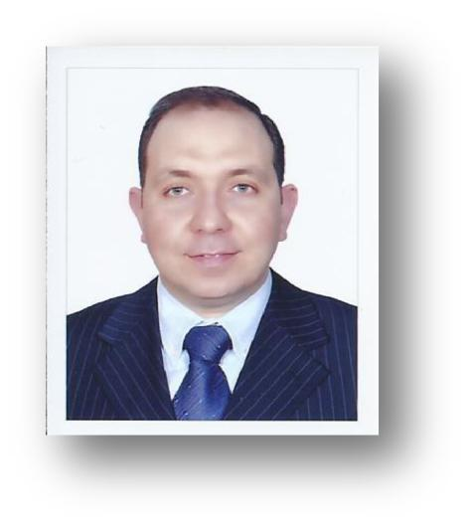
Islam.235609@2freemail.com

Personal Information:

- Nationality: Egyptian

- Date of Birth: 02/11/1979

- Place of Birth: Alexandria, Egypt

- Marital Status: Married

Objective:

Seeking an exciting opportunity to be a part of a company where I can utilize my skills, knowledge and experience.

Education and Certificates

- Bachelor of Pharmaceutical Science, Alexandria University June, 2002

- Master of Business Administration(MBA), Chifly Business School,Australia,2014

- HAAD ( Health Authority of Abu Dhabi ) licensed pharmacist UAE, Dec. 2004

- BLS certificate- American Heart Association (March-2013)

Skills:

- Experience of more than 12 years in the field of community pharmacy, Hospital and pharmaceutical company.

- Exceptionally good in practices and principle of administration and development.

- Profound ability to coordinate, manage and direct the technical and professional personnel.

- Strong ability to deal with the problems, identify the problems and implementation of the resolution.

- Good knowledge and ability of performance, supervision and training.

Work Experience:

Pharmacy branch manager, Insurance officer, Quality in-charge, Recruitment officer
Alain Pharmacy group-Alain-UAE (ISO9001-certified)

Dec. 2004 - present

- Awarded as the best Pharmacist in the group- 2010.

- Team Leader for Jawda Program requirements implementation.

- Team leader in the implementation of the requirements for the ISO certification and renewal of certificate.

- Managing the different operations within the work environment and guiding the teams under supervision for the proper management of the different operations including the inventory management, purchase, storage, dispensing the medicines and general items either on cash or insurance bases,……etc

- Maintain high level of application of the quality issues and guiding the teams under supervision for the proper management of the Quality and teaching and training the teams under supervision for the implementation and adherence and maintenance of the quality aspects.

- Dispensing medications with excellent skills for patient counseling.

- Managing the inventory of the branch including the purchase and preparation of the LPO of the required inventories and monitoring of the expiry and storage conditions.

- Monitoring the sales of the branch including cash and credit and insurance sales.

- Interview and selection of the new candidates.

- Full responsibility of Training and supervision of the implementation of training programs and practice and adherence of the newly taught instructions.

- Design of the Orientation programs for the newly hired members teaching them the general policies and procedures and the different operations running in the work environment.

- Full responsibility for the insurance processes with Excellent knowledge and practice in dealing with all the insurance companies such as: Daman, ADNIC, NAS, Nextcare, AXA, ALICO, FMC, Amity, Wapmed,

Globmed……….etc going through all the procedures of dealing with the insurance prescriptions for pre-approval through the different ways of communication and excellent experience with the different PBM systems and links and expert of e-claim.

- Excellent experience of dispensing insurance prescriptions and the preparation of the e-claims and the final claims for the different insurance co.

- Full responsibility for the training of the new staff and advanced training for the old staff for all the steps and procedures of the insurance.

- Preparation of the different monthly reports and sheets required by the HAAD and by the GM of the group and the different head departments in the group.

Medical representative/Product specialist
Feb.2004 -Nov. 2004
Merck AG, Alexandria-Egypt

(Merck-serono now)

- Responsible for the promotion of cardiovascular product concor® (Bisoprolol)in Alexandria-Egypt.

- Arranging appointments with doctors, pharmacists and hospital medical teams.

- Delivering presentations to doctors, practice staff and nurses in GP surgeries, hospital doctors and pharmacists in the retail sector.

- Building relationships with medical staff.

- Performing product demonstrations, installations, and application support.

- Improving product knowledge and disease awareness

- Gathering, analyzing and delivering information from the field to allow the company to develop strategies and products appropriated to the Quality and Safety Testing market.

- Launched a new products in cardiovascular area:.

  - Lodoz® (Bisoprolol/Hydrochlorothiazide) as a new antihypertensive medicine.

Pharmacist in-charge | 2003-2004
Chest Hospital-Egypt.

- Responsible for all the management duties and operations of the in-patient pharmacy.

- Training and supervision of the staff.

- Managing the inventory of the pharmacy including the purchase of the required inventories and monitoring of the expiry and storage conditions.
- Dispensing medication for in-patients.

- Preparation of the monthly report of the movement of the medication to the Ministry of Health.

Second Pharmacist
2002-2003
Al Akramen Pharmacy-Egypt

References

Available on Request

