RESUME

liju

lilu.236352@2freemail.com
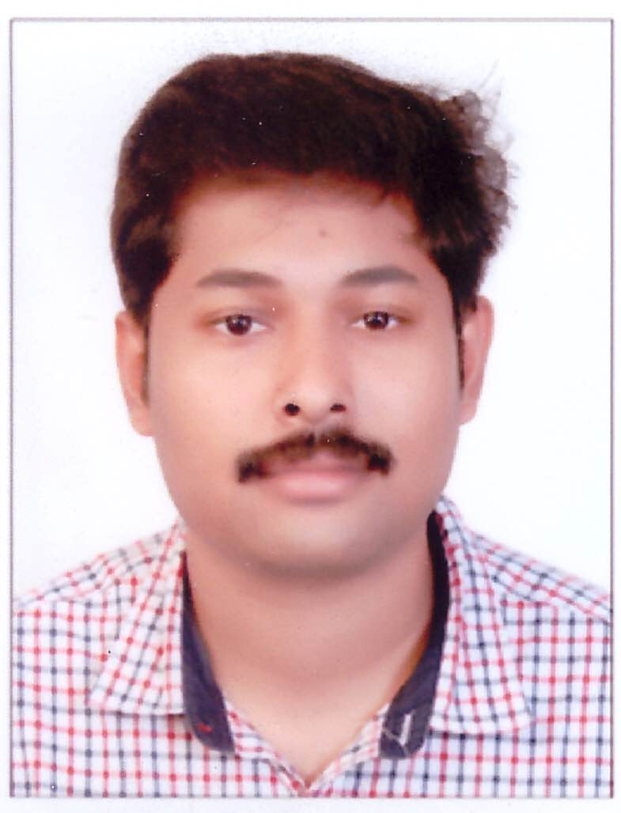  Hobbies and interests :  - Listening to music, watching ,Reading, documentaries, movies  - Playing Football, Cricket and Chess  Language Proficiency:  - English  - Malayalam  - Hindi  - Tamil | Career Objective  Being a committed team player to contribute towards the growth of the organization, based on my expertise and to further my personal capabilities by learning from the new exposure within the structured framework of the organization.  Career Profile  - I have total 3 years of experience as a Mechanical Engineer in Maintenance Department. I worked in RIYADH CABLES GROUP OF COMPANES, RIYADH from Nov 2012 to Nov 2014  Career Skils and Job responsibilities  I gained experience in the maintenance of major Cable Manufacturing Equipment’s in CCV line, stranding machines, drawing and annealing machines, Lead Extruders, Screening Machines, Taping Machines, Drum twister Machines ,Slitting Machines and pneumatic/hydraulic systems associated with all.  I also obtained substantial experience in pipe line works, oil burners, compressors, Chiller units and Nitrogen production plan Equipment.  - Give day to day technical support for breakdown diagnostics & repair, including risk and failure analysis  - Design and develop engineering components  - Improve & update the maintenance (preventive and predictive) program regularly Identify, update & continuously improve reliability  - Identify, select & update the required spare part list.  Controlling work performance & monitoring work quality and taking corrective action to solve any problem rapidly.  Academic Profile  - B-E in Mechanical Engineering  - Marks obtained : 74%  - Institute : SCAD College of Engineering And Technology  - Year of Passing: 2012  Industrial Training  - Successfully completed a 7 day Implant Training in Southern Railway Thiruvananthapuram Division during January 2011  Project Work  - Successfully completed a mini project in the field of design and fabrication titled “Automatic can crushing Machine” under the supervision of Mr. ALLWYN KINGSLY GLASTSON B.E, M.E, Professor, SCAD College of Engineering and Technology, Tirunelveli.  - Successfully completed final year project in composite materials on “Composite material ZN-AL Alloy reinforced with Sic particulate”under the supervision of Mr.ALLWYN KINGSLY GLASTSON B.E, M.E, Professor. SCAD College of Engineering and Technology, Tirunelveli  COMPUTER PROFICIENCY  - Design Software’s : Auto Cad 2011,Solid works(basics)  - Application Tools : Microsoft Word, Excel, power point.  - Versified at using operating system of windows 7,8,2000 and XP  Personal Strength  - Good communication skills.  - Ability to take on responsibility and work as a team leader.  - Negotiation Skills and hardworking nature  - Good problem solving skills.  - Self-motivated & able to work under pressure.  - Highly energetic & hard work responsibility.

