RAHUL 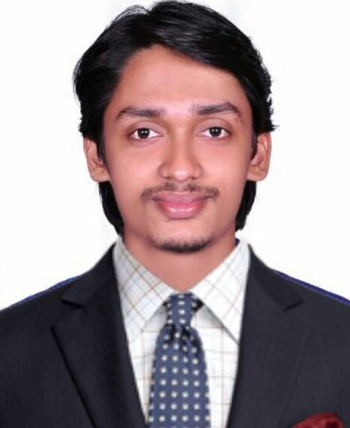
Mechanical Engineer
Al Karama, Dubai-UAE
rahul.236370@2freemail.com

“Make the changes that you want to see in the world.”

Mechanical Engineer with first class honor and having 19 months of experience in oil and gas field and HVAC, would like to be in a position where my job qualifications are well suited. So that my experience, professional skills and interpersonal skills can be best utilized for the growth of the company where I am a part of.

EXPERIENCE
BPCL Cochin Refinery Kerala, India
Piping Supervisor May 2016-Jul 2017

- Inspection of site as per isometric, GAD and P&ID, fabrication of pipe spool, organize inspection of welding, coordination for the NDT, installation of piping.
- Responsible and acknowledged for Implementing Hydrostatic tests, SR test, Radiography ,Hot tapping, Blinding on lines
- To assist pre commissioning and commissioning activities of piping systems completed include flange joint leak test, air flushing, water flushing, nitrogen purging etc.
- Responsible and acknowledged to select pipes, valves and fittings as per approved piping standards and codes
- To prepare the Bill of Material (Material Take Off) as per drawing.
- Reporting - Attend schedule project meetings, present management with status updates, potential issues and project risk.
- Responsible for conducting daily tool box talk, maintaining proper housekeeping for the work location.
- Prepare one week look ahead schedule that need to be submitted to the maintenance department for the review and input to draw up to the final execution plan for the piping department.

Prime MEP Solution Kerala, India
HVAC Engineer Jul 2017-Nov 2017

- Work experience in HVAC, Fire Fighting designing and Heat load calculation using E20 method
- Site supervision & inspection as per approved shop drawing.
- Check the material submittal, method statement for installation, site work & material delivery.
- Good knowledge in AutoCAD, career HAP, McQuay Ductsizer, E20, ESP calculation, Pump head loss, Storage tanks, Fire piping, Supply and Drainage lines.
- Strong proficiency in architectural and engineering drawing interpretation and quantity take off from the drawing.
- On job training in Kochi metro station, Info park HVAC.
- Estimation and preparation of BOQ.

EDUCATION
SIMAT (Sreepathy Institute of Management and Technology) Kerala, India
B.Tech in Mechanical Engineering with CGPA 7.6 (First Class) Jul 2012-May 2017

- Relevant Courses: Fluids, HMT, HVAC, Material Science, Finite Element Method
- Evaluate final products overall performance and safety
- Engage in lifelong learning and develop new theories or methods
- Design systems and components that meet needs and requirements
- Conduct experiments methodically, analyze data and interpret results
- Alter and modify design to meet requirements and to eliminate malfunctions
PROJECT
Velocity boundary layer analysis over a flat plate using Ansys-Fluent (6.3) Kerala, India
Jan 2016-May 2016
- Project was carried out to analyze and study boundary layer developed over nose of a F1 car. The result predicts minimum drag at lower elevation of nose.

SKILLS

- Auto CAD, Catia v5, Ansys-fluent, Gambit, Latex, Carrier HAP
CERTIFICATIONS

- Diploma in HVAC, Fire Fighting and Plumbing
- Diploma in AutoCAD (2D, 3D) 2016, Catia V5

PERSONAL PROFILE

- Nationality :INDIAN
- DOB :14/05/1994
- VISA STATUS :Visiting Visa (Expires on Feb-02-2018)
- Languages Known :English, Malayalam, Hindi

