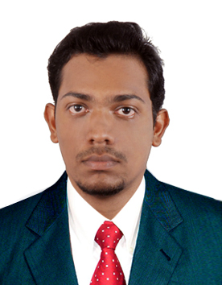
238447@gulfjobseekers.com

CAREER FOCUS
Intend to build a career with leading corporate of Hi-tech environment with committed and dedicated people, which will help me to explore myself fully and realize my potential. Willing to work as a key player in challenging and creative environment. Seeking a good profession to extract my knowledge in Mechanical Engineering field.

WORK EXPERIENCE
- PIPING QUALITY CONTROL INSPECTOR – QUALIMATIONS, INDIA
FROM 9TH SEPTEMBER 2013 TO 26TH SEPTEMBER 2014
In Qualimation as piping quality control inspector for checking the Welding inspections, Structural, piping inspections, visual, dimensional, and witness Nondestructive tests on process piping inspection by NDT methods [ UT, MT, and PT] hands on experience .Isometric and Structural Drawing, International codes & standards ASME & ASTM.Material identification and inspection report preparation and to offer client inspection.

EDUCATIONAL QUALIFICATION

Qualification | Board/University | Year of Completion
BE Mechanical Engineering with  70% Marks | Nehru Institute of Engineering Technology- Anna University Coimbatore | 2011
Higher Secondary  (12th std) with  60% marks | Board of Higher Secondary Examination - Kerala | 2007
SSLC  (10th std)  with 60% | Board of Higher Secondary Examination - Kerala | 2005

CERTIFIED COURSE
- Done a Certified course in Computational Fluid Dynamics(CFD) in JetWings Technologies Bangalore
- Done a Certified course in NDT (LEVEL I & II) , QA & QC in Qualimation
- Done a Certified course in GD&T, NX CAD , NX NASTRAN in CADD Centre Bangalore
- Done a Certified course in Professional HVAC Training Programme & HVAC Design And Drafting in ACE Training Institute bangalore
- Done a Certified course in Foundation Course in CATIA Modeller in CADD Centre Coimbatore

COMPUTER SKILLS

Operating system : Windows Xp, Windows 7, 98, 2000.
Application Software : Solid Works , Catia V5 , NX-Nastran , NX-Cad , MS Office.

AREA OF INTEREST

- NDT ,QA & QC
- Production
- Manufacturing
- Hvac
- Design

PERSONAL APPRAISAL

- Sincere, Honest and dedicated
- Disciplined and sociable
- Hardworking, Self motivated and result oriented
- Ability to work under pressure.

CERTIFICATION

I, Adarsh Ravindran , declare that the above information is true and correct to the best of my knowledge and nothing has been concealed or distorted. I request you to kindly intimate the good opportunities as and when they come.

