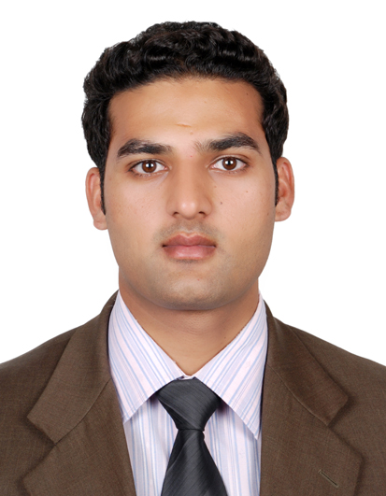
239136@gulfjobseekers.com

Objective:

Well-qualified & dedicated, self-assumed, result oriented, quality conscious, responsible, honest, working in group as well individual situation with high standard of discipline.

Education:

- Master in Management (Marketing)

Willington University PLA (USA)

Marketing Specialization Certificate.
- Sales and Marketing specialization Certificate
American Institute of Business Management Dubai UAE
- Bachelor in Commerce (Business Management & Commerce)

Allama Iqbal Open University Federal Govt. Islamabad Pakistan
- Diploma in PGDIT (Administration)

Govt. Skill Development Council, Pakistan

Achievements

- Letter of appreciation on “outstanding performance 2014” from CEO Ms. Cleopatra Abdulla (Board member of Patra Foam Group of companies).
- Certificate of Achievement on Outstanding Performance and Commitment for the year of 2011 by CEO Mr. Rick Pudner(Emirates NBD)
- Direct Sales Force Certification Curriculum for the year of 2011 by Head of DSF - Mr. Tala Al Mazrooei and Head of Learning and Development Mr. Shekhar Sarwat.
- Lunch Invitation from CEO Mr. Rick Pudner on Outstanding performance for the year of 2011.
- Certificate of Achievement on “Creating Truly Memorable Experience” by Training Manager Mr. Saeed Shah and Director HR Mr. Moin Uddin (Islamabad Serena Hotel).
- Commendable Service Appreciation letter by Director F&B Mr. Usman Sadiq on Admirable and distinctive services & support at “South Asian Association for Regional Cooperation (SAARC)” Conference June 2010
Experience:

Al Futtaim Motors Toyota Abu Dhabi, United Arab Emirates
SME Sales Executive (Nov 15 –Apr 16)

- Intermediate segment fundamental outdoor business activity
- SME cliental Tracker & organization system planned diary
- Case studies to prepare Fleet proposal and presentations
- Negotiations and Finalizing agreement
- Preserving complete CCS, sales record for future planning.
- Dealing in system diary data for company’s marketing campaigns and other activities.
- Exceptional knowledge of UAE local market for Automotive Industry.
- Direct reporting to HOD, SM & BM for respective business consideration.
- Head to Toe business sales process, finding the business opportunities for procurement new fleet, Traffic Department associated works, bankrolling and insurance as well.

2GIS Advertising LLC Dubai, United Arab Emirates
Project Business Development Consultant (Nov 14 – Jul 15)

- Managing brand awareness through daily pre-planned meetings with CEO’s, GM’s and other Decision Makers.
- Handling the whole kit and caboodle for more than 300 mixed small and corporate Clients.
- Providing sales and marketing services at B2B & B2C Level.
- Experienced in Organizational Customer Service Module.
- Sustaining Company advertising Business.
- Managing DSR, WSR and MSR reports of team.
- Proficient in to grip customer development without failure, and guest complaint effectively and efficiently under the SOP’s of the company.
- Please visit –

CMS Mattress Industries LLC (Patra Foam Group) Dubai, United Arab Emirates
Sales Manager (Nov 13 – Oct 14)

- Manage to start the business from trash, maintained 10 e-commerce & 9 hotels corporate clients in less than one year “of net worth of more than one million”.
- Handling all supervisory works for more than 50 corporate Customer’s Service & Sales.
- Practicing Organizational CCS, sales, retails and online webbing deals.
- Experienced in Organizational Customer Service Module.
- Managing CCS Compliance and SOP's.
- Sustaining Company E-commerce Business.
- Maintaining complete CCS, sales record for future planning.
- Hiring & firing staff based on manpower requirement.
- Ardently involve in bulk orders booking and Shipments activities for Whole GCC Sector as an extra support in suave operational chores.
- Deep knowledge of import and export goods from UAE to other part of the world.
- Direct reporting to MD, managing departments of Sales, Customer Cares, Transportation, production and Administration works.
- Please visit –

Emirates NBD Dubai, United Arab Emirates
Retail Banking Supervisor (Mar 11 – Oct 13)

- Expertise in SME accounts, PDC, Business and Merchant Loans.
- Handled Payrolls and credit card accounts.
- Target Oriented outdoor bank financial Services profile.
- Provided excellent customer services to maintain Bank Service standard and long term relationship with the customer.
- Deep knowledge of back-office processing for personal loans, credit cards and SME loans.
For more information –

Islamabad Serena Hotels Islamabad, Pakistan
Food and Beverage Service (Jul 09 – Mar 11)
- Worked in F&B Department in different Units,(Cashier and Night Shift In-charge at Zamana Restaurant- 24 Hour Coffee Shop, Order Taker at Room Service, Cashier, Order Taker and Shift In-charge at Rakaposhi ~Pastry Shop, Shift In-charge at F&B Pantry and have experienced of F&B Banquet Unit).
- Practice in customer development without failure.
- Handling guest complaint effectively and efficiently
- Deep knowledge of Events operation management (Wedding, Birthday, Marriage Ceremony and National Days).
- Knowledge about Food and beverage, hospitality amenities, features and all other services offered by the hotel.
- Deal with Micro and Debts.
- Also have knowledge about Fidelio.
For more information –
Skills
- Operating Systems:
Data Base Management System, Operating system (DOS, Windows, Linux), Networking, Object Oriented Programming, Web Page Designing (HTML, DHTML, Front Page, Flash), Functioned DAPS, Micros and Opera systems. Microsoft Office Suite (Word, Excel, PowerPoint, Outlook), MS Office appliances Training, Print Artist, and Internet Operating.
- Personals:
Result Oriented, hardworking, quick learning ability, flexible, reliable, self-motivated and above of all passionate to do quality work.

Personal Information
Nationality Pakistani
Visa Residency Visa (NOC) Transferable

