CURRICULUM VITAE
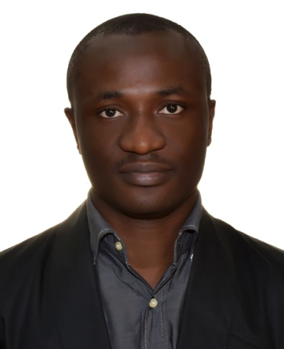
E-mail: alaneme.239271@2freemail.com
Dubai, UAE.
BIO-DATA
ALANEME
Profession: Optometrist
Sex: Male
Date of Birth: 6th December, 1988
Marital Status: Single
Language: English (excellent)
Nationality: Nigerian
Present location: UAE (Dubai)

PROFILE:

- A resourceful and committed Optometrist with good computer/ICT knowledge.
- A vibrant Optometrist with good organizational and working ethics.
- Ability to work in a professionally challenging environment and willingness to learn.
CAREER OBJECTIVE:
To always put in my best in the practices of my profession in truth and humility, also actualizing the goal and objective of my employer by devoting my time, energy and intellectual capabilities.

PROFESSIONAL LICENSE OBTAINED:
- DHA License Eligibility(Ref: DHA/LS/2382017/742080) valid till November 2018
- ODORBN License (Optometrists and Dispensing Opticians Registration Board of Nigeria) (ODORBN/2794/2013)
INSTITUTIONS ATTENDED WITH DATE:
- Imo State University, Owerri Nigeria
Doctor of Optometry (O.D) 2006-2012
- Basic Comprehensive Secondary School, Abakpa-Nike
Senior School Certificate 2000-2006
- Station Urban Primary School, Abakaliki
First School Leaving Certificate 1999
CERTIFICATES OBTAINED WITH DATE:
- NATIONAL YOUTH SERVICE CORPS (NYSC) 2015
- DOCTOR OF OPTOMETRY (O.D) 2012
- NECO 2006
- FIRST SCHOOL LEAVING CERTIFICATE 1999

WORK EXPERIENCE:
Optometrist at Al jaber Optical Dubai UAE (Optical Retail) 2017- till Date
Optometrist at Shalom Medical and Eye Clinic 2016-2017
Optometrist at Cherith Pearl Eye Foundation (Optical Retail) 2015-2016
Optometrist at General Hospital Onicha, Ebonyi State (NYSC) 2014-2015
Optometrist at Obule Medical Centre, Sapele (internship) 2013-2014
Outreaches Powered By Optometry Department Nigeria 2011-2012

SPECIAL SKILLS:
- Primary eye care assessment and visual analysis.
- Proficient in refraction (Subjective & Objective) and pathological diagnosis.
- Retail Optical sales and making best recommendations to customers.
- Fitting contact lenses (soft, toric).
- Excellent Customer Service.
- Assist Sales in marketing brands and reaching Targets.
- Ability to work with little or no supervision, effective communication skill, obedience, effective use of my initiative and team work.
- Good computer and ICT knowledge.

TRAININGS ATTENDED WITH DATES:

- Optical Sales Consultant Training (July 2017)
- Optical lens training (Rodenstock, Hoya & Egma lens) (August 2017)
- Perfect history taking by Moorfied Hospital (September 2017)
- Contact lens training (BIO-TRUE B&L) (October 2017)

HOBBIES:
Reading, Research, searching the net, planning and Meeting people.

