239560@gulfjobseekers.com

Senior QS Professional
A result-oriented professional with excellence in implementing quality mechanisms to deliver desired output; Proficient in running successful method-oriented operations and taking initiatives for business excellence through process improvement
|QUANTITY SURVEYING |PROJECT MANAGEMENT| SITE OPERATIONS|
Location Preference: UAE-Abu Dhabi

AREAS OF EXPERTISE  Quantity Surveying  Cost Management  Contract Management  Site Operations  Cost Engineering  Project Management  Tendering  Property Valuation & Estimation  Liaison & Coordination  Documentation & Reporting  Resource Planning  Techno-Commercial Operations | PROFILE SUMMARY  - A result-oriented professional with nearly 13 years of experience in the areas of Quantity Surveying, Project Monitoring & Execution in construction sector  - Proficiency in Infrastructure Works, Concrete Work, Machine Foundation and Industrial Roof Steel Structure  - Skilled in handling MEP Works for Hotel, Villas, Commercial, Retail & Recreational Centres, Marina and Spa  - Versatile in managing functions related to Pre-Contract & Post-Contract, Invoice & Variation Claims, Property Valuation, Estimation, Cost Engineering, Project Tendering, Cost Management and Site Operations with a reputed organisation  - Resourceful in planning & executing construction projects with a flair for adopting modern construction methodologies in compliance with quality standards  - Proficient in devising the detailed and abstract estimates, bill of quantities, alignment plans, longitudinal and cross sectional drawings including cross and longitudinal profile correction  - Abilities in liaising with clients, architects, consultants, contractors, sub-contractors & external agencies for determining technical specifications, approvals and obtaining statutory clearances  - Efficient organizer, motivator, team player and a decisive leader with the ability to motivate teams to excel and win

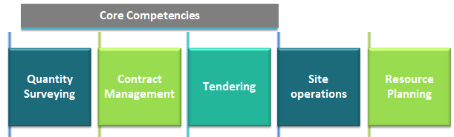

ORGANISATIONAL EXPERIENCE
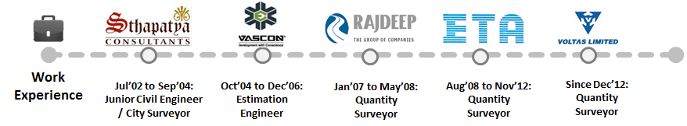

Since Dec’12 M/s. Voltas Limited-A Tata Enterprises, UAE as MEP Quantity Surveyor
Aug’08 to Nov’12 Emirates Technical Associates, M & E Division Abu Dhabi, UAE as MEP Quantity Surveyor
Jan’07 to May’08 M/s. Rajdeep Buildcon Pvt. Ltd., Pune, Maharashtra as Civil Quantity Surveyor
Oct’04 to Dec’06 M/s. Vascon Engineers Limited, Pune, Maharashtra as Civil Estimation Engineer
Jul’02 to Sep’04 Sthapatya Consultancy Amravati, Maharashtra as Junior Civil Engineer / City Surveyor

Key Result Areas:

- Monitoring & controlling projects with respect to cost, resource deployment, time over-runs and quality compliance to ensure satisfactory execution of projects
- Preparing:
- Contractual claims from contract documents, site instructions, correspondence, drawing revisions and change in specification of material and so on
- Variation Orders for changes in the contract scope and Certification from Consultant
- Formulating & implementing stringent systems and quality plans / manuals to ensure high quality standards during all stages of project
- Ensuring adherence to quality standards, maintaining all related documents as well as practicing the quality standards with key emphasis on improving quality
- Generating periodic status & cost reports for apprising management of project progress; reviewing, analysing contract financial data for facilitating development and proceedings
- Keeping record of all the back charges imputable to vendors or any third party agency; listing the resource needs for projects, after considering the budgetary parameters set
- Coordinating activities like scheduling of project, monthly budgeting, monitoring as per master plan, project closing and analysis of bought out materials
- Developing specification for subcontractor works, Preparation of work orders & BOQ's, Preparation of cost estimates & Finalization & approval of materials from Client/Consultant
- Anchoring site construction activities to ensure completion of project within the time & cost parameters and effective resource utilization to maximize output
- Arriving new / star rates for non-bill of quantities items and other day work claims
- Attending commercial meetings with client, negotiating and agreeing additional claims
- Collecting / recording event details from site to establish variations / contra charges and so on
- Ensuring execution of various commercial activities within set time, quality and terms & conditions in the prime contracts management manual

Highlights:

- Executed “The Ritz Carlton Hotel Abu Dhabi-Grand Canal” through measures such as Re-measurable Contract which resulted in additional benefits to the company within given time period.
- Implemented process enhancement initiatives through measures such as divided area between team for full attention on each activity that resulted in to track accurate site changes & re-work which benefits to increase revenue for the company.
- Acknowledged with an appreciation letter from manager for best performance on the contribution on above project in ETA.
- Steered the implementation of quality initiatives such as daily site visit to ensure the activities & maintaining drawing revisions update that instilled basic quality philosophies of doing things right the first time, resulting in an 90% reduction in company rework cost

PROJECTS HANDLED

At M/s. Voltas Limited-A Tata Enterprises
- YAS Retail Mall
- PMC / Cost Consultant: Jacob International Holding
- ENGG: AECOM
- Main Contractor: Six Construct

At Emirates Techinical Associates
- The Ritz Carlton Hotel Abu Dhabi-Grand Canal
- PMC: MACE International
- ENGG: OTAK International
- Cost Consultant: - NEA & Partner

At M/s. Rajdeep Buildcon Pvt. Ltd., Pune
- Construction of industrial project for M/s. Cummins India Ltd., Pune

At M/s. Vascon Engineers Limited, Pune
- Construction of Industrial Project Suzlon Energy Plant Chakan Pune

At Sthapatya Consultancy Amravati
- City Survey for Raipur City, Capital of Chhattisgarh, Chandrapur, Wani, Morshi City (MH)

MEMBERSHIP/ COURSE ATTENDED

- Pursuing a Certificate Course in Cost Engineering, AACE Conducted by Association for the Advancement in Cost Engineering International USA at the Chicago Training & Consultancy Abu Dhabi, UAE

EDUCATION
Pursuing Bachelor’s Degree in Civil Engineering through Distance Learning Education

2002 Diploma in Civil Engineering from Government Polytechnic, (An Autonomous Institute of Technology) Amravati, Maharashtra

TRAININGS & WORKSHOPS ATTENDED

- Attended Two Days Training Program on “Quantity Surveying” Sponsored by ETA HRD Division on 28th & 29th March -2012 at Yas Island Site, Abu Dhabi, UAE
- One Day Workshop on “Environment and Pollution Awareness” Sponsored by the ACC Mumbai

SEMINAR & PAPER PRESENTATION
~Grouting as a Structural Repair, Retrofitting & Strengthening Technique Seminar & Project in DCE
~Detailed Survey for “National Highway No.6 Amravati-Nagpur in DCE
~Preparation and submission of Technical Paper on Risk Management in BOT Projects for AACEI

IT SKILLS
- Proficiency in:
- Windows XP & Windows 98
- AutoCAD 2007, MS Office Suite, Word & Excel
- ERP Data Entry & Internet Functioning

PERSONAL DETAILS

Date of Birth: 18th July 1982
Nationality: Indian
Marital Status: Single

