A. MOHAMED MUKTHAR
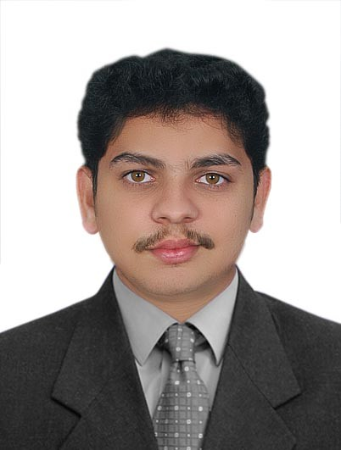

Photo

ADDRESS
2/61, Main Road,
Avoor P.O.,
Thiruvarur (Dt), PIN – 612 701
Tamil Nadu, India.

E-MAIL: mohd.muktharsa@gmail.com

PROFILE

Hardworking and quick individual seeking an engineering position in a reputed organization that offers a challenging job and opportunity to prove my credentials towards the benefit of the management and towards growth of an organisation.I wish to contribute my knowledge of various processes & methods to profit the company wherein I can further move towards my professional advancement.

PROFFESIONAL EXPERIENCE

ROVE AUTOMATION & INST. WORLS LLC. September, 2013 – December, 2014
Design & Estimation Engineer
U.A.E

- Designing Schneider Electric’s C-Bus/EIB KNX lighting control system for Hotel/Residential/Office Building.
- To carry out Instrumentation design & detail engineering activities and execution of BMS System as per the required automation control.
- Preparation of Material & Technical submittals, Shop drawings, supporting documents & obtaining consultant’s approvals.
- Design & Engineering of Lighting Control System, Guest Room Management System, CCTV System & Access Control System
- Cost estimation & Value Engineering of the project
- Co-ordination with main contractor and suppliers of third party systems to be monitored and/or controlled by BMS, Coordinating the commissioning activities on site.
- Site inspection for lighting control/GRMS/Structured Cabling/CCTV/Access control System design if any.
- Building relation with Estimation team of the contractors.
- Assist in project management.
- Supervision of installation works at site
- To Support for ISO Certifications and responsible for all re-certifications
POLAR ELECTRICALS LTD. July, 2011 – August, 2012
Electrical Design Engineer
India

- Confer with engineers, customers and others to discuss existing or potential engineering projects & products.
- Design, implement, maintain and improve electrical instruments, equipment, facilities, components, products and system for commercial, industrial and domestic purposes.
- Operate computer assisted engineering and design software & equipment to perform engineering task.
- Direct and co-ordinate manufacturing, construction, installation, maintenance, support, documentation & testing activities to ensure compliance with specifications, codes and customer requirement.
- Perform detailed calculation to compute and establish manufacturing, construction and installation standards and specifications.

PROJECT EXECUTION IN UAE

- Dubai Police Building, Al Barsha, Dubai - Stand Alone Motion Sensor – Theben Product (Design, Installation, Testing & Commissioning)
- Villa Myra & Villa Pera - Stand Alone Motion Sensor – Schneider Product (Design, Estimate, Installation, Testing & Commissioning)
- Al Fattan Crystal Tower – Lighting Control System – Schneider Product (Design and Estimate)
- Al Amal Psychiatric Hospital, Dubai - Lighting Control System – Schneider Product (Design and Estimate, Shop drawing)
- Emirates Printing Press, Dubai - Lighting Control System – Schneider Product (Design and Estimate, Shop Drawing)
- Rashid Hospital - Lighting Control System - Qlite Product (Design and Estimate, Shop Drawing)

ACADEMIC QUALIFICATIONS

Bachelors of Engineering July, 2007– Dec, 2011

- Four years Degree in Electrical & Electronics Engineering, from Anna University, Thiruchirappalli Chennai, India.

PGD in Industrial Automation
- Post Graduate Diploma in Industrial Automation (PGDIA) at Prolific Systems and Technologies Pvt. Ltd., Chennai, India.
Foundation in Electrical CADD
- CADD Centre, Kumbakonam, India.

PROJECTS

Project Title: Fiber Optics Based Speed Management

- Description: The project helps in speed management of motor using Optical Fiber & PIC microcontroller. Optical Fiber is the basic transmission medium at which the control inputs are given from required distance.

TRAINING & WORKSHOP

- Implant training in Dharangathara Chemical Works (DCW) for fifteen days in Tuticorin, India.
- Internship Training Workshop on Renewable Energy Sources & Energy Conservation organized by Technical Training and Development Centre, TNEB (TANGEDCO)

ADDITIONAL SKILLS & HABITS

- Flexible, positive attitude and willingness to collaborate with others.
- Qualified Low Voltage Building Systems (Lighting Control, Guest Room Management, Home Automation, CCTV, Access Control System) professional with more than 1 year of experience
- Time management skill. Ability to perform physically demanding work. Strong Oral and Written Communication Skills.
- Microsoft Office& DCA.
- Auto CADD 2010 and 2011
- PLC

I hereby certify that the above information is true and correct to the best of my knowledge and belief.

A.Mohamed Mukthar
APPLICANT

Passport Expiration: 22 February, 2020
Visa Type: Tourist | Visa Expiry: 05 September 2015
Place: Dubai

