RAJAN.242113@2freemail.com 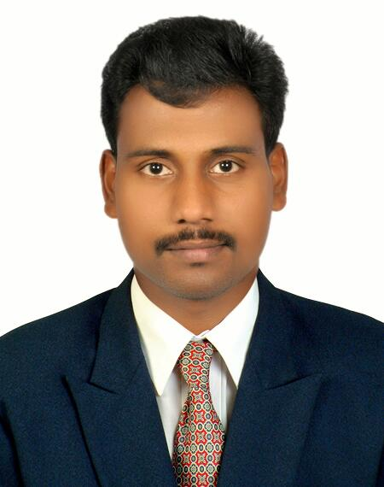
RAJAN

CAREER OBJECTIVE:

To strive for a challenging job in a progressive organization, where I can contribute and build my professional career along with the growth of organization.

ACADEMIC PROFILE:

Secondary Education

➢ 2002-2003
BHSS PUNALUR
Higher Secondary Education
RASHTRA MANDIRAM PARALLEL COLLEGE , KADAKKAL
➢ 2003-2005
Bachelor Degree
➢ 2006-2009
B-COM , ASBM INSTITUTE COCHIN
Master Degree
➢ 2009-2011
MBA ( HUMAN RESOURCES)
MBA ( MARKETTING) , ASBM INSTITUTE COCHIN

TECHNICAL QUALIFICATION:

➢ 2005-2006
- Diploma in Computer Hardware & Networking.
CYBER COMPUTER EDUCATION , ANCHAL
SOFTWARE SKILLS

- DTP, MS Office , PHOTOSHOP

STRENGTHS:

➢ Leadership Skills.
➢ Self Confidence, Patience.

EXPERIENCE1E:
  
    ➢ Working in KALBA HOSPITAL ( JCI International Quality USA
Accredited Hospital ) in SHARJAH MEDICAL DISTRICT as Clerk
(Sep 2013 till Continuing)

    ➢ Worked in HDFC BANK Kollam as a DSA Co- ordinator in 2 years

    ➢ Worked in BHARTI AIRTEL (Broadband & Telecom Services)
Trivandrum as Technical Engineer in 2 years
➢ Worked in VISWAS EXPORTS, Kollam as Service
Engineer in 1 1/2Year
LINGUISTIC ABILITY:

➢ English (Read, Write and Speak)
➢ Arabic ( Speak)
➢ Hindi (Read, Write and Speak)
➢ Malayalam (Read, Write and Speak)
➢ Tamil (Speak)

HOBBIES:

➢ Editing & Configuring Windows Operating Systems
➢ Internet Browsing & Searching for new knowledge
- Reading

PERSONAL PROFILE:

Age : 27 yrs

Date of Birth : 10-05-1988

Sex : Male

Religion : Hindu

Nationality : Indian

Martial Status : Single

Declaration

I hereby declare that the above-mentioned information is correct up to my knowledge and I bear the responsibility for the correctness of the above mentioned particulars.

