Gulfjobseeker.com CV No: 1458870
Mobile +971504753686, +971505905010
cvdatabase[@]gulfjobseeker.com

To contact this candidate use this link
http://www.gulfjobseeker.com/feedback/contactjs.php

SUMMARY
An Architect with +5 years of experience in architectural design and visualization.
Producing architectural concepts, preparing architectural drawings, sketches, drafting.
Providing Interior and Exterior Architectural design for Residential, Commercial, Industrial, Educational and Hospitality.
A hard worker who willingly, takes additional responsibilities while juggling multiple projects.

I believe that our mission as architects is to make everything as simple as possible, and for instance applying “LEED” principles with the approach of “PMP”.

SPECIALTIES
Architectural Design, Sustainable Design, Green Buildings Coordination, Project Management, Defining Project Scope, Creating WBS, Reporting, BIM.

FUTURE STEPS
Studying and applying (LEED AP BD+C).
Learning Energy Simulation Software.
  CERTIFICATIONS  Project Management Professional (PMP)®  Certification Number : 1812217    Building Information Modeling (BIM)  Autodesk Revit Architecture 2015  Certification Number : 1SISIHVW82    LEED GREEN ASSOCIATE (LEED GA)  Certification Number : 10996969-GREEN-ASSOCIATE |  |  |  |  | SOFTWARE SKILLS  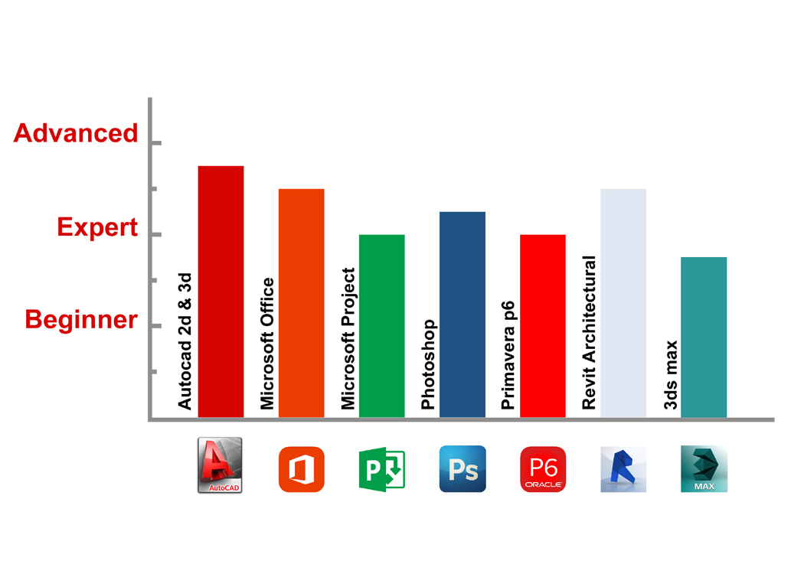
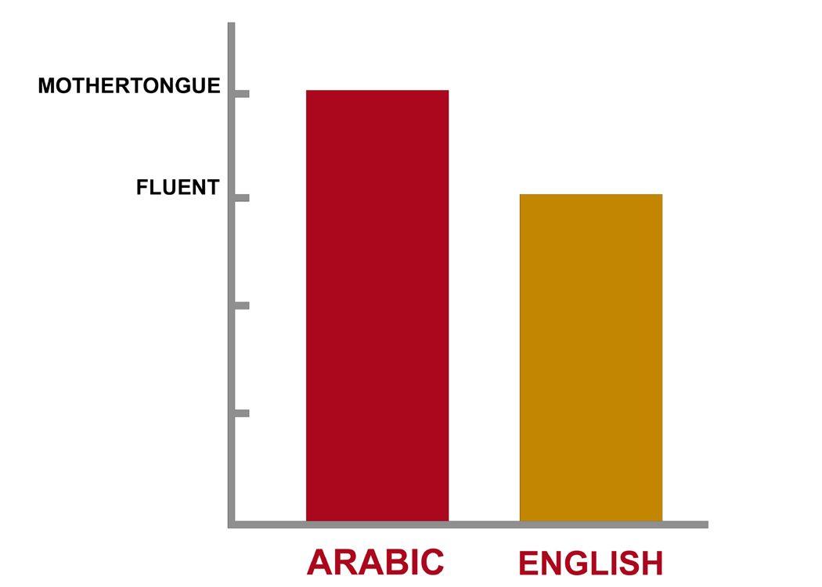
LANGUAGES

EXPERIENCE
Mar. 2011 To Feb 2013 |  |  | Mar. 2013 To Oct. 2014 |  |  |  |  | Nov. 2014
SITE ENGINEERING At  New Life Scale - Egypt:  -Overseeing parts of construction projects  -Overseeing building work.  -Setting out sites and organizing facilities  -Supervising contracted staff.  -Ensuring projects meet agreed  specifications, budgets or timescales.  -Checking and preparing site reports  -Designs and drawings. |  |  | ARCHITECT At  Seqayah Consulting Engineers – KSA  -Supervises the architectural design of complex buildings and structures.  -Advises others on practical, aesthetic and social considerations in architectural design projects.  -Develops project objectives, schedules and performance benchmarks in architectural design.  -Directs the selection of appropriate techniques according to different types of design work. |  |  |  |  | ASSISTANT PROJECT MANAGER At  New Life Scale - Egypt:  -Schedule the project in logical steps and budget time required to meet deadlines.  -Inspect and review project design according to client requirements.  -Interpret and explain plans and contract terms to workers, and clients representing the owner.  -Prepare contracts and negotiate revisions, changes and additions to contractual.  -Agreements with clients, suppliers and subcontractors.
EDUCATION  2015  Regional IT Institute.  Diploma in Project Management. |  |  | 2010  Faculty Of Engineering At Tanta University  Bachelor's Degree, Architectural Engineering  Key courses: Architectural Design, Architectural Theories, and Urban Design.  Working Drawings, Steel Structure, Concrete Structure, Sustainable Studies. |  |  |  |  | INTERESTS  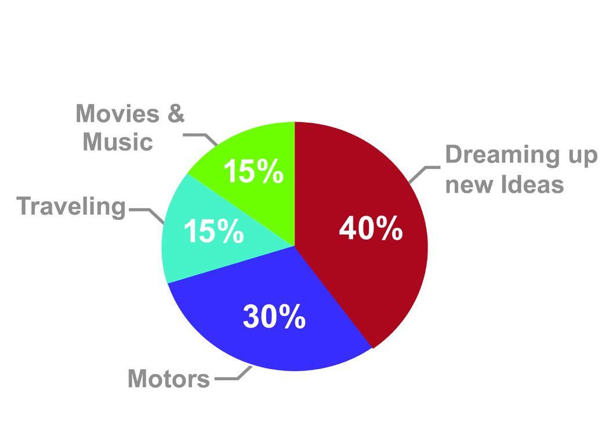  (% Of spare time)  UPDATED IN SEP. 2015

