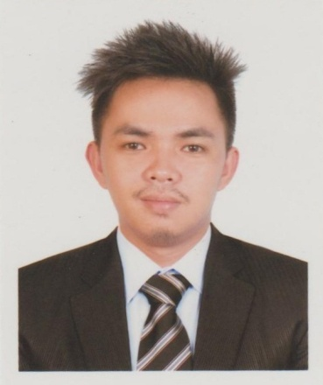
Norman

Norman.243878@2freemail.com

BS- Information Technology
Major in Management Information Systems

Personal Data:

- Age: 26 years old
- Birthdate: April 20, 1991
- Civil Status: Single
- Gender: Male
- Height: 5’9’’
- Weight: 140lbs

Credentials
- Excellent in written and spoken English, Tagalog and Cebuano
- Excellent in Microsoft Word, Excel, and PowerPoint (Microsoft Office)
- Excellent in Computer Programming
- Excellent in Computer Hardware Servicing & Networking (Technical Support)
- Excellent in Typing & Data Entry Skills
- Experienced in Photo, Video and Audio Editing
- Experienced in Managing a Business
- Fast Learner and Attention to details
- Works in Minimum Supervision
- Adaptability and ability to work under pressure
- Willing to try new things and interested in improving efficiency on assign tasks
- Ambitious, Persistent, Reliable, Friendly, Responsible, Goal-Oriented, Customer Oriented, Public Speaker, Motivate Others

WORK EXPERIENCE
- IT Technician / Car Parking Manager
Doha Exhibition and Convention Center (DECC) Site
Computer Station Co.
Bldg. No. 82, Al Ghazali St, Uhm Lakhba Area, Al Duhail South
September 2015 – April 2017

- Accounting Staff / Bookkeeper
Unified Communications One Corporation (UC-1 Corp.)
Corrales Avenue, Cagayan de Oro City
September 2013 – August 2015

- Computer Operator
Misamis Oriental-1 Rural Electric Service Coop., Inc. (MORESCO-1)
Poblacion, Manticao, Misamis Oriental
May 2013

- Document Controller / Data Entry
National Statistics Office Project Outsource (NSO)
Eastern Terra Enterprises
Poblacion, Naawan, Misamis Oriental
February 2013

- On-The-Job Training
Management Information Systems Division
Province of Misamis Oriental Office
Provincial Capitol, Cagayan de Oro City
April 2012 – May 2012

- Special Program for Employment of Students
Management Information Systems Division
Province of Misamis Oriental Office
Provincial Capitol, Cagayan de Oro City
April 2011 – May 2011

SEMINARS AND TRAININGS ATTENDED
- Customer Service Seminar
Unified Communications One Corporation (UC-1 Corp.)
Cagayan de Oro City
February 2, 2014

- 10th Iligan City Computer Fair
Mindanao State University at Iligan Institute of Technology
Iligan City
September 19, 2012 – September 21, 2012

- 10th Philippine Youth Congress on Information Technology
University of the Philippines
Diliman, Quezon City
September 10, 2012 – September 14, 2012

- 9th Iligan City Computer Fair
“Information Freedom: Ethical Computing Towards Responsible Netizenship”
Mindanao State University at Iligan Institute of Technology
Iligan City
September 22, 2011

- TRAINING and DEVELOPMENT for CALL CENTER AGENT (NCII)
Quezon City, Philippines
July 6, 2009 – July 22, 2009

REFERENCES AVAILABLE UPON REQUEST

