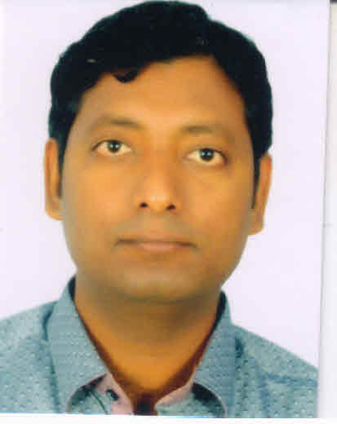

AKSHAY AKSHAY

university2

**EDUCATION**

To join an organization that gives me an opportunity to showcase my skills and also helps me gain practical exposure in business sector.



[**Akshay.245613@2freemail.com**](mailto:Akshay.245613@2freemail.com)



**CAREER GOAL**

**Bachelor of Pharmacy | 2012**

**Nagpur University, India**

**Diploma in Pharmacy | 2006**

**Raipur University (C.G.), India**

**H.S.S.C. | 2003**

**Nagpur Board (M.S.), India**

**S.S.C. | 2001**

**Nagpur Board (M.S.), India**



● **Excellent Communication Skills**

● **Target Driven**

● **Ability to work in a fast paced environment to set deadlines**

● **Hard Working Individual**

● **Ability to Prioritize**



medal



**medal**

● Windows 8 Applications (Word, Excel, PowerPoint, Outlook, Access)-Advanced

● Microsoft Office Imaging and Scanning

● Acrobat Reader 8 - Intermediate

**`**



**COMPUTER**

**SKILLS**



**WORK**

**EXPEREINCE**

**Pharmacist | Aug 2012 – July 2015**

**New Lifeline Medical Stores, Amravati, M.S., (India)**

Responsibilities included providing pharmaceutical services. Communicated regularly with medical staff. Duties included checking & verifying the dispensing & compounding activities of pharmacy technicians.

**Quality Control Trainee | Dec 2011 – May 2012**

**Active Pharma Lab, Hyderabad (A.P.)**

Handling of following instruments –

Operation of High performance liquid chromatography (HPLC), Gas chromatography (GC), UV-Visible spectrophotometer, Karl-Fischer Apparatus, pH meter & Volumetric solutions preparation and standardization.



● A high standard of professionalism in my work

● The ability to remain calm and objective in all situations

● Able to work autonomously and in a team environment

● A good sense of humour and the willingness to be part of a team









Date of Birth: 24/09/1985

Nationality: Indian

Languages Known: English, Hindi & Marathi

Marital Status: Unmarried

Visa Status: Visit

**PERSONAL**

**DETAILS**



**PERSONAL**