Gulfjobseeker.com CV No: 1476096
Mobile +971504753686, +971505905010
cvdatabase[@]gulfjobseeker.com
To contact this candidate use this link
http://www.gulfjobseeker.com/feedback/contactjs.php

CURRICULAM VITAE |  |  |  |  |  |  |  |  |  | 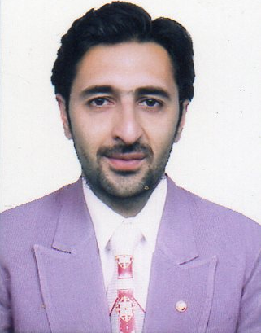
Locations of Interest |  |  | Overseas
Total Experience |  |  | 06 Years
Career at Glance
Company Name |  | Designation |  |  |  | Duration |  |  | Experience
New Kashmir Pharmaceuticals pvt.ltd. in Kashmir j&k India.  . |  | Marketing Representative. |  |  |  | April 2009-May 2012 |  |  | 03 Years
Joy Tour &Travels pvt.ltd. in Kashmir j&k India. |  | Senior Sales Executive. |  |  |  | Sep. 2012- July 2015 |  |  | 03 Years
Career Objectives |  |  |  | I Intend to build a career with leading corporate of Hi-Tech environment with committed and dedicated people, which will help me to explore myself fully and realize my potential. Willing to work as a key player in challenging environment.
Positions of Interest |  |  |  | Any assignment related to my interest or nonrelated which will surely support to the organization and for the betterment of society by virtue of loyalty and hard work, I am ready to work on any challengeable & responsible position.
Work Experiences  Educational Qualifications |  | C  C |  | Sales Executive from last 06 Years.  B. A through University of Kashmir.
 |  |  |  | 10+2 through J&K State Board of School Education.
 |  |  |  | 10th through J&K State Board of School Education.
References |  |  |  | Credentials & References shall be produced on demand.
Personal Information

NATIONALITY |  |  |  |  |  |  | ■ | Indian
RELIGION |  |  |  |  |  |  | ■ | Muslim
D.O.B |  |  |  |  |  |  | ■ | 15/09/1985
SEX |  |  |  |  |  |  | ■ | Male
MARITAL STATUS |  |  |  |  |  |  | ■ | Single
identification mark |  |  |  |  |  |  | ■ | Mole on shoulder
HEIGHT |  |  |  |  |  |  | ■ | 5.10 Inches “Approx”
BLOOD GROUP |  |  |  |  |  |  | ■ | A+ive
LANGUAGES | Read, Write & Speak |  |  |  |  |  | ■ | Kashmiri, Urdu, English & Punjabi
LANGUAGES | read Only & Speak Poor |  |  |  |  |  | ■ | Arabic
HOBBIES |  |  |  |  |  |  | ■ | Photography & Playing cricket

